Open the TI-Nspire document Biodiversity_and_the_Environment.tns.

You may often hear of classrooms, schools, or towns having a certain amount of “diversity.” Used in this way, “diversity” refers to variety within a single species: OURS!

Even though students in your classroom, school, or town might seem to be diverse on the surface, they are all human, just like you. Outside of your school’s walls, there are many different species of organisms living with and among each other. The number of species and the abundance of individuals in populations are governed by the interactions between organisms and between organisms and their physical environment. Biodiversity—the variety of life forms in an ecosystem or biome—is a measure of the health of an ecosystem. Each ecosystem contains an assembly of species that are adapted to the range of conditions typically found in that environment. If conditions change dramatically, some species may not be able to survive, resulting in lower diversity. In this activity, you will examine some of the factors influencing the biodiversity of an ecosystem.

Move to page 1.2. | Press /¢ and /¡ to navigate through the lesson.
1. Read the background information.

Background Information
Organisms are impacted by the abiotic, or nonliving, factors in their environments. The actions of organisms can affect abiotic factors and other biotic factors. Abiotic factors are important drivers for biodiversity. As the variety of physical characteristics in an ecosystem increases, so does species diversity. This is because each species is adapted to tolerate a certain range of abiotic conditions.

On a global scale, there is an interesting relationship between biodiversity and temperature. Generally, species diversity increases from the poles to the equator. This is known as the Latitudinal Diversity Gradient. Scientists have not reached consensus on the primary mechanism for this global pattern, but the greater amount of solar energy and larger available area near the equator are thought to be important.

Move to pages 1.3 – 1.5. Answer questions 1-3 below and/or on your handheld.
Q1. Give two examples of abiotic factors in an environment.

Q2. Which of the following ecosystems is likely to support the highest biodiversity?

- Forest with three soil types and varied land features
- Forest with one soil type and relatively flat land
- Forest with three soil types, varied land features, and a small stream

Q3. Which of the following is an example of a biotic factor influencing another biotic factor?

- Lower soil phosphorus concentrations decrease plant productivity.
- Higher plant diversity increases animal diversity.
- Concentrations of hippopotamuses in ponds increase water turbidity.
- Accumulation of wood debris increases forest fire intensity.
Move to page 1.6.  2. On page 1.6, you will see a model of a lake ecosystem. Carefully read the directions that are covering the picture of the lake. When you understand what your task is, click and make the adjustments that the directions recommend. Pay close attention to what happens as the temperature and pH of the lake are changed. Press b if you need to view the directions again. | 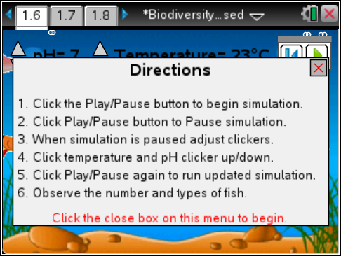
Move to pages 1.7 – 1.8. Answer questions 4 and 5 below and/or on your handheld.
Q4. What are the variables that you can regulate in the simulation? (Select all that apply.)

- pH
- population density
- plant diversity
- temperature
Q5. Which of the following represent "biotic" factor(s) in the simulation? (Select all that apply.)

A. fish biomass
B. dissolved oxygen
C. plant diversity
D. water pH
Move to pages 1.9 – 1.10. Answer question 6 below and/or on your handheld.
3. Read the content information about pH on page 1.9.

Q6. A lake with a pH of 6.5 would be considered:

A. neutral
B. highly acidic
C. slightly acidic
D. slightly basic

Move to pages 1.11 – 1.12.
4. On page 1.11, you will read about the meaning of biodiversity. After reading the information on this page, move to page 1.12. On this page, you will be instructed to return to the simulation on page 1.6 and review what happens when the pH and temperature of the water are changed.

Move to pages 1.13 – 1.16. Answer questions 7-10 below and/or on your handheld.
Q7. How do temperature and pH affect each other?

- As temperature goes up, pH goes up.
- As temperature goes up, pH goes down.
- As temperature goes down, pH goes up.
- Temperature and pH do not affect each other.

Q8. In general, there is a greater diversity of fish when the water is warmer.

- Agree
- Disagree

Q9. As the water becomes more acidic, the diversity of fish decreases. Which is the best explanation?

- The maximum sustainable number of individuals is reduced by acidic conditions.
- Only a small number of species are adapted to survive in acidic conditions.
- Most fish prefer very basic conditions.
Acid rain from fossil fuel combustion can strongly impact the pH of aquatic ecosystems. In recent years, the U.S. has recorded acid rain with a pH as low as 4.3.

Q10. Go back to the simulation and set the temperature at 20ºC and the pH at 7. Note the population and species values. Now change the pH to 5 and keep the temperature at 20ºC. What do you observe?

Move to page 2.1 for the simulation on dissolved oxygen.  5. This next simulation deals with the relationship between water temperature and the levels of dissolved oxygen in the water. As in the first simulation, read the directions in the pop-up window. When you are ready to run the simulation, close the directions box by clicking . You will then vary the water temperature and collect data on dissolved oxygen levels. | 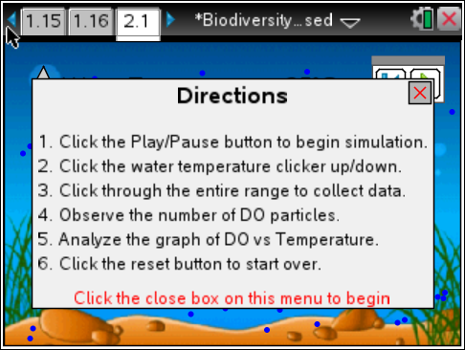
Move to pages 2.2 – 2.8. Answer questions 11-17 below and/or on your handheld.
Q11. What happened to the amount of dissolved oxygen as you increased the temperature of the water?

Q12. Which term do you think best describes the relationship between water temperature and dissolved oxygen levels?

- Direct B. Inverse
Q13. Water has less capacity to hold dissolved oxygen as temperature increases, because gas molecules move faster and spread apart in warmer water.

- Agree
- Disagree

Q14. Which of the following factors do NOT contribute to higher dissolved oxygen levels?

- photosynthesis
- turbulence
- decomposition of organic matter
- low water temperature
Q15. Fish such as salmon and trout need a lot of oxygen to survive. Which water temperature do you think would be best for these fish?

- 40ºC
- 30ºC
- 20ºC
- 10ºC

Q16. Catfish have a lower oxygen requirement than many freshwater fish. In which aquatic habitat are they likely to be better adapted than other fish?

- mountain stream
- shallow tropical lake
- deep temperate lake

Q17. Oxygen is rarely a limiting abiotic factor in aquatic ecosystems.

- Agree
- Disagree

Move to page 2.9.
6. On page 2.9, there is a graph of the data that was collected automatically as you made changes to the water temperature in the simulation. Plot the data below as it appears in the graph on your handheld.
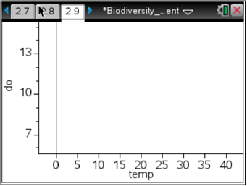
Move to pages 2.10 – 2.11. Answer questions 18 and 19 below and/or on your handheld.
Q18. Which words could be placed in the blanks below to make the statement true? (Select all that apply.)

As water temperature goes _____, the dissolved oxygen level goes _____.

- up; up
- up; down
- down; up
- down; down

Q19. Predict what would happen if the water continued to get warmer and warmer.

- The dissolved oxygen levels would continue to drop and level off at 0 ppm.
- The dissolved oxygen levels would level off near 6 ppm.
- The dissolved oxygen levels would continue to drop and eventually become negative.

Move to page 2.12.
7. The final page of the activity shows you the actual data that was collected as you made changes to the temperature of the water in the dissolved oxygen simulation.

