Open the TI-Nspire document Compare_Linear_Exponential.tns.  In this activity, you will explore the values of the expressions 3x and 3^{x} as x changes from 0 to 5. You will compare the two expressions by investigating patterns in how their values change both in a table and graphically. | 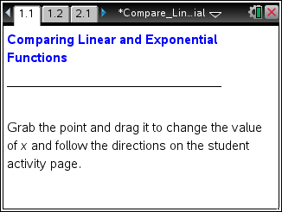

Move to page 1.2. | Press / ¢ and / ¡ to navigate through the lesson.
1. Grab and drag the point to change the value of x. Complete the table below. Which column is growing faster?

x | 3x | 3^{x}
0
1
2
3
4
5

2. a. As x increases from 2 to 3 in the table, how does the value of 3x change?

b. As x increases by 1, describe the pattern in the numbers in the 3x column of the table.

3. a. As x increases from 2 to 3 in the table, how does the value of 3^{x} change?

b. As x increases from 3 to 4 in the table, how does the value of 3^{x} change?

c. As x increases by 1, describe the pattern you notice in the numbers in the 3^{x} column of the table.

4. Complete the bottom row of the table for x = 6. How did you determine the values for 3x and 3^{x}?

x | 3x | 3^{x}

5. Why are the values for 3^{x} increasing faster than the values for 3x?

6. The function f(x) = 3^{x} is called an exponential function, while the function f(x) = 3x is a linear function. Describe the differences in the two functions.

Move to page 2.1. | Press / ¢ and / ¡ to navigate through the lesson.
7. Drag the point on the arrow to the right to produce two graphs—one red and one blue. Use the information from the table in question 1 to identify which graph represents an exponential function and which graph represents a linear function. Justify your answer.

8. How do the graphs of f(x) = 3x and f(x) = 3^{x} support your response to question 5?

9. Aaron says that the values of f(x) = 5^{x} will increase faster than the values of the linear function f(x) = 5x. Do you agree or disagree? Support your answer.

