Activity Overview
In this activity, you will create a new document with a Graphs application which contains a system of equations that can be used to illustrate solving a system by graphing.

Materials
- Technology needed (TI-Nspire™ handheld, computer software)

Step 1: Preparing the title page  1. Create a new document: pressing c > New Document > Add Notes.  2. Type Solving Systems by Graphing.  Note: To create capital letters, press g, then the letter.  3. Press ~ > File > Save As  Type: Solving_Systems_by_Graphing.  Tab to ¾, and press ·.  Note: To create underscore, press / _. | 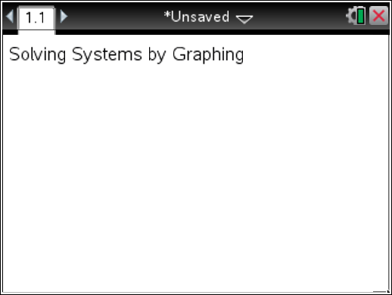
Step 2: Adding the Graphs application  1. Add a graphs application: press /~ > Add Graphs | 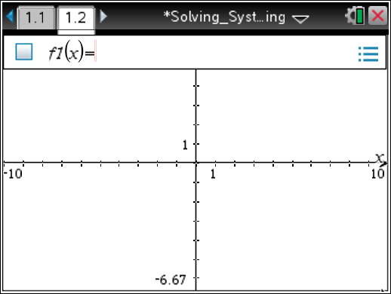
Step 3: Graph two lines  1. To graph the line y = x + 1, press X + 1·.  2. To bring up the f2(x) entry line, press e.  3. With the cursor in the f2(x) = entry line, graph the line y = –x + 3 by pressing vX+3·.  4. To add a dot grid, select Menu > View > Grid > Dot Grid. | 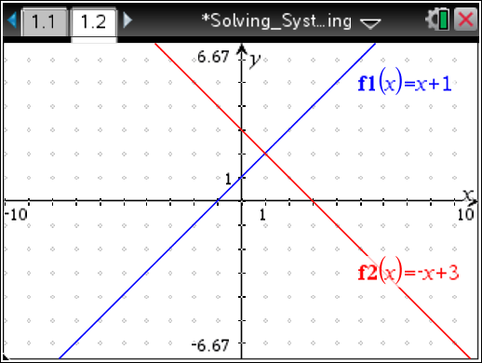
Step 4: Create a point that moves  1. To create a point that is on a grid mark and on the x-axis, select Menu > Geometry > Points & Lines > Point On.  2. Move the arrow near a tick mark on the x-axis until you see ø and “grid e.” Press e. You will see “axis e.”  3. Press · twice.  4. Press d. | 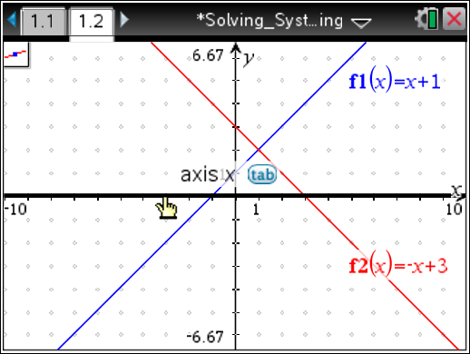
Step 5: Create a perpendicular line to the x-axis  1. To graph a line through this point that is perpendicular to the x-axis, select Menu > Geometry > Construction > Perpendicular.  2. Move the cursor until you see ø and “point e”. Press ·. A dotted line will appear.  3. Move the cursor until you see ø and “axis x”, and the x-axis has become bold. Press ·. Press d. | 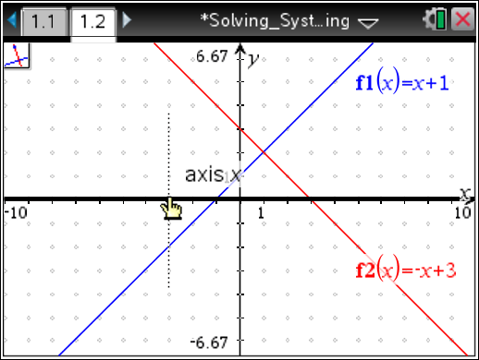
Step 6: Construct two points of intersection  1. To find the intersection points of the vertical line with the graphs of f1(x) and f2(x), select Menu > Geometry > Points & Lines > Intersection Point(s).  2. Move the cursor to anywhere on the graph of f1(x) until you see ø and “graph f1”, and the line for f1 is bold. Press ·.  3. Move the cursor to anywhere on the vertical line until you see ø and “line”. The vertical line will be bold and the point of intersection will appear. Press ·.  4. Move the cursor to anywhere on the graph of f2(x) until you see ø and “graph f2”, and the line for f2 is bold. Press ·.  5. Move the cursor to anywhere on the vertical line until you see ø and “line”. The vertical line will be bold, and the point of intersection will appear. Press · Press d. | 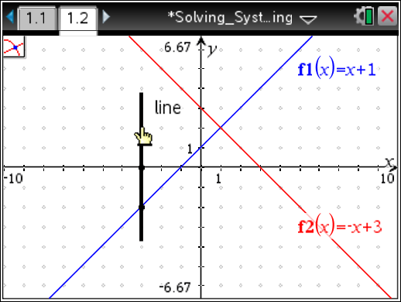
Step 7: Display the coordinates  1. To display the coordinates of the points of intersection, select Menu > Actions > Coordinates and Equations.  2. Move the cursor to the point of intersection of f1 and the vertical line until you see ø and “point e”. The point will become bold and the ordered pair will be displayed faintly. Press · twice.  3. Move the cursor to the point of intersection of f2 and the vertical line until you see ø and “point e”. The point will become bold and the ordered pair will be displayed faintly. Press · twice.  4. Press d. | 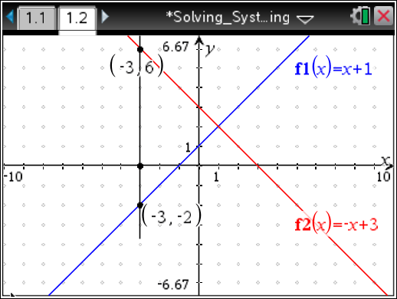
Step 7: Hiding the Vertical Line  1. To hide the vertical line from view, press Menu > Actions > Hide/Show.  2. Move the cursor to the vertical line until the vertical line becomes bold and you see ú and “line.”  3. Press x. Press d. | 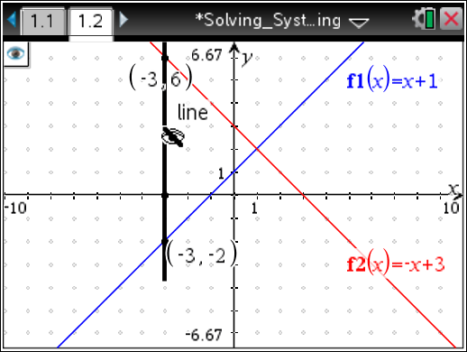
Step 8: Save the Document  Press / S. | 