Open the TI-Nspire document Zeros_of_a_Quadratic_Function.tns.  In this activity, you will observe graphs of pairs of linear functions and the related quadratic function. You will investigate the points at which the functions cross the x-axis and the zeros of the functions. | 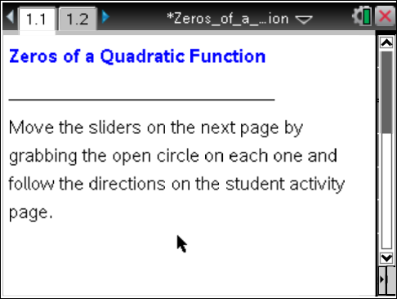

Move to page 1.2. | Press / ¢ and / ¡ to navigate through the lesson.
1. Use the sliders to set y₁ = 2x + 2 and y₂ = 1x – 2. Observe that the graph of y₁ = 2x + 2 appears to cross the x-axis at x = –1. When x = –1, y₁ = 0 because 2(–1) +2 = 0.
x = –1 is called a zero of the function y₁ = 2x + 2.
a. Where does the graph of y₂ = 1x – 2 appear to cross the x-axis?

b. Verify that this value of x is a zero of y₂.

2. a. When y₁ = 2x + 2 and y₂ = 1x – 2, what is the function y₃?

b. How many times does the graph of y₃ = 2x² – 2x – 4 cross the x-axis?

c. What are the zeros of y₃?

d. Write a conjecture about the relationship between the zeros of the linear functions and the zeros of the quadratic function.

3. a. Given the information below, use the sliders of the .tns document to fill in the rest of the table.

y₁ | y₂ | Zeros of  y₁ y₂ |  | y₃ | Zeros of  y₃
2x + 4 | x – 1
3x + 3 |  |  | –4
 |  |  |  |  | –5 and 4
 |  |  |  | x² – 2x – 15

b. What is the relationship between the zeros of the quadratic function and the zeros of the linear functions? Compare this to the conjecture you made in question 2d.
4. Factor each of the quadratic functions below.
a. 2x² + 2x – 4

b. 3x² + 15x + 12

c. x² + x – 20

d. x² – 2x – 15

5. How do the factors in question 4 relate to the information in the table in question 3?

6. Write a pair of linear functions whose product yields a quadratic function with zeros of
3 and –2. What is the corresponding quadratic function? Describe the process you used to determine your answers.

7. Given the quadratic function y = x² – 11x + 30, determine its zeros. Describe the process you used to obtain your solutions.

8. Samuel says, “I can solve x² – 11x + 30 = 0 by factoring it, setting each factor equal to zero, and solving for x.” Is this a valid method? Explain.

