Activity Overview
In this activity, you will draw triangles and polygons and find their area geometrically and through the use of determinants.

Materials
- Technology needed (TI-Nspire™ handheld, computer software)

Step 1: Getting the document ready  1. Press c > New Document > Add Notes and type “Areas of Polygons”.  2. Press /~ and choose add a Graphs page.  3. Press Menu > View > Grid >Dot Grid.  4. Press / G to hide the entry line.  5. Press ~ > Page Layout > Select Layout > Layout 3.  6. Press Menu > Window / Zoom > Standard.  7. Using the Click Pad or Touch Pad, click the newly created page section. (When selected, a box should appear around it.)  8. Press Menu > Add Notes.  9. Press / e to select the Graphs section of the page. (When the Graphs portion is selected, a box should appear around it.) | 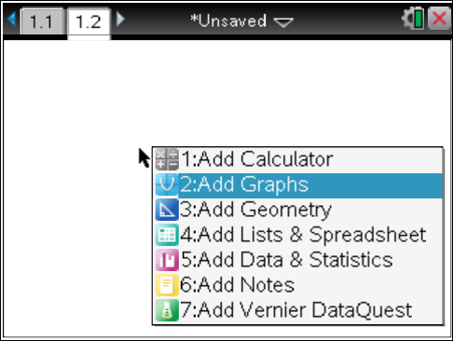
Step 2: Making a copy and saving the document  1. Press / £ to open the page sorter.  2. Use the Click Pad or Touch Pad to select the words Problem 1. Press / C to copy the problem.  3. Press / V to paste one copy of Problem 1. Delete the first page of problem 2 by pressing ..  4. Use the Click Pad or Touch Pad to select the second page of problem 1 and press ·.  5. Page 1.2 should now be the active page.  6. To save this document, press ~ > File > Save As and enter Areas_of_Polygons. | 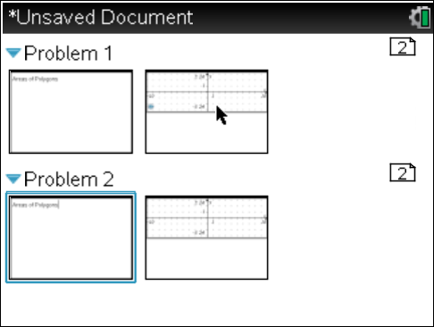

Step 3: Creating a triangle and measuring its area  1. Press Menu >Geometry>Shapes>Triangle.  2. To create the vertices, move the cursor to each desired grid point until the phrase point on appears. Press x to create each vertex.  3. Press Menu>Geometry>Measurement>Area.  4. Move the cursor to the triangle. The word triangle should appear when the cursor hovers over the triangle.  5. Press x to select the triangle, use the touchpad to move the calculated area to an open location in Quadrant I, and press x again to permanently display the measured area. | 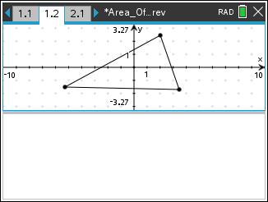
Step 4: Displaying the coordinates of the triangle vertices  1. Press Menu > Actions > Coordinates and Equations.  2. Move the cursor to a vertex of the triangle. The word point as well as its coordinates should appear when the cursor hovers above one of the vertices.  3. Press x to select the vertex, and press x again to permanently display the coordinates.  4. Repeat for all vertices.  5. Press d. | 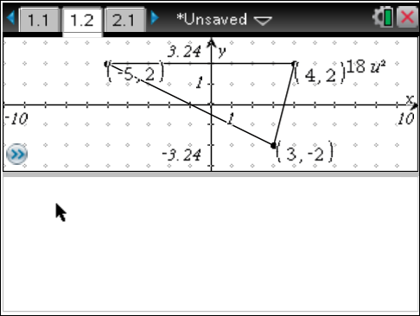
Step 5: Linking the coordinates to variables  1. Move the cursor to the value of the x-coordinate of one of the vertices. The word text will appear.  2. Press / Menu > Store, enter x1, then press ·. Notice that the value of the x-coordinate is now bold. Any value that is stored as a variable appears in bold text.  3. Move the cursor to the value of the y-coordinate of the same vertex.  4. Press / Menu > Store, enter y1, then press ·.  5. Repeat this for the other two vertices, but use x2, y2 and x3, y3. | 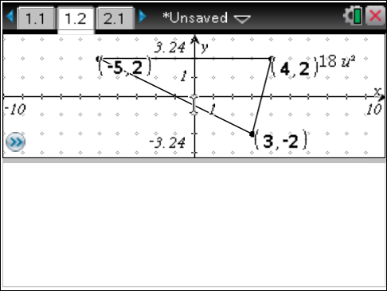
Step 6: Adding the matrix area calculation to the Notes page  1. Press / e to select the Notes portion of the page. Insert a math box into the Notes section of the page by pressing / M.  2. Enter the determinant function into the Notes section by typing D E T (  3. Enter a 3 × 3 matrix template into the Notes section by pressing t and selecting the 3 × 3 matrix template. A matrix window appears with fields for the numbers of rows and columns. Type 3 in the row field, type 3 in the column field, and press ·.  4. Fill in the template to form the matrix , then press ·. | 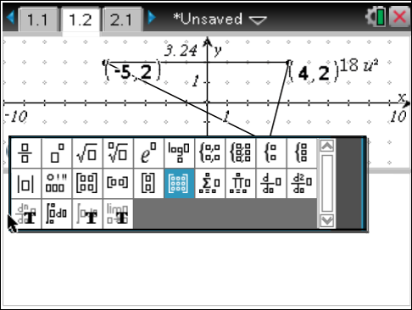  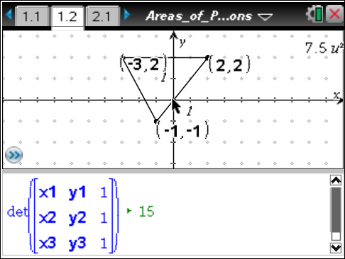
Step 7: Creating a quadrilateral and measuring its area  1. Press / ¢ to move to the page 2.1.  2. Press Menu > Geometry > Shapes > Polygon.  3. To create the vertices, use the Pad to move the cursor to the desired grid point until the phrase point on appears. Press x to create each vertex. After creating the fourth vertex, press x again to finish the shape.  4. Press Menu > Geometry >Measurement > Area.  5. Move the cursor to the quadrilateral. The word polygon should appear when the cursor hovers over the quadrilateral.  6. Press x to select the quadrilateral. Use the Touch Pad to move the calculated area to an open location in Quadrant I and press x again to permanently display the measured area. | 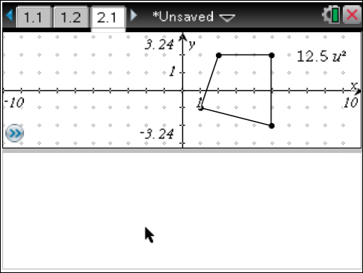

Step 8: Displaying the coordinates of the quadrilateral vertices  1. Press Menu > Actions > Coordinates and Equations.  2. Move the cursor to a vertex of the quadrilateral. The word point as well as its coordinates should appear when the cursor is above one of the vertices.  3. Press x to select the vertex, and press x again to permanently display the coordinates.  4. Repeat for all vertices.  5. Press d. | 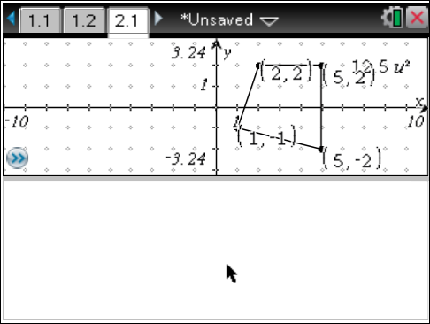
Step 9: Linking the coordinates to variables  1. Move the cursor to the value of the x-coordinate of the bottom-right vertex. The word text will appear.  2. Press / Menu > Store, enter x1, then press ·. Notice that the value of the x-coordinate is now bold. Any value that is stored as a variable appears in bold text.  3. Move the cursor to the value of the y-coordinate of the same vertex.  4. Press / Menu > Store, enter y1, then press ·.  5. Choosing the remaining vertices in a counterclockwise manner from the first one chosen, repeat this for the other three vertices, but use x2, y2 and x3, y3 and x4, y4. | 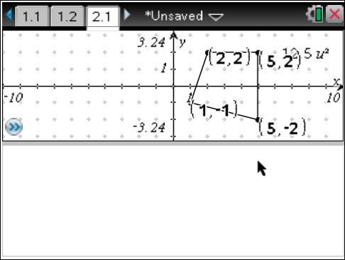
Step 10: Dividing the quadrilateral into two triangles  1. Press Menu > Geometry > Points and Lines > Segment.  2. Move the cursor to a vertex on the left side of the polygon.  3. Press ·. To finish drawing the line segment, move the cursor to a vertex on the opposite side to form a diagonal and press ·. The quadrilateral is now divided into two triangles.  4. Press d.  5. Move the cursor to the diagonal and press / Menu > Attributes.  6. Arrow down one and to the right and change the appearance of the diagonal to dotted. Press x. | 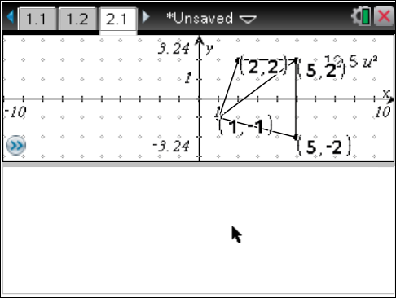
Step 11: Adding the matrix area calculations to the Notes page  1. Press / e to select the Notes portion of the page. Insert a math box into the Notes section of the page by pressing / M.  Now sum the determinants of each triangle formed by the diagonal.  2. Enter the determinant function into the Notes section by typing D E T (  3. Enter a matrix template into the Notes section by pressing t and selecting the 3 × 3 matrix template. A matrix window appears, with fields for the number of rows and columns. Type 3 in the row field, type 3 in the column field, and press ·.  4. The idea is to list the vertices of each triangle.  5. Fill in the template to form the matrix . Click to move right of the parentheses, then press +. | 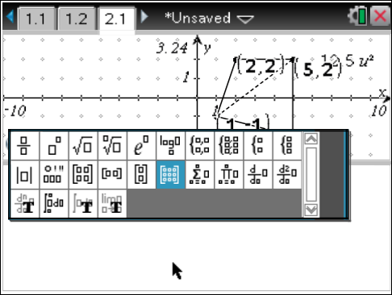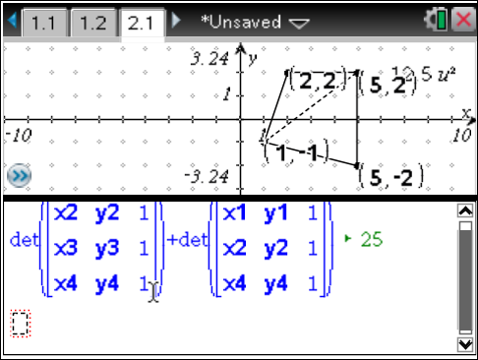
6. For the second triangle, enter the second determinant function into the Notes section by typing D E T (.
7. Press t and select the 3 × 3 matrix template. A matrix window appears, with fields for the number of rows and columns. Type 3 in the row field, type 3 in the column field, and press ·.
8. Fill in the template to form the matrix , then press ·.
9. Save the document again.

