Open the TI-Nspire document Elliptic_Variations.tns.  A standard ellipse has the Cartesian equation and is the locus of points in the plane whose distances to two fixed points have a constant sum. In this activity, we will consider two “what-if” questions:  (1) What if the exponent in the Cartesian equation ≠ 2?  (2) What if “sum” is changed to “product”? | 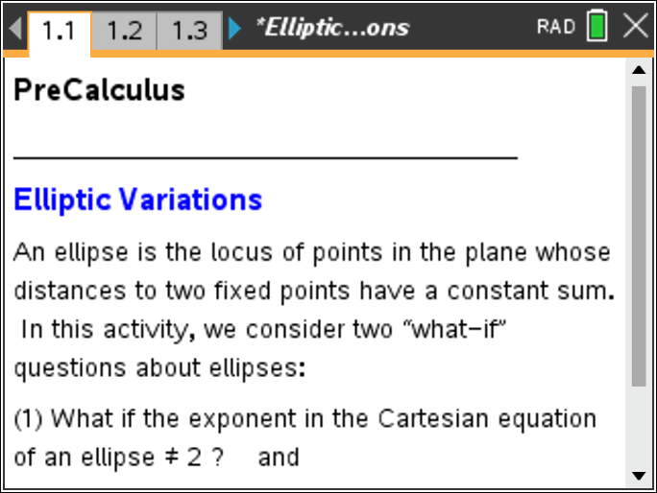

Problem 1: Superellipses  Move to page 1.2. | Press / ¢ and / ¡ to navigate through the lesson.
The curves described by the equation, where is a positive rational number, are called superellipses.
To conveniently explore fractional values of , we set = and consider the values of from to 4, or equivalently, the values of from 1 to 24.

Piet Hein popularized these curves around 1960 for values of > 2 [especially = 2.5]. The curves for these values of n are “rounded rectangles” that have been used in the design of a town “square” in Sweden to improve traffic flow and in the design of tabletops and other furniture.

Move to page 1.3.

We will use parametric equations to produce a graph of these superellipses. The derivation of these equations is shown later in this section.

Move to page 1.4.

Use the -clicker and -clicker to set the values of and to = 6 and = 4 Using the -clicker, scroll through the values of = 1 to 24. As you answer the questions below, you might want to experiment with other values of and to confirm your responses.
1. Which value of generates the graph of a standard ellipse?

2. Which value of generates the graph of a polygon, instead of a curve? Identify the type of polygon.

3. Let k* denote the value of k in your answer to Question #2. Describe the graphs for 1 ≤ k ≤ k*.

4. Use the -clicker and -clicker to set the values of and to = 6 and = 6 Using the -clicker, scroll through the values of = 1 to 24. Describe the curve when =.

5. What do you predict will happen to the graph of as becomes very large? Why?

6. What do you predict will happen to the graph of as becomes very small? Why?

Recall that the parametric equations for the standard ellipse are and for .

To modify these equations for a superellipse, we have .
These equations are valid because =.

The difficulty with using these equations is that there are four of them. We would need to draw four different curves corresponding to the four possible combinations of + (plus) and - (minus). Fortunately, we can incorporate the signum function, , into these equations to combine all of them into one equation. The signum function is defined by

Note: On the calculator,. This anomaly does not affect the graphs in this problem.

The parametric equations for a superellipse become
for 0 ≤ ≤ 2π.

7. Explain carefully how these equations determine the set of points on the graph in the second quadrant when .

Problem 2: Cassini Ovals
Move to page 2.1.

A Cassini oval is the locus of points in the plane whose distances to two fixed points have a constant product. Giovanni Domenico Cassini developed this set of curves in 1680 because he believed that the motion of the Earth and Sun followed the path of a Cassini oval.

In other words, a Cassini oval is the graph of the equation for various values of and . The fixed points are (,0) and (,0), and the distance is . In this activity, we consider the case when = 4.

Move to page 2.2.

We will use polar equations to produce graphs of Cassini ovals. The derivation of these equations is shown later in this section.

Move to page 2.3.

Set the value of the -clicker to = 1.6. Scroll through the values for = 1.6 down to = 1.0.
8. Describe how the curve changes for values of between 1.6 and 1.0.

9. What do you predict will happen to the curve as becomes very large? Why?

Move to page 2.4.

Set the value of the -clicker to = 0.95. Scroll through the values for = 0.95 down to = 0.5.
Note: Because of an anomaly in the way the calculator draws such graphs, the graphs of the ovals appear to be open, or disconnected, but, in fact, they are closed, connected graphs.
10. Describe how the curve changes for values of between 0.95 and 0.5.

11. What do you predict will happen to the curve as becomes very small?

To derive the general polar equations of , we start by letting and . Then

(1)
(2) =
(3)

Solving for and then gives
(4) or
(5) so that
(6) .

12. Explain how to go from step (2) to step (3) and from step (4) to step (5) in the argument above.

