Open the TI-Nspire document Natural_Selection.tns.  In this simulation, you will observe the effect of natural selection on a population, and how that results in changes to the population over time. You will be able to adjust the variables that influence natural selection to see how different traits or selections influence a population. |  | 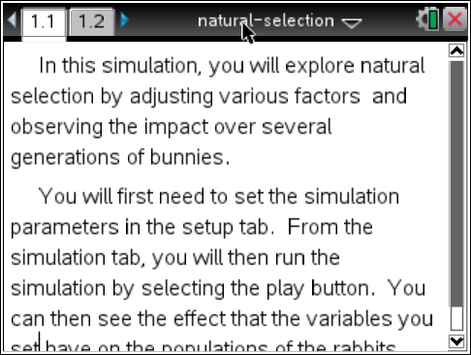
Natural Selection is a term that Charles Darwin first used to describe the forces that act on a population to shape evolutionary changes. There is always a natural variation in a population. Some traits, like fur color or beak shape, have a neutral effect, or can help or hurt. Those that hurt an individual in the population cause them to be naturally removed. This then increases the influence of helpful traits. It’s important to understand that natural selection acts on the phenotype, or the observable traits in the population that are controlled by genetics, not the genotype, which is the genetic information.

In this simulation, you will set up experiments to see how different phenotypes respond to natural selection. Read the directions on page 1.1.

Part One: No Selection

Move to page 1.2.
Select the Setup tab. First, you will examine how populations grow when there is no natural selection, or selective pressure.
- Change the Selection Factor to None by selecting the up and down arrows.

- Pick a mutation you would like to examine.
- First, you will see what happens when the mutation is dominant. Make sure all the settings are as shown to the right. To change any category/trait/variable, select the appropriate up and down arrows.

- Select the Simulation tab. Select Play to start the simulation. Let the simulation proceed to at least 6 generations (Gen6) before answering the questions. Select Pause to stop the simulation.
Q1. What is a phenotype?

Q2. When you used the long tail or teeth mutation, did any of the rabbits have white fur? Explain why or why not?

Q3. For the Mutation you selected, after 6 generations, how many rabbits show the dominant phenotype? The recessive phenotype? Why do think this is? What do you think will happen with 6 more generations?

Q4. In this simulation with None as the Selection Factor, what force changes the proportion of each phenotype?

Select the Setup tab. Change the mutation from dominant to recessive, leaving the other variables the same.  A dominant trait masks the effect of a recessive trait. To understand how basic dominant and recessive genotypes influence phenotypes, look at an example. Although people inherit two copies of every gene (one from their mother, one from their father), a trait like freckles can be seen even if you only have one copy. In this case, “freckles” are dominant and “no freckles” is recessive. Someone who doesn’t have freckles has no copies of a freckle gene. | 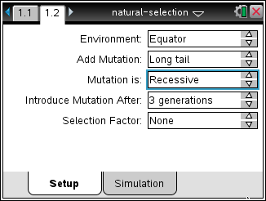
Q5. Do you predict more or less rabbits will show the recessive mutation than no mutation after 6 generations?

- Select the Simulation tab. Select Reset to reset the simulation. Run the simulation for 6 generations and then select Pause .

Q6. Was your prediction in Q5 correct? If not, why do you think you were incorrect?

Part 2: Selection by Hunger
Next you will examine how the population changes when influenced by selection. Only individuals that survive can pass their genes on to the next generation. If a certain mutation gives the individual an advantage, that mutation is more likely to be seen in the population after several generations.

- Select the Setup tab.
- Change the Selection Factor to Hunger, and Mutation to Dominant.
- Select a mutation you would like to examine in this simulation (you will have a chance to compare with classmates and try other mutations). Select the Simulation tab and run the simulation. Do not reset the simulation.
Q7. How does the phenotype of parents influence the offspring? Do you see rabbits with a phenotype that you have not selected?

Q8. What trait gives a selective advantage against hunger? Explain why you think so.

Q9. How does a phenotype provide a selective advantage?

Part 3: Selection by Wolves
In the previous section you saw that a trait which can give an advantage to individuals becomes more common in the population. The opposite is true as well, sometimes traits give a disadvantage (individuals with those traits die before they can be passed on), and these traits are less common in the population.

- Select the Setup tab. Set the Selection Factor to Wolves. In this simulation, there are two factors that can influence the outcome, wolves and environment (Arctic or Equator).

Q10. Record the values of the variables you are testing with a Selection Factor of Wolves in a log book on the Nspire.

Tech Tip: To export the data for a simulation, select b and then select 4: Export Data > 1: Export All.
Tech Tip: To export the data for a simulation, select 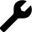 > Export Data > Export All. You may need to back-out to the main Tools Menu to see the desired menu option.
You can create a spreadsheet of your results to keep track of the results after each generation.

Tech Tip: To add a spreadsheet, select Doc > Insert > Lists and Spreadsheets. To enter data in cells, select any cell and then enter a value.
Tech Tip: To add a spreadsheet, select 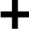 > Lists and Spreadsheets. To enter data in cells, select any cell twice. The keyboard view will appear. If you wish to enter text into a cell, select the “ABC” button.
Q11. Given these settings, which phenotype do you predict will be most common after 9 generations?

- Perform the simulation. Was your prediction correct?
- Compare your answers with a classmate who has done a different simulation, or perform another simulation yourself in order to answer the remaining questions.
- Next, test how changing only the environment changes the simulation. For some mutations, this has no effect.
Q12. When wolves are performing natural selection, which phenotype gives the selective advantage? That is, what do the rabbits that are most likely to survive look like?

Q13. How does the choice of environment influence natural selection? Do you get the same results in the Arctic and at the Equator?

