Open the TI-Nspire document Its_Getting_Hot_in_Here.tns.

Move to page 1.2.
1. Read the introduction explaining key vocabulary below and in the tns file.

Global warming is perhaps one of the hottest topics today because global temperature increases will impact every living thing on Earth. Photons (light energy) from the sun are constantly bombarding Earth's atmosphere and are trapped by Earth's greenhouse gases. Earth then releases excess energy in the form of infrared radiation, some of which escapes into space. With this simulation, you will be able to manipulate the level of greenhouse gases and measure the resulting temperature.

Move to page 1.3. | Press /¢ and /¡ to navigate through the lesson.
2. Read the directions, then click the close box. Press the play button to begin the simulation. Once the play button has been pressed, yellow arrows will appear from the sun, which represent the photons entering Earth’s atmosphere. You will also see two sets of red arrows representing infrared radiation. Some of this radiation is retained by Earth’s atmosphere and the rest of it escapes into space. | 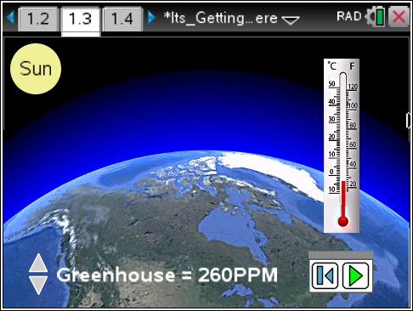
Greenhouse gasses are measured in parts per million (ppm). This tells you the concentration, or level, of gas in the atmosphere. You can change the level of greenhouse gases by clicking the Greenhouse Gases slider. As you click, you will be recording the gas level and the resulting temperature, in degrees Celsius, from the gases.
Move to page 1.4.
Here you will see a spreadsheet of the data points from the simulation. As you adjusted the level of greenhouse gases, the temperature changed and is indicated on this page.
Move to pages 1.5 – 1.6.
On page 1.5, read the information related to the graph on page 1.6.
3. On page 1.6, you will be able to graph a line showing the relationship between the level of greenhouse gases and the overall temperature. To do this, press MENU > Analyze > Regression > Show Linear (mx+b).

Move to pages 1.7 – 1.15. Answer questions 1-9 here and/or in your handheld.

Q1. Use your graph on page 1.6 with the linear regression equation in slope-intercept form. For every 20 ppm increase in greenhouse gasses, how much does the temperature increase?

Q2. Using your graph, is there evidence to support a relationship between the concentration of greenhouse gasses and global temperature?

- Yes
- No

Q3. In this simulation, which variable is the outcome (dependent) variable?

- ppm
- temperature
- photons of light
- amount of energy released by the sun

Q4. The sun releases energy in the form of _______, which heats up our planet.

- infrared radiation
- greenhouse gases
- photons

Q5. As you decrease the total amount of greenhouse gases in the atmosphere, the temperature increases.

- True
- False

Q6. When running the simulation you are able to manipulate the level of greenhouse gases and observe a temperature change. As you increase the amount of greenhouse gases, what happens to the total amount of energy released by the sun?

- The amount of energy increases.
- The amount of energy stays the same.
- The amount of energy decreases.

Q7. As you increase the concentration of greenhouse gases, what happens to the amount of infrared energy that escapes into space?

- The amount of energy that escapes into space increases.
- The amount of energy that escapes into space stays the same.
- The amount of energy that escapes into space decreases.

Q8. How would life on Earth be different if we did not have the greenhouse effect?

Q9. In what ways will the Earth change if the average global temperature rises?

