Activity Overview:  This activity guides you through the steps to create a document that will use the Regular Polygon tool and Reflection tool to help students explore the question, “Which regular polygons form a monohedral tessellation of a plane and why?”  Materials  • Technology needed (TI-Nspire™ handheld, computer software) | 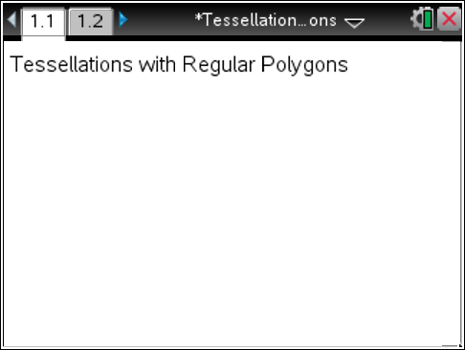
Step 1 Preparing the document  - Open a new document by clicking on  c > New Document > Add Notes.  - Type Tessellations with Regular Polygons.  Note: To obtain capital letters, press the g key, then the letter.  - Press ~ > File > Save As …  Type Tessellations_with_Regular_Polygons.  Tab to ¾ and press ·.  Note: To obtain the underscore, press / _.  4. To add a new page, press / ~ > Add Geometry.  5. To hide the scale in the upper right corner of the screen, select Menu > View > Hide Scale.  6. Press Menu > Settings. Press e to move from one field to the next, and press x to uncheck all the boxes. Tab to OK and press x or ·. | 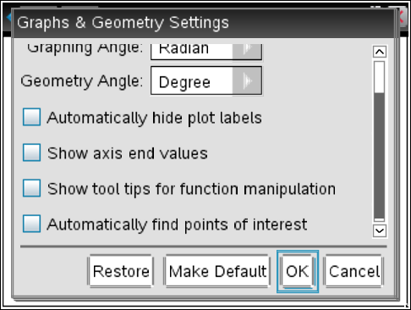
Step 2 Creating an equilateral triangle  1. Press Menu > Shapes > Regular Polygon. (Note: All regular polygons are constructed in a circle, so think about drawing a circle by constructing the center and then moving away to establish the radius of the circle.)  2. Move the cursor to a location near the center of the screen and press x to establish the center of the regular polygon.  3. Move the cursor away from this center point and you will see the regular polygon form on the screen.  4. Move the cursor far enough from the center point to construct a moderately sized regular polygon. Once the desired radius is reached, press x to set the radius. (This can easily be changed later, if necessary.)  5. Move the cursor in the clockwise direction around the “circle” of the regular polygon. As the cursor is moved, the number of sides in the polygon will decrease. Move the cursor until the number of sides is 3 for an equilateral triangle.  6. Press x or · to select 3 sides. Press d to exit the Polygon tool.  7. Grab and drag a side of the triangle to reposition the figure on the screen, if needed.  8. Grab and drag the center or any of the vertices to change the radius of the regular polygon if needed. | 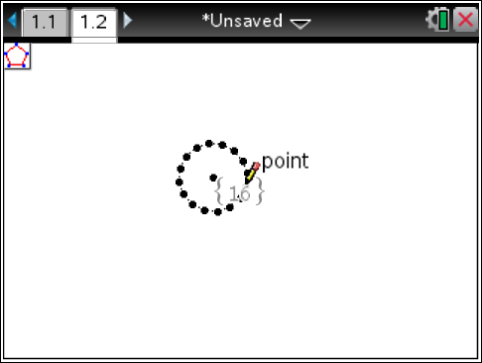  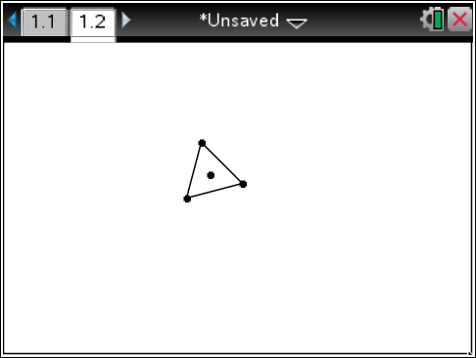  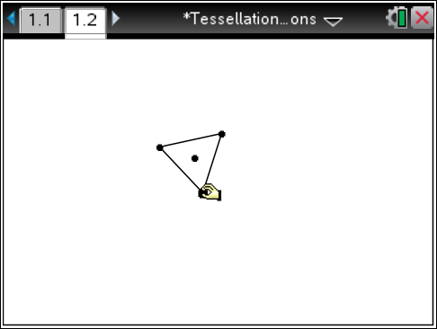
Step 3 Tessellating the equilateral triangle  1. Press Menu > Transformation > Reflection to select the Reflection tool from the Transformation menu.  2. Move the pointer to a side (not a vertex) of the triangle and press x twice. (The first click selects the entire regular polygon as the pre-image for the reflection. The second click selects the side of the polygon as the line of reflection.)  3. The Reflection tool is still active. Continue clicking twice on any side of the original regular triangle or on any side of a reflected image. | 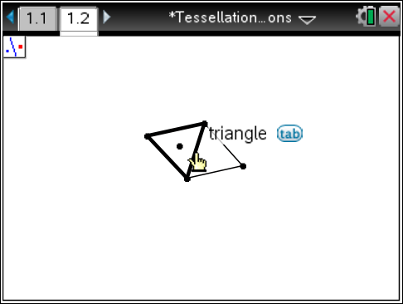  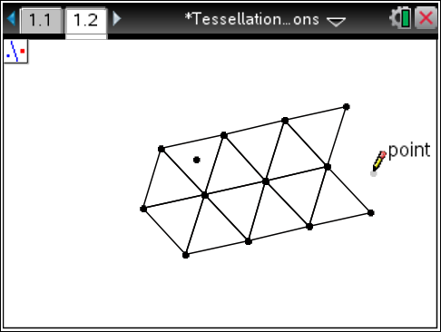
Step 4 Measuring the interior angles  1. Press Menu > Measurement > Angle.  2. Move to a vertex of any triangle and press · or x.  3. Move to a second vertex of the same triangle, and press · or x.  4. Move to the third vertex of that same triangle, and press · or x.  5. Repeat the process for the remaining angles in that triangle.  6. Press d to exit the Measurement tool.  7. Move the angle measurements if needed. Also, the triangles can be enlarged by grabbing the original “center” point and moving it to make the triangles the preferred size. | 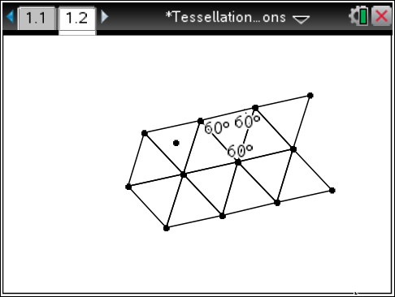  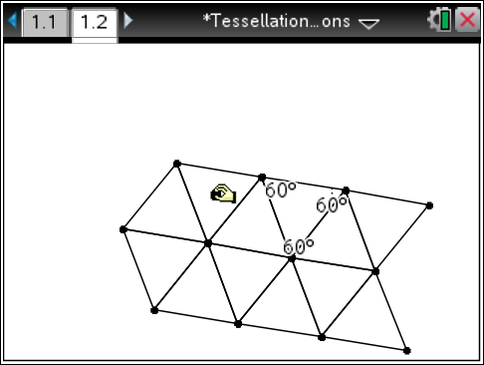
Step 5 Inserting a new Geometry page  1. Press / ~, and select Add Geometry.  2. Press Menu > View > Hide Scale. | 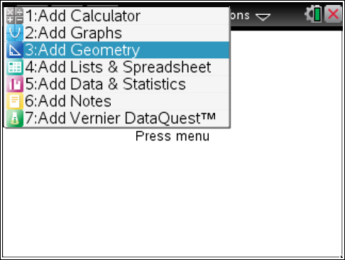
Step 6 Creating a square  1. Press Menu > Shapes > Regular Polygon.  2. Move the cursor to a location near the center of the screen and press x to establish the center of the regular polygon.  3. Move the cursor away from this center point until the desired radius is reached. Then, press x.  4. Move the cursor in the clockwise direction around the “circle” to choose 4 as the number of sides in the polygon.  5. Press x or · to choose 4 sides.  6. Press d to exit the Polygon tool. | 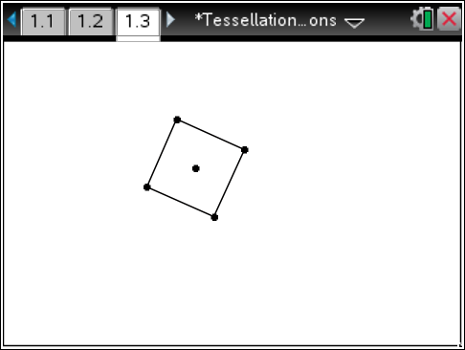
Step 7 Creating text  1. Press Menu > Actions > Text.  2. Move the cursor to the top left of the screen, and press ·.  3. Type Square, and then press ·.  4. Press d to exit the Text tool. | 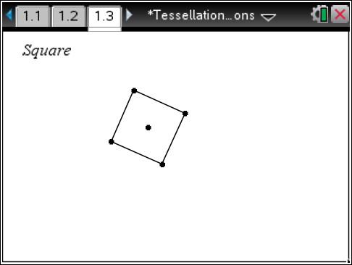
Step 8 Creating other regular polygons  1. Repeat steps 5 and 6 to create pages for a pentagon, a hexagon, a heptagon, and an octagon. | 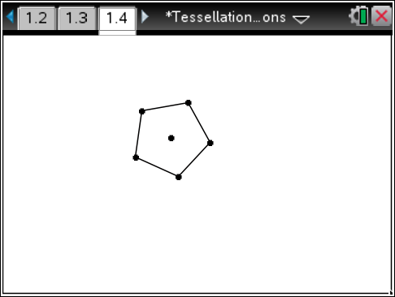
Step 9 Saving the document
1. Press / S.

