Open the TI-Nspire document Exploring_Vertical_Asymptotes.  Given the equation of a rational function, will you always be able to determine the domain? In this activity, you will explore vertical asymptotes and removable discontinuities. | 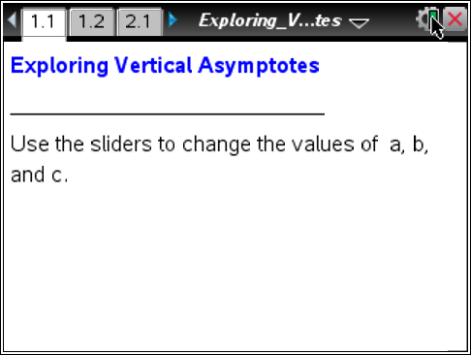

Move to page 1.2.

1. Use ▲ and ▼ to change the value of a. Describe how the graph changes.

2. Use ▲ and ▼ to change the value of b. Describe how the graph changes.

3. What do the values of a and b represent in the function?

4. What are the equations of the vertical asymptotes?

5. State the domain of the function in terms of a, b, and c.

6. Use ▲ and ▼ to change the value of c. How does changing c affect the domain?

7. Describe how you could find the vertical asymptotes for any rational function with a constant numerator.

Move to page 2.1.

8. Use ▲ and ▼ to set a = 2 and b = –1, and then change the value of c. For which values of c are there no asymptotes? Explain why there are no asymptotes for these values of c.

9. The “hole” in the graph is called a removable discontinuity. Explain why the hole exists and how you might remove it by modifying the function definition.

Move to page 2.2.
10. Answer the question on Page 2.2.
Describe the graph of the function | .
Move to page 3.1.

11. Use ▲ and ▼ to set b = –1 and c = 4. Then use ▲ and ▼ to change the value of a.
a. Describe how the graph changes as the value of a changes.

b. What is the domain of the function in terms of a, b, and c?

c. For which values of a is there only one asymptote? Describe the graph at these values.

d. Explain algebraically why the graph looks as it does at these points.

12. Describe how the domain would change if you changed the values of b and c.

Move to page 3.2.

13. Answer the question on Page 3.2.
Describe the graph of the function .

Move to page 4.1.

14. Answer the questions on Pages 4.2 and 4.3.
Holes were discussed in question 9. While manipulating the sliders for a and b on
Page 4.1, what would a and b have to be for f1(x) to have a hole? To have a vertical asymptote?

