Open the TI-Nspire document Equivalent_or_Not.tns.  What does it mean for expressions to be equivalent? This activity investigates expressions that are equivalent under certain conditions on the variable. | 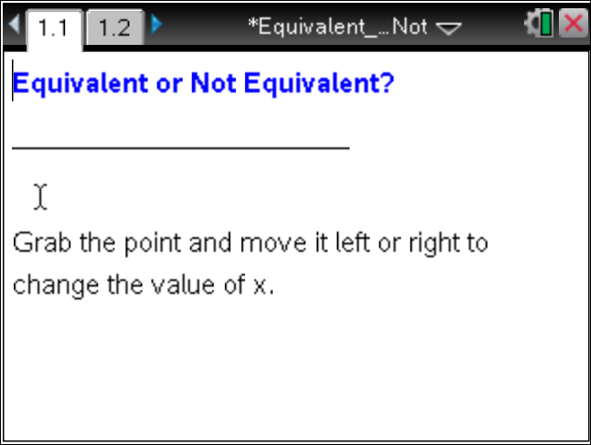

Move to page 1.2. | Press / ¢ and / ¡ to navigate through the lesson.
1. Find the value for each expression when
a. x= 2. = _____ = _____ |x| = _____

b. x= 4. = _____ = _____ |x| = _____

2. Based on your answers from question 1, predict the value for each expression when x = 15.
= _____ = _____ |x| = _____

3. Find the value for each expression when

a. x = −3. = _____ = _____ |x| = _____

b. x = −8. = _____ = _____ |x| = _____

4. Based on your answers from question 3, predict the value for each expression when x = ⁻20.

= _____ = _____ |x| = _____

5. Find the value for each expression when x = 0.

a.
b.

c. |x|

Two algebraic expressions that are equal for every substituted value of the variable chosen from a set of numbers are said to be equivalent for that set of numbers.

6. a. Is the expression equivalent to x for the set of positive real numbers? Why or why not?

b. Is the expression equivalent to x for the set of negative real numbers? Why or why not?

c. Is the expression equivalent to x for the set of real numbers? Why or why not?

7. Tom says that the expression is equivalent to x for the set of real numbers. Do you agree? Why or why not?

8. For what values of x are and |x| equivalent? Explain your reasoning.

