Open the TI-Nspire™ document Sweating_Alcohol.tns.  Everyone is familiar with the effects of perspiration on the skin. The cooling effect is very refreshing on a hot summer day. What if we perspired some liquid other than water? Would we cool off more rapidly? Would we heat up? | 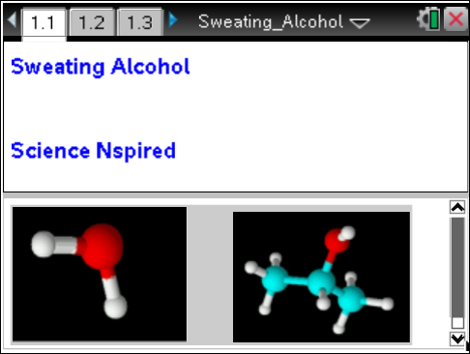

The goal of this activity is to help you begin to understand the "magic" of the water molecule. Without water and its incredibly unique characteristics, life as we know it would be impossible. Not only is water a really good solvent (a dissolver of things), it is a POLAR molecule, which means it is "charged" on either end; one end is positive and the other is negative. Thus, water molecules stick to each other.
This "cohesion" of water molecules makes it hard to heat it up and cool it down. This may sound bad, but it is REALLY good for us living things! Since most organisms are made mostly of water, they retain their heat really well. On a grander scale, since Earth is covered mostly with water, the overall global temperature remains pretty constant. Again, this helps make life possible here.

Move to pages 1.4 through 1.7. | Press / ¢ and / ¡ to navigate through the lesson.
Answer these questions on your handheld.
- Because of its properties, most of the water on Earth is very warm. True or False.
- In a solution of sugar-water, the sugar is called the ___, and the water is called the ___.
- A water molecule is considered to be "polar" because it is negatively charged on both "ends" of the molecule.
- What do you predict is the approximate percentage of water inside human beings? Express your answer as a percentage (ex: 30%).
Move to page 2.1.

5. Pour a small quantity of alcohol into the plastic cup (an inch or so).
6. Plug in the temperature probe, and place it into the alcohol.
7. Set the TI-Nspire™ handheld to collect data every second for 30 seconds.
8. Click start to begin sampling, count to 2, THEN lift the probe straight out of the alcohol, keeping the tip pointed down, until the data collection is complete.
- The data is graphed on Page 2.2.

Move to page 2.2.

9. To determine the rate of cooling, select MENU > Analyze > Regression > Show Linear (mx+b).
10. Record the equation in the data table below.
11. Move back to the DataQuest™ page, and run a trial with water instead of alcohol.  12. Move back to the graph, and start sampling. Store the previous run by clicking on the “filing cabinet” icon.  13. Pour a little water into a clean cup, and repeat the procedure for water.  14. Analyze the data as before, and record it in the data table to the right. | Data Table  Equation for Alcohol:  Equation for Water:
Move to page 3.1.

Answer the following questions on your handheld or here on this worksheet.
15. Which liquid showed a greater decrease in temperature?

16. Which liquid seemed to evaporate more slowly?

17. Which liquid “cooled” more quickly?

18. In the equation that you generated for the regression line (y=mx+b), what is "b"?

19. In the equation that you generated for the regression line (y=mx+b), what is "m"?

20. What is another name for “slope”?

21. In this activity, what data label should be included with the rate of change?

22. If, rather than perspiring water, you perspired rubbing alcohol, would you cool off more slowly or more rapidly?

23. Consider the heat that is produced and then is taken "away" by your perspiration. What is the source of this heat in your body?

24. So, if you perspired something like rubbing alcohol, rather than water, how would your lifestyle need to change?
25. Is water a polar or a nonpolar molecule?

26. Predict whether alcohol is a polar or a nonpolar molecule.

