Open the TI-Nspire document Euler_Intro.tns.  The purpose of this activity is to visualize Euler’s method for approximating the solution to an ordinary differential equation with a given initial condition and to estimate specific values of the solution. This activity allows you to generate points on a graph corresponding to steps in Euler's method, record the coordinates, and sketch the actual solution curve for comparison. | 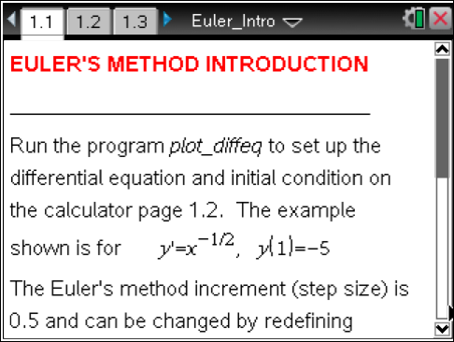
Euler’s method is based on the slope of the tangent line at a point on the solution curve. An approximate solution curve is graphed by taking small steps in the direction of the tangent line at each point. This numerical procedure will allow you to visualize the graph of the solution to the differential equation and to approximate values of the solution function.

Move to page 1.2. | Press / ¢ and / ¡ to navigate through the lesson.
Consider the differential equation . You will use Euler’s method to find several approximations for the value of y, the solution to this differential equation, at .

1. Suppose you know the graph of the solution to the differential equation passes through the point , (the initial condition). The default value for the step size is . Enter the following command on page 1.2: .

Move to page 1.3.

xfwd represents the value of x at each step in the approximation, and yfwd represents the approximate value of y at each step. Use the spreadsheet on page 1.3 to complete the following tables.

i | 0 | 1 | 2 | 3 | 4 | 5
 | –5.0 | –4.5 | –4 | –3.5 | –3.0 | –2.5

i | 6 | 7 | 8 | 9 | 10
 | –2.0 | –1.5 | –1.0 | –0.5 | 0

Move to page 1.4.

2. On page 1.4, increase step i 10 times by tapping the slider arrow to visualize Euler’s method. Based on this graph and the table above, what is the approximate value of?

3. Open a Calculator Scratchpad and use the function deSolve to find the general solution to the differential equation. Verify analytically that the function is a solution to the differential equation that satisfies the initial condition.

4. Find . Is the approximation in problem 2 an overestimate or underestimate? Add the graph of the solution to the right side of page 1.4. Notice how Euler’s method produces successive approximations very close to the true value of y until x gets close to 0. Use the characteristics of the graph of the solution to explain this observation.

5. The starting point and the step size in Euler’s method may affect the approximation. On page 1.2, change the value of and the initial condition (using the function ) as indicated and use page 1.3 or page 1.4 to complete the following table.

 | 0.5 | 0.25 | 0.5 | 0.25 | 0.1 | 0.1

Which combination of initial condition and step size produces the best approximation? Why?

6. Explain how each of the following affects an approximation using Euler’s method.
a. The initial condition, .

b. The step size, .

c. The local linearity of the graph of the solution to the differential equation.

d. The concavity of the graph of the solution to the differential equation.

7. Enter the appropriate command on page 1.2 to consider the differential equation with initial condition (0, 0) and . On page 1.4, use the up arrow to visualize 40 points on the graph of the solution curve using Euler’s method. What is the solution to this differential equation suggested by Euler’s method? Add a graph of your guess to the right side of page 1.4. How close is the graph produced by Euler’s method to the solution? Why?

