Open the TI-Nspire document build-an-atom_MG.tns.  In this simulation, you will learn about the particles that make up an atom, protons, neutrons, and electron. You will adjust the number of these particles to observe how changing the numbers of these particles affects the properties of an atom. Then you will apply what you learned to how elements are organized in the Periodic Table. | 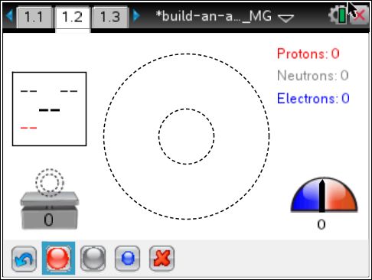
Everything on Earth is made up of matter. The basic building blocks that make up matter are elements, pure substances that cannot be broken down into other substances. Each element is made up of only one specific atom.
An atom is made of a combination of three particles:
1) protons, which carry a positive charge (+) charge
2) neutrons, which carry no charge
3) electrons, which carry a negative (–) charge
A neutral atom has an equal number of electrons and protons. When an atom gains or loses an electron it becomes either a positive ion or negative ion of that element.
Scientists organize all known elements into a chart called the Periodic Table of Elements. Over 100 known elements are on this chart, along with information about the atomic characteristics of each one.
Move to page 1.1.
The two rings in the center made up the atom structure. Protons and neutrons gather in the center of the first ring. Electrons form on the center ring first, and then on the outside ring as more are added.
Select to add a proton. Select to add a neutron. Select to add an electron. To remove the particle, select the proton, neutron, or electron and then use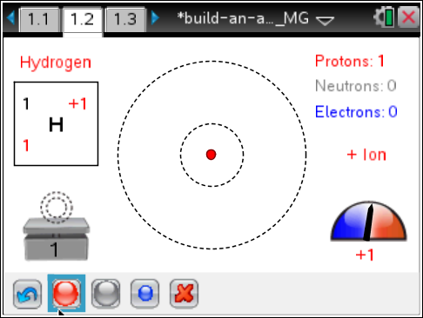to remove.
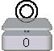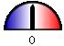
atom’s mass atom’s charge
Tech Tip: To remove particles, use the grab tool x to first select and then selectto remove the particle.
- Add and take away protons.
- Select the Reset/Undo button 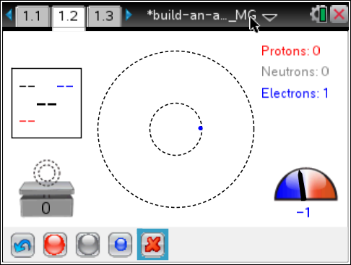 in the bottom left. Add 1 proton. Then add and take away neutrons. Then add and take away electrons. Observe the changes in the mass and charge indicators.
Q1. What happens to the mass of the atom if you add more neutrons? More electrons?

Q2. What happens to the charge of the atom if you add more neutrons? What happens if you have more protons than electrons? Fewer protons than electrons? The same number of protons as electrons?

- The square in the upper left corner represents the element. The letters in the middle of the square is the abbreviation of the element name. Press the Reset/Undo button. Do any combinations of protons, neutrons, and electrons. Observe the changes in the element square.
Q3. How is one element changed into an entirely different element?

Q4. Which number in the element square represents the atom’s mass? How do you know?

Q5. Which numbers of particles are added together to determine the atom’s mass?

Q6. Which number in the element square represents the atom’s charge? How do you know?

Q7. Which numbers of particles are added together to determine the atom’s charge?

Q8. The third number in the square is the atomic number of the element. How do you get that number?

- Show a positive hydrogen ion. Add one proton by selecting once. Now add two neutrons. The atom is unstable.
Q9. What can you do to make the atom stable again?

Q10. In general, when does an atom become unstable? Why do you think this is so?

- Select the Reset/Undo button . Show a positive hydrogen ion by adding one proton. Change the atom from an ion to neutral. The element should remain hydrogen.
Q11. What did you do to neutralize the hydrogen atom?

- Select the Reset button . Add two protons. This shows a helium atom. Neutralize this atom.
Q12. What did you do to neutralize the helium atom? Is there a general rule for neutralizing an atom?

Move to page 1.3.  - Set the game to Level 1. Use the up and down arrows to adjust the number of particles. The goal is to show the mass, charge, and atomic number of each atom.  - Then press Check. If you incorrect, try again. If you are correct, press Next for the next problem.  - At the end of Level 1, view your score and time.  - Select New Game or use the Reset button . Set the game to Level 2 and play again. | 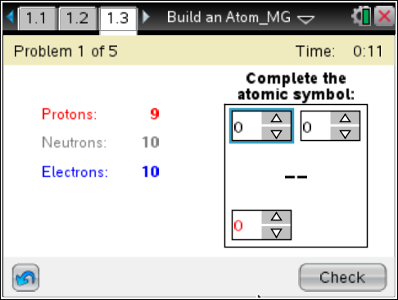
Q13. Did you discover anything else about how the numbers of particles affects the atom in Round 2? Explain.

Extension
- Now use a Periodic Table of Elements.
Q14. Is any of the information in the element squares in the Table in the element squares in this simulation? If so, how are they the same and how are they different? What other information is found in each of the element squares in the Periodic Tables you found through your research?

Q15. What additional information is found in each of the element squares in the Periodic Tables you found through your research?

Q16. What information about the atom of each element changes moving left to right along the rows (periods)?

Q17. How do you think a tool such as the Periodic Table of Elements helps scientists study atoms of elements?

