Open the TI-Nspire™ document Maximize_Area_Garden.tns.  A garden with a rectangular shape is attached to a barn. Exactly three sides of the garden must be fenced, and 22 meters of fencing will be used. What are the dimensions of the garden with the maximum possible area? | 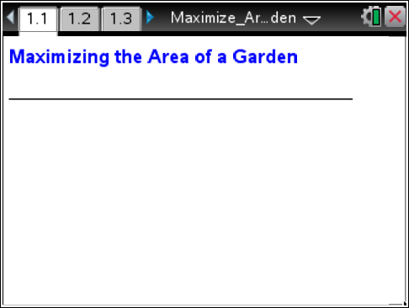

Move to page 1.2.

1. As directed on page 1.2, draw a sketch of each of your five different gardens. Be sure to use a variety of width values. Remember that only three sides of the garden are to be fenced and that you will use 22 meters of fencing.

2. Record the width, length, and area of each garden in the table below. Be sure to include appropriate units of measurement.

Sketch no. | Width | Length | Area
1
2
3
4
5

3. Considering the data from your sketches, describe what happens to the area of the garden as the width of the garden increases.

4. Compare your answer to question 3 with the answers of other students in your class. Use the class data to describe what happens to the area of the garden as the width of the garden increases.

5. If the goal is to maximize the area of the garden, which of your garden sketches would be the best option? Why? Give the width, length, and area of the garden.

Move to page 1.3.

6. On page 1.3, click in cell A1 of the spreadsheet in the lower-left work area of the screen. Enter the width and area data for each of your five garden sketches.

Tech Tip: To enter data in the spreadsheet, double-tap the cell and use the on-screen keyboard to enter the desired value.
7. As you enter data in the spreadsheet, a scatter plot of the data will be graphed. Describe the shape of the plot.

8. Write a formula for the amount of fencing used in terms of the width (w) and length (l) of the garden.

9. Rearrange the formula from question 8 to express the length (l) of the garden in terms of the width (w).

10. Write an equation that could be used to determine the area (A) of the garden if you know only the width (w) of the garden. Hint: Use your answer from question 9 that expresses the length of the garden in terms of the width.

11. Let x represent the width of the garden and let f(x) represent the area of the garden in terms of its width. Write a function to express the area of the garden in terms of the width of the garden.

12. What values can be used for the width of the garden in this problem? In other words, what is the domain of your function?

Move to page 1.4.

13. On page 1.4, graph your function with the scatter plot on a full page.
- Press / G or e to show the entry line.
- f1(x) = is displayed. Enter your function definition, and then press ·.

Tech Tip: Double-tap the graphing window to make the function entry line appear.
14. If the graph of the function does not fit your data, recheck your data entries on page 1.3 and your answer for question 11.

15. What are the width and area of the garden with the maximum possible area?

16. How did you determine the maximum area of the garden?

17. Suppose that a rectangular garden of this type (with three sides fenced using 22 meters of fencing) is to have an area of 52.5 square meters.
a. What width and length could be used to form a garden with this area? (Add pages, as needed, to the TI-Nspire document to solve this problem.)

- Describe the method you used to find the width and length.

18. Jackie will use 44 meters of fencing to make a garden with a rectangular shape that will be attached to a barn. (Only three sides will be fenced.) How will the maximum area of her garden compare to the maximum area of the same type of garden that used 22 meters of fencing? Justify your answer. (Add pages, as needed, to the TI-Nspire document to solve this problem.)

Extension:

1. Suppose that a garden with a rectangular shape is not attached to a barn. You will still use 22 meters of fencing, but all four sides must be fenced. What width and length do you think the garden should have to produce the maximum area? Make a conjecture, and explain your reasoning.

2. Use Problem 2 in the TI-Nspire document to explore the dimensions of this type of garden. Add pages, as needed, to determine the width and length that will result in a garden with the maximum area.

3. How does the maximum area of a garden with four fenced sides compare to the maximum area of the garden that was attached to a barn? Compare your answer to those of your classmates.

