Math Objectives  - Students will use symbols to represent variables.  - Students will look for patterns and represent generalizations.  - Students will represent relationships among quantities using visual models, tables, graphs, and words.  - Students will define, evaluate and compare functions.  - Students will reason abstractly and quantitatively (CCSS Mathematical Practice).  - Students will look for and make use of structure (CCSS Mathematical Practice).  Vocabulary  - function  - growth rate  - constant rate  - linear function  About the Lesson  - This lesson involves using pattern growth to construct functions.  - As a result, students will:  - Explore growing tile patterns pictorially, graphically and in tabular form.  - Examine the relationship between the stage number and the number of tiles.  - Determine a rule for the number of tiles as a function of the stage number.  TI-Nspire™ NavigatorTM System  - Send a document.  - Use Class Capture to formerly assess students’ understanding.  - Use Live Presenter to demonstrate and provide a means for students to share their thinking.  - Use Quick Poll to assess students’ understanding.  Activity Materials  - Compatible TI Technologies:  TI-Nspire™ CX Handhelds,   TI-Nspire™ Apps for iPad®,  TI-Nspire™ Software | 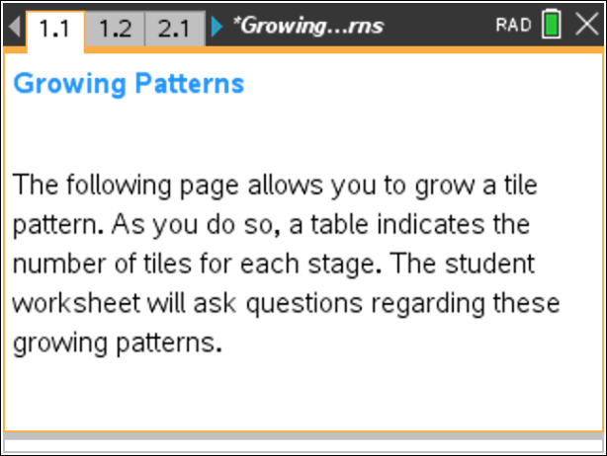  Tech Tips:  - This activity includes screen captures from the TI-NspireTM CX handheld. It is also appropriate for use with the TI-NspireTM family of products including TI-Nspire software and TI-Nspire App. Slight variations to these directions may be required if using other technologies.  - Watch for additional Tech Tips throughout the activity for the specific technology you are using.  - Access free tutorials at http://education.ti.com/calculators/pd/US/Online-Learning/Tutorials  Lesson Files:  Student Activity  - Growing_Patterns_Student.pdf  - Growing_Patterns_Student.doc  TI-Nspire document  - Growing_Patterns.tns

Discussion Points and Possible Answers

Tech Tip: If students experience difficulty with the sliders, check to make sure that they have moved the arrow until it becomes a hand (ø). When finished with a slider, press d to release it.

Move to page 1.2.  1. On page 1.2, the first stage of a tile pattern is shown. Use the slider for stage to ‘grow’ the pattern.  a. What remains the same in the tile pattern, and what changes as it grows?  Answer: The three horizontal tiles are always there and two tiles are added vertically each time. | 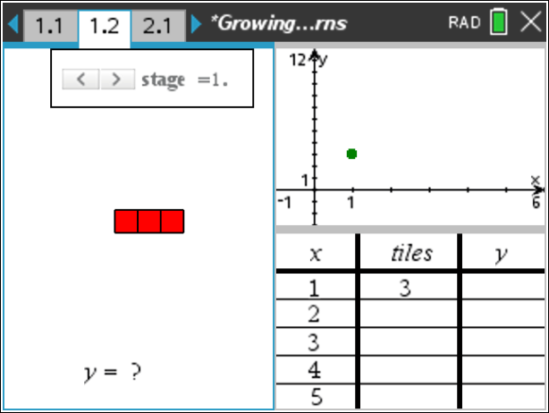  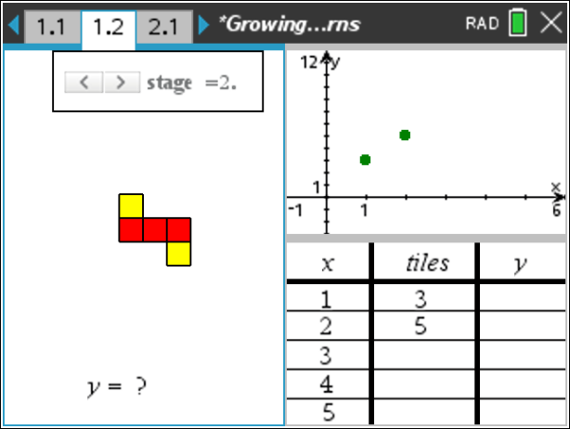
b. In the table, what does the x variable represent?

Answer: x represents the stage number.

c. What remains the same, and what changes in the table as the pattern grows?

Answer: Although the numbers change in both columns, what stays the same is the amount they change. As the x column changes by 1, the number of tiles column changes by 2.
d. In the graph, what do the x- and y- coordinates of the ordered pairs represent?  Answer: The x-coordinate represents the stage number, and the y-coordinate represents the number of tiles. | 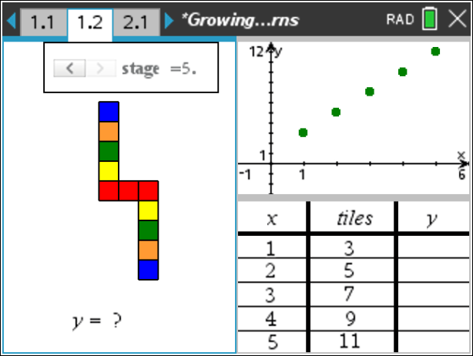
e. What remains the same, and what changes in the graph as the pattern grows?

Answer: The points are 1 unit apart horizontally and 2 units apart vertically which reflects the change in the number of tiles for each stage.

Teacher Tip: You might want to be sure that students are paying attention to the graph and table at the right hand side of the screen as they use the slider.

TI-NspireTM NavigatorTM Opportunity: Quick Poll
See Note 1 at the end of this lesson.
2. On page 1.2, you are limited to showing 5 or fewer stages of growth for the pattern.
a. If the pattern continued to grow in the same way, draw the 6th stage, and determine the number of tiles needed.

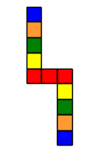

Answer: 13 tiles are needed.

b. How many tiles would be in the 10th stage? How do you know?

Answer: 21. 13 tiles are needed for the 6th stage and you would add two more tiles four more times. 13 + 2(4) = 21.

c. Write an algebraic rule to state the number of tiles in the xth stage.

Answer: number of tiles = 2x + 1

d. Would there ever be a stage in which there were 58 tiles? Why or why not?

Answer: No. There will always be an odd number of tiles because you start with odd number of tiles and then increase by an even number of tiles. An odd number plus an even number is always odd.

TI-NspireTM NavigatorTM Opportunity: Quick Poll
See Note 2 at the end of this lesson.
3. When you write the rule from part 2c as an equation in which, y, the number of tiles, is related to x, the stage number, you are writing y as a function of x.
a. Write the function that represents this pattern.

Answer: y = 2x + 1.

Teacher Tip: Students might state the function in various equivalent forms, such as y = 2(x – 1) + 3. A good time to discuss the equivalence of these forms would be now or after problem 3 b where you could take a Class Capture of student handhelds.

b. Check that your function is correct by typing it in the text box after “y=.” (To open the text box, double click on the question mark. Be sure to ONLY select the question mark and type to the right of the equals sign. DO NOT double click on the “y=.”) Press ·. How can you tell if your rule is correct or incorrect by looking at the table and graph?

Answer: In the graph, the line should pass through all of the points. In the table, the values in the third column, the y-column, should match the values in the second column, the tiles column.
Tech Tip: To modify the text on screen, double-tap the text and the keyboard will open.
Tech Tip: When entering the equation, sometimes students accidentally delete the “y” or the “y=” or the “?.” Depending on what has happened, an undo (CTRL+Z) might bring back whatever was deleted. Otherwise they should close the document, Do Not Save, and then reopen it.
Teacher Tip: You might want to discuss with students the fact that our model is a discrete model but the graph of the line represents a continuous function. To clarify this, you could ask the students if it makes sense to have a stage number of 2.25 with 5.5 tiles.
c. If your rule was correct, move on to Question 3d. If your rule was incorrect, find a new rule to relate the stage number and number of tiles. Check your rule.

Sample Answers: Student answers will vary.

d. The growth rate of the pattern is the change in the number of tiles per stage. What is the growth rate for this pattern?

Answer: The growth rate is 2 tiles per stage.

e. Where does the growth rate appear in the function? In the table? In the graph?

Answer: The growth rate appears in the function as a multiplier of the variable x. In the table, it shows up as the constant change in the number of tiles from one stage to the next stage. The growth rate is the slope of the graph of the linear function.

f. Move to stage zero. Where does the number of tiles at this stage show up in your function? In the graph?  Answer: The number of tiles at stage zero is the 1 that is being added (or the constant term in the function). In the graph, the number of tiles in stage zero corresponds to the y-intercept. |  | 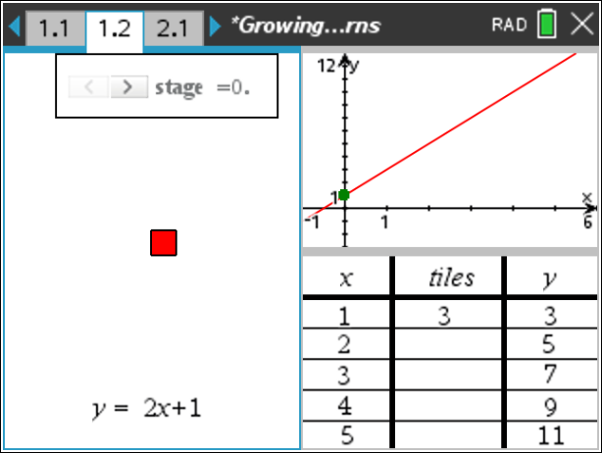
Teacher Tip: You might want to discuss the definition of the constant term in a linear function.

TI-NspireTM NavigatorTM Opportunity: Quick Poll and Class Capture
See Note 3 at the end of this lesson.
Move to page 2.2.  4. On page 2.2, use the slider for stage to grow a second pattern. Determine the growth rate and write a function that represents the number of tiles in relation to the stage number.  Answer: The growth rate is 4 tiles per stage, and the function is  y = 4x + 3. | 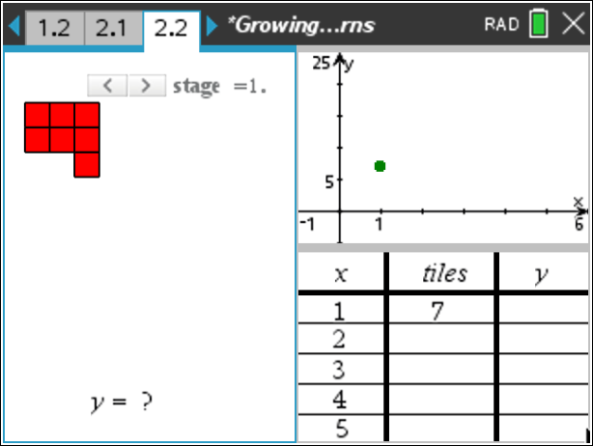  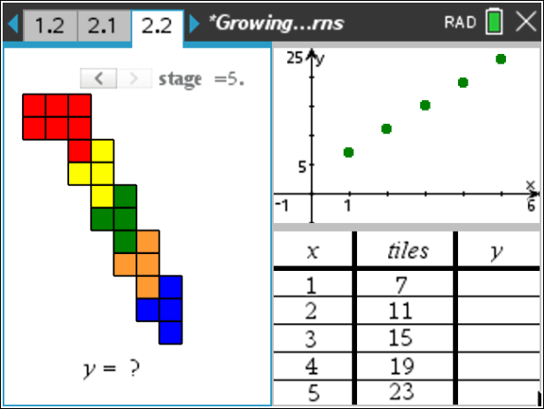
TI-NspireTM NavigatorTM Opportunity: Quick Poll
See Note 4 at the end of this lesson.

Move to page 3.2.  5. On page 3.2, use the slider for stage to grow a third pattern. Determine the growth rate and write a function that represents the number of tiles in relation to the stage number.  Answer: The growth rate is 5 tiles per stage, and the function is  y = 5x + 3. | 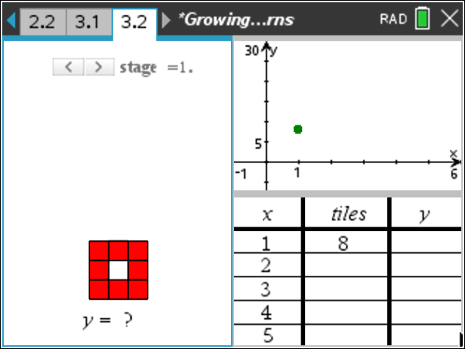  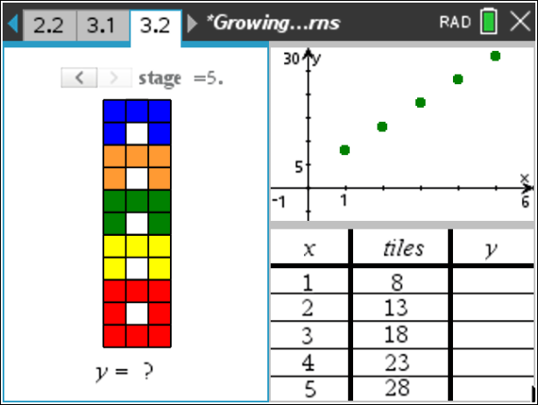
TI-NspireTM NavigatorTM Opportunity: Quick Poll
See Note 4 at the end of this lesson.
6. Design a pattern that grows at a constant rate but more quickly than all of the previous patterns. Draw the first 4 stages of your pattern and write a function that represents the number of tiles in relation to the stage number.

Sample Answers: Student answers will vary. The function that represents the pattern depicted is y = 6x.
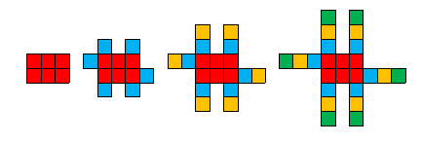
Teacher Tip: You might need to check to make sure that students created a linear function.

TI-NspireTM NavigatorTM Opportunity: Quick Poll
See Note 4 at the end of this lesson.

Wrap Up
Upon completion of the lesson, the teacher should ensure that students are able to understand:
  - A linear function can model a relationship between two quantities.
  - The rate of change (the growth rate in this activity) and initial value of a linear function can be determined from a description of a relationship or from two (x, y) values, including reading these from a table or from a graph.
  - The rate of change and initial value of a linear function can be interpreted in terms of the situation it models and in terms of its graph or a table of values.

TI-NspireTM NavigatorTM System

Note 1
Question 1 Quick Poll (Open Response)
Send an Open Response Quick Poll, asking students to submit their answers to questions 1 a – f.

Note 2
Question 2 Quick Poll (Open Response)
Send an Open Response Quick Poll, asking students to submit their answers to questions 2 a – c.
Note 3
Question 3 Quick Poll (Open Response)
Send an Open Response Quick Poll, asking students to submit their answers to questions 3 a and d.

Question 3 Class Capture
Take a Class Capture of Page 1.2 where students have graphed the function that they have created. As a class, discuss the various cases that occur.

Note 4
Question 4 Quick Poll (Open Response):
Send an Open Response Quick Poll, asking students to submit their answer to questions 4, 5, and 6.

