Math Objectives  - Students will explore transformations of a quadratic function.  Vocabulary  - quadratic function  - parabola  - vertex  About the Lesson  - The teacher has the option of having the student create the document. Give students Transformations_of_a_Quadratic_Function_Create.doc if you wish to do so. It is suggested that the students create the document for the activity.  - Otherwise, send each student Transformations_Quadratics.tns.  TI-Nspire™ Navigator™ System  - Use Screen Capture to observe students’ work as they proceed through the activity.  - Use Live Presenter to have a student illustrate how he or she used a certain tool. | 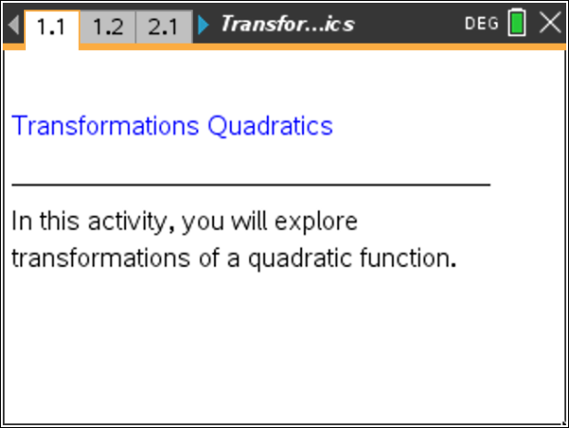  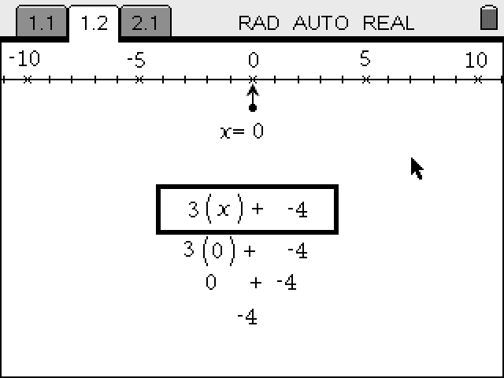  TI-Nspire™ Technology Skills:  - Download a TI-Nspire document  - Open a document  - Move between pages  Tech Tips:  - Make sure the font size on your TI-Nspire handheld is set to Medium.  - You can hide the function entry line by pressing / G.  Lesson Materials:  Create Instructions  Transformations_of_a_  Quadratic_Function_Create.pdf  Student Activity  Transformations_of_a_  Quadratic_Function_Student.pdf  Transformations_of_a_  Quadratic_Function_Student.  doc  TI-Nspire document  Transformations_Quadratics.tns  Visit www.mathnspired.com for lesson updates and tech tip videos. (optional)

Discussion Points and Possible Answers

Move to page 1.2.  Step 1: Use the slider to change the value of the parameter variable. To do so, click on the right or left arrow on the slider. Observe the changes in the graph. Press d. | 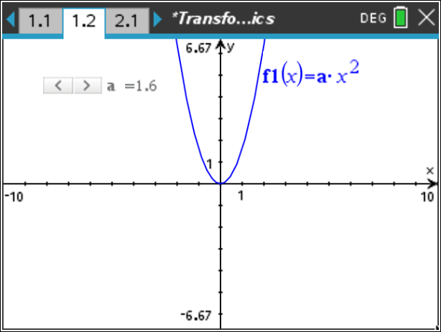
Step 2: Observe the graph as you change the slider and move a to the following values:
5, 1, 0.2, 0, –0.2, -1, and –5.

Answer these questions.

1. What do you observe about the vertex of each of the parabolas?

Answer: The vertex is at the origin for each of the parabolas, with the exception of when a = 0. For that special case, the parabola becomes the horizontal line y = 0.

2. How does the value of a affect whether the graph opens up or down?

Answer: If a > 0, the parabola opens upward. If a < 0, the parabola opens downward.

3. How does the value of a affect the shape of the graph?

Answer: As the absolute value of a gets larger, the opening of the parabola gets narrower,
As the absolute value of a gets smaller, the opening of the parabola gets wider.

Move to page 2.1  Step 3: Observe the graph as you click on the slider and have c become the following values: 4, 2, 0, –2, and –4. | 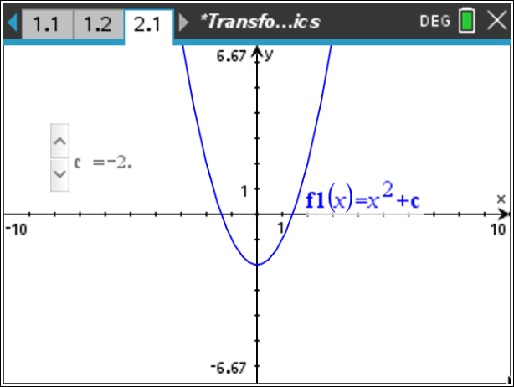
Answer these questions.

4. What did you observe about the vertex of each of the parabolas?

Answer: The vertex of the parabola moves up and down, depending upon whether the constant is positive or negative.

5. How does the value of c affect the shape and whether the graph opens up or down? Explain.

Answer: The value of c does not affect the shape of the graph; it only affects where the graph is placed.

6. How does the value of c affect the graph?

Answer: If c > 0, the entire parabola is shifted up c units. If c < 0, the entire parabola is shifted down the absolute value of c units.

Wrap Up
Upon completion of the discussion, the teacher should ensure that students can explain:
- How the value of the parameter a affects the graph of .
- How the value of the parameter c affects the graph of .

Assessment
For each of the following, answer the following questions:
- In which direction does the graph open?
- Is the parabola wider, narrower, or the same as ?
- Is the graph shifted up, down, or not at all compared to ?
- What are the coordinates of the vertex of the parabola?
1.

Answers: a. upward
b. narrower
c. not at all
d. (0, 0)

Answers: a. upward
b. same
c. up
d. (0, 4)

Answers: a. downward
b. wider
c. up
d. (0, 3)

Answers: a. upward
b. narrower
c. down
d. (0, –3)

