Open the TI-Nspire document What_is_a_Solution_to_a_System.tns.  An ordered pair (x, y) can be thought of in two ways. The two numbers represented by x and y could be substituted into an equation involving x and y. Those same two numbers can be thought of as the coordinates (x, y) of a point in the plane. This activity relates those two ideas to each other to give you a visual way of thinking of the solution to a system of two equations. | 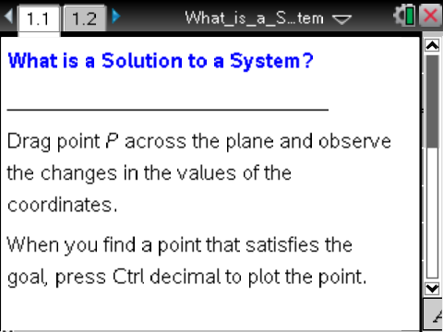

Move to page 1.2. | Press / ¢ and / ¡ to navigate through the lesson.
- Move point P. Describe how the coordinates relate to the Current equation shown in the lower-right corner of the screen.

- a. In the Goal equation, x + y = 10, if x = –3, what value of y is needed to make the equation true?

b. Move point P so that the x-coordinate is –3 and the Current equation matches the Goal equation. Press / ^ to mark this point.

- Move point P to a new location where the Current equation again matches the Goal equation. Press / ^ to mark this point. Mark at least four more points that make the equations match.
What do you observe about the pattern of the points you have marked?

- A solution to an equation in two variables is an ordered pair (x, y) that makes the statement true. Each point you have marked is one solution to the Goal equation x + y = 10. How many solutions does this equation have? How do you know?

Click the slider (∆) to change the problem.
- Move point P to a location where the Current equation matches the Goal equation. Mark at least two more solutions to the equation.

- Describe a pattern you could use to determine two more solutions without randomly moving
point P.

- Use your pattern to explain how many solutions you can find for this equation.

Click the slider (∆) to change the problem.
- Move point P. Identify a point that satisfies each condition.
a. Rule 1 is true and Rule 2 is false.

b. Both rules are false.

c. Rule 1 is false and Rule 2 is true.

d. Both rules are true.

- A solution to a system of equations is any ordered pair (x, y) that makes both equations true simultaneously.
    - How many solutions are there for the system ? Explain your reasoning.

b. What is the solution to the system?

- How can you verify your solution in question 7b?

- Candice says that (3, 5) is the only solution to the system .
Do you agree? Why or why not?

