Open the TI-Nspire™ document Comparing_Linear_and_Exponential_Data.tns.  In this activity, you will use the Lists & Spreadsheet application along with the Data & Statistics application to compare a linear and an exponential relationship. | 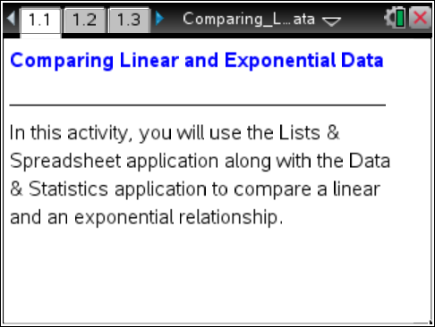

Move to page 1.2. | Press / ¢ and / ¡ to navigate through the lesson.
In this activity, you will use the Lists & Spreadsheet application along with the Data & Statistics application to compare a linear and an exponential relationship. The data will be generated by examining two scenarios: a prize award that begins with $10 and increases by $5 each week for 16 weeks, and a prize award that begins with $0.01 and doubles each week for 16 weeks.

- Complete the table for the first five weeks, where the first column (Weeks) represents the week number of the prize award. The second column (Adding) represents the amount of the prize award each week from the first scenario. The third column (Doubling) represents the amount of the prize award each week generated by the second scenario. Feel free to use the Scratchpad if necessary.
Weeks | Adding | Doubling
0
1
2
3
4
5

- Describe any patterns that you see in the Adding column of the table.

3. Describe any patterns that you see in the Doubling column of the table.

4. If only looking at the first five weeks, which prize would you rather have?

5. Bella says she thinks that after computing more weeks, the better prize to take is the prize that begins with $0.01 and doubles each week.
a. Do you agree?

b. How could she justify this?

c. Approximately when might this happen?

Move to page 1.3.

6. The columns are populated with data from each prize scenario. Scroll down the columns and determine if Bella was correct. At what week does the doubling prize become the greater prize?

7. What if the prize was changed to 20 weeks?
a. How much prize money would there be for the adding scenario? How did you find the amount?

b. How much prize money would there be for the doubling scenario? Explain how you found the amount.

Move to page 1.4.

On this page, there are places for two graphs. Move to the bottom of the left side of the page and click to choose the variable “weeks”. Move to the left center and click to choose the variable “adding”. Move to the right side and create a scatter plot with “weeks” as the horizontal variable and “doubling” as the vertical variable.

8. Describe any similarities or differences in the trend of the data as the weeks increase.

