Open the TI-Nspire document Trig_Ratios.tns.  If the measure of one acute angle in a right triangle is fixed but the side lengths are allowed to vary, what will happen to the ratios of the sides? | 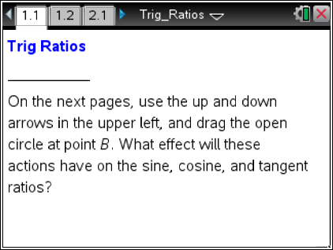

Move to page 1.2.

  - Use the up and down arrows in the upper left.
a. What measures shown on ABC stay the same?

b. What measures shown on ABC are changing?

  - a. Observe all the triangles you see as you select the up and down arrows. Are all of the triangles similar? Explain your thinking.

b. What do you observe about the ratio as you select the up and down arrows?

  - Drag the open circle at point B.
a. What measures shown on ABC stay the same?

b. What measures shown on ABC are changing?

c. What is the measure of ∡A? Explain how you found this measure.

  - a. Observe all the triangles you see as you drag the open circle at B. Are all of the triangles similar? Explain your thinking.

b. What do you observe about the ratio as you drag the open circle at B?

  - When will the ratio be constant even though $\overline{\text{AC}}$, $\overline{\text{BC}}$, and $\overline{\text{AB}}$ change?

6. The side of a right triangle opposite the right angle is called the hypotenuse. The leg that has point B as one of its endpoints is called the side adjacent to ∡B, and the other leg is called the side opposite ∡B.
The ratio is called the cosine of angle B and is written as cos B.
a. Describe cos B as a ratio, using the terms measure of hypotenuse, measure of adjacent leg, and/or measure of opposite leg.

b. Express cos A as a ratio using the side lengths AC, AB, and/or BC of the triangle on page 1.2.

Tech Tip: Once you use the up and down arrows on the slider – make sure you release the slider by hitting the esc key. This will allow you to move the open circle ONLY.

Move to page 2.1.

- Use the up and down arrows and drag the open circle at point B. When is the ratio AC : AB constant even though $\overline{\text{AC}}$, $\overline{\text{BC}}$, and $\overline{\text{AB}}$ change?

- The ratio AC : AB is called the sine of angle B and is written as sin B.
a. Describe sin B using the terms measure of hypotenuse, measure of adjacent leg, and/or measure of opposite leg.

b. Express sin A as a ratio using the side lengths AC, AB, and/or BC of the triangle on page 2.1.

Move to page 3.1.

- Use the up and down arrows and drag the open circle at point B. When is the ratio AC : CB constant even though $\overline{\text{AC}}$, $\overline{\text{BC}}$, and $\overline{\text{AB}}$ change?

- The ratio AC : CB is called the tangent of angle B and is written as tan B.
a. Describe tan B using the terms measure of hypotenuse, measure of adjacent leg, and/or measure of opposite leg.

b. Express tan A as a ratio using the side lengths AC, AB, and/or BC of the triangle on page 3.1.

- What is the connection between similarity of right triangles and the sine, cosine, and tangent ratios?

Extension:
Move back to page 2.1.

On this page, you found that sin B = AC : AB.

1. a. Write an expression for cos A.
b. What is the relationship between angles A and B?

Move back to page 1.2.

On this page, you found that cos B = BC : AB.

2. a. Write an expression for sin A.
b. What is the relationship between angles A and B?

3. In right triangle ABC with right angle C and sin A = 5/13, what is cos B?

