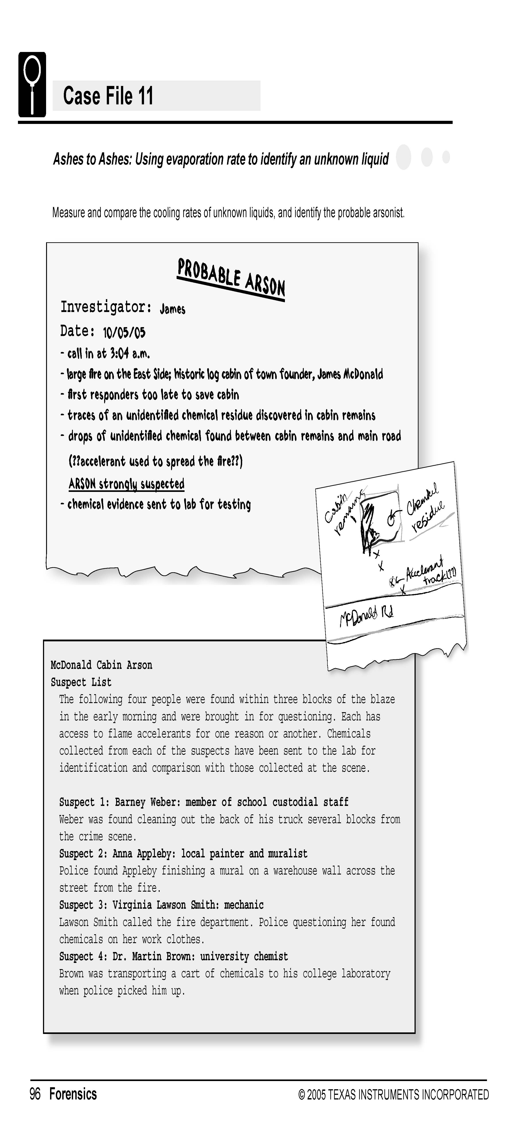

Science Objectives
- Identify the likely accelerant in an arson investigation
- Identify a solution based on evaporation rate
- Understand that evaporation rate is a characteristic property of a liquid

Activity Materials
- TI-Nspire™ technology  - Case 11 Ashes to Ashes.tns file  - Vernier EasyTemp®  - accelerant samples from 4 suspects  - accelerant samples from crime scene  - 5 small test tubes | - test tube rack  - 6 pieces of filter paper cut into 2 × 2 cm squares  - 6 small rubber bands  - lint-free tissues or paper towels  - masking tape
Procedure
Open the TI-Nspire document Case 11 Ashes to Ashes.tns.  Move to pages 1.2–1.3.  CAUTION: Obtain and wear goggles during this experiment. The compounds used in this experiment are flammable and poisonous. Avoid inhaling their vapors. Avoid touching them with your skin or clothing. Be sure there are no open flames, heat sources, or sparks in the lab during this experiment. Notify your teacher immediately if an accident occurs.  In order to determine whether any of the accelerants found with the suspects matched the accelerant found at the crime scene, you will need to compare the evaporation rate of each suspect’s sample with the evaporation rate of the sample from the crime scene. You will compare the samples by first, graphing the temperature change of each sample as it evaporates and second, comparing the graphs of each sample to look for a match. |  | 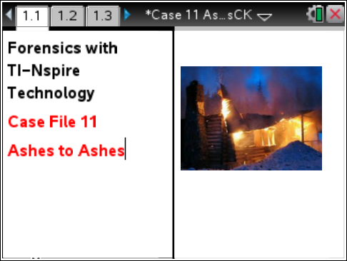
Part 1 – Collecting Data
Move to pages 2.1–2.5.
1. Prepare the samples to be tested.
a. Obtain five small test tubes and a test tube rack.
b. Label a separate test tube for each of the four suspects and a fifth test tube for the crime scene.
c. Pour a small amount of each of the four accelerants into their respective test tubes. Pour a small amount of the accelerant found at the crime scene into the test tube marked “crime scene.”
d. Secure the five test tubes in a test tube rack.
2. Prepare two pieces of masking tape, each about 10 cm long, to be used to tape the probes in position during Step 7.
3. Wrap the tip of each of the Temperature Probes with a square of filter paper. Roll the filter paper around the probe tip in the shape of a cylinder. Hint: First slip the rubber band up on the probe, wrap the paper around the probe, and then finally slip the rubber band over the wrapped paper. The filter paper should be even with the tip of the probe.
4. Place the temperature sensor into the test tube for Suspect 1. The filter paper should be covered by the liquid in the bottom of the test tube.
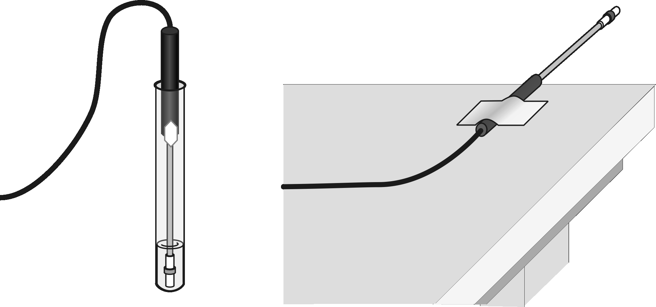

5. On page 2.4, Connect the EasyTemp to the TI-Nspire.
Collect temperature data.
a. When the probes have been in the liquid for at least 30 seconds, start data collection .
b. Leave the probes in the test tubes for 15 seconds to establish the initial temperature of the liquids.
c. Pull the probes from the test tubes, and tape each to the table so the tip of the probe extends over the edge of the tabletop.
6. When data collection has finished, roll the rubber band on each probe up the probe and dispose of the filter paper as directed by your teacher.
7. Determine the maximum and minimum temperatures for each of the data sets.
a. Press menu key. Choose Analyze > Statistics to determine the maximum (T_{max}) and minimum (T_{min}) temperature values for the accelerants.
b. Record the maximum (T_{max}) and minimum (T_{min}) for all accelerants in your Evidence Record.
c. For each of the liquids, subtract the minimum temperature from the maximum temperature to determine the temperature change during evaporation. Record these values in the Evidence Record.
8. To store the data that you collected during this run, select the  icon.
9. Repeat Steps 5–9 with the accelerants from Suspects 2-5.
10. Repeat Steps 5–8 with the accelerant from the crime scene. DO NOT store the last run of data.
11. Select, Run and select All Runs to view a graph that displays all of the data.
Part 2 – Analyzing the Data
Move to page 3.1- 3.2
12. Compare the plots on the graph to determine which of the suspects had an accelerant that is likely to be the same as the accelerant used at the crime scene. If one of the suspects’ accelerants produces a plot that matches the shape of the plot from the crime scene accelerant, it could be the accelerant that was used.

Evidence Record
Substance | Tmax  (°C) | Tmin  (°C) | Tmax – Tmin  (°C) | Cooling-Rate  Graph Match?
Suspect 1
Suspect 2
Suspect 3
Suspect 4
Crime Scene |  |  |  | N/A

Case Analysis
Move to pages 4.1–4.5.
Answer the following questions here, in the .tns file, or both.
Q1. Which of the suspects’ accelerants best matches the accelerant from the crime scene?

Q2. Did any of the suspects’ accelerants appear to be the same liquid? If so, which ones?

Q3. Why may the graphs of the crime scene accelerant and primary suspect’s accelerant not match exactly?

Q4. In what other ways can you examine the accelerants to determine which one was used in the crime?

