Open the TI-Nspire document Transformations_of_Exponential_ Functions.tns.  The purpose of this activity is to examine the family of exponential functions of the form where and are parameters. At the end of this activity, you will use your results to match each function with its corresponding graph. | 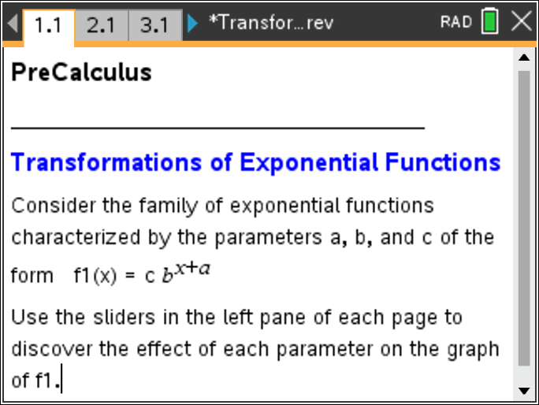

Note: The parameter is the base of the exponential function and

Move to page 2.1. | Press / ¢ and / ¡ to navigate through the lesson.
1. The graph of is shown in the right panel. Click the arrows in the left panel to change the value of , and observe the changes in the graph of
a. Explain why for every value of the graph of passes through the point

b. For describe the graph of

c. For describe the graph of

d. Find the domain and range of function

e. Does the graph of intersect the -axis? Explain why or why not.

Move to page 3.1.

2. The graph of is shown in the right panel. For a specific value of , click the arrows to change the value of and observe the changes in the graph of Repeat this process for other values of
a. Describe the effect of the parameter on the graph of Discuss the effects of both positive and negative values of

Move to page 4.1.

3. The graph of is shown in the right panel. For specific values of and , click the arrows to change the value of , and observe the changes in the graph of Repeat this process for other values of and
a. Describe the effect of the parameter on the graph of Discuss the effects of both positive and negative values of

Move to page 5.1.

4. Display the graphs of and
a. Describe the similarities between these two graphs. Use the properties of exponents to justify your answer.

b. Insert a new problem, and display the graph of Use the properties of exponents to find a function of the form such that the graphs of and are the same. Verify your answer.

c. Use your answers to parts (a) and (b) to explain the relationship between a horizontal translation and a vertical stretch of the graph of an exponential function.

5. Match each equation with its corresponding graph.
(a) (b)

(c) (d)

(e) (f)
Note: The function in part (e) is the “natural” exponential function and involves the number

(i) | 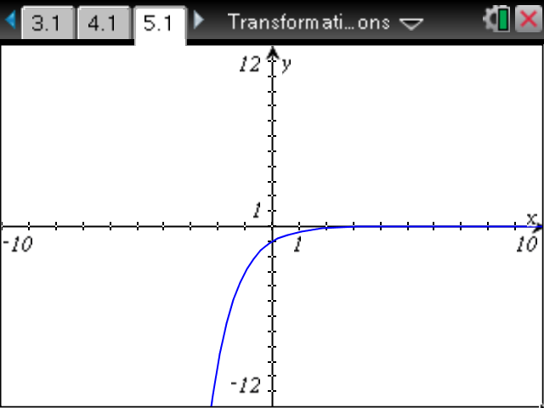 | (ii) | 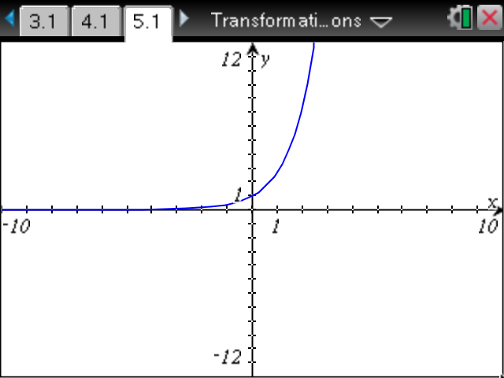
(iii) | 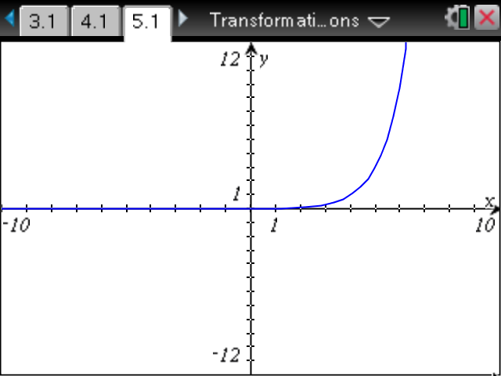 | (iv) | 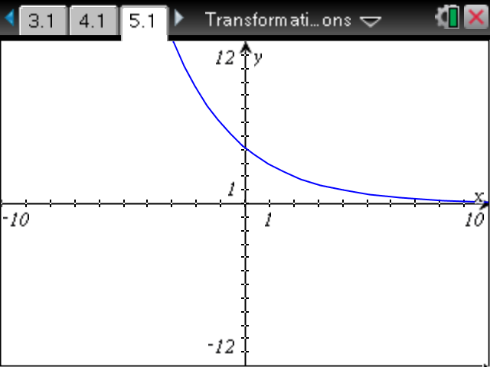
(v) | 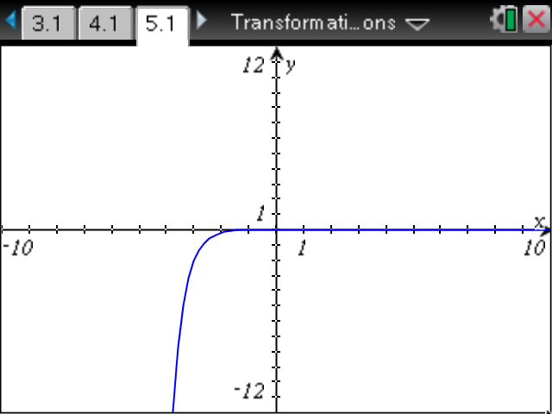 | (vi) | 