Problem 1 – Fast Food Hamburgers
Calories are a unit of energy. You may burn around 70 Calories just sitting at your desk and over 100 Calories while you sleep. The energy required to lift a book from the floor to the table is only about 0.003 Calories.  The table to the right shows the grams of fat and Calories for 11 hamburgers from three different fast food places. How many fast food hamburgers do you eat in a week?  - Look at the data. What do you think is the relationship between the grams of fat and the Calories in a hamburger? Is it a positive or negative association?  - In order to graph the data and set up an appropriate viewing window, consider the following.  - What is the independent variable? What is the domain?  - What is the dependent variable? What is the range of the data?  - Estimate about how much the Calories increase for every increase of 1 gram of fat.
  Fat (g) | Calories
  11 | 270
  9 | 270
  19 | 360
  24 | 400
  28 | 450
  35 | 570
  38 | 620
  43 | 660
  49 | 720
  53 | 790
  79 | 1060
Plot the Calories vs. grams of fat as a scatter plot, and then find the line of best fit. Enter the data into your calculator by pressing S e to open the ListEditor. Enter the grams of fat in L₁ and the Calories in L₂.  Plot the data as a scatter plot as shown to the right by pressing ` ! for å. Then press @ and set up the window you decided upon in questions 2. The Xscl and Yscl sets up the tick marks. Press %.  - How does your answer for question 3 relate to the graph? | 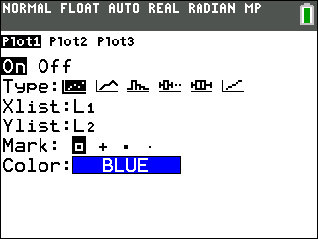
To create your own line of best fit press S, arrow over to choose CALC, and up arrow to select Manuel-Fit. Arrow down to and select Calculate. Your equation will automatically be stored in Y₁. With the TI-84 Plus C you can press the soft key % to change the STYLE.  Move the cursor along to where the line of best fit appears to be and press e. Move the cursor again to pick another point further away. Think of it as lining up your ruler along the data points. Press e again. Use the arrows and type in a value to change the slope and y-intercept until you are satisfied with your line. To quit press ` M.  - What is the equation of your line? Explain the meaning of your slope. Include units.  - How does your equation compare with the linear regression? View the data and the two linear equations together. S, CALC, LinReg (ax+b). Use aª to select Y₂ to store the regression equation in Y₂ as shown to the right and select Calculate. | 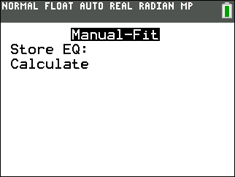  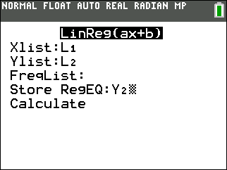
Use the regression equation to answer the following questions.
- What does the y-intercept mean in terms of the number of hamburgers?

- How many Calories are in a hamburger with 22 grams of fat?

- If one of the fast food places created a triple burger with 1243 Calories, approximately how many grams of fat would it have?

Extension
- Find nutritional data on other fast food hamburgers and compare them to your results.
- Find nutritional data on various other types of food (ice cream, candy, chips, pop, etc.) and explore the relationship between grams of sugar and Calories.

