Open the TI-Nspire document Plane_Mirrors.tns.  When you look into a mirror how far away does your image seem to be behind the mirror? Are there times when you look in a mirror and you cannot see your whole body? How would you adjust the situation so you can see more? | 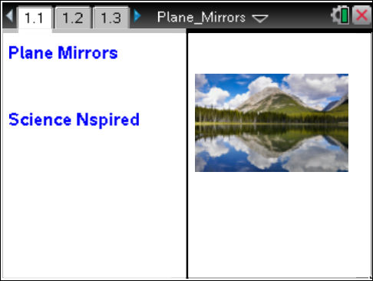

Move to pages 1.2 and 1.3.  In this activity you will explore the images seen in a mirror. You will explore how distance between a mirror and an object is related to distance between the mirror and the image. You will also determine how to observe the image of objects that are not at eye level.  1. Using the Reflection tool, reflect point X over the mirror  and label the point X'. Select the reflection tool using Menu > Transformation > Reflect. When the tool is active, click on point X. Then click on the line (representing the mirror) that you wish to reflect across. When the image point appears, type “X'.” | Press / ¢ and / ¡ to navigate through the lesson.  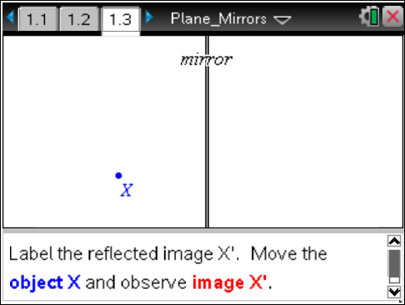
Move to pages 1.4–1.6. Answer the following questions here or in the .tns file.
Q1. Describe how the image moves as you move the object.

2. On page 1.5, measure the distance from X to the mirror using the Length tool (Menu > Measure > Length). This is the object distance. Then measure the image distance from X' to the mirror.
Q2. How is the object distance related to the image distance? Does this relationship stay the same when you move the object?

Move to pages 1.7 and 1.8.
3. Follow directions on page 1.7. Construct a line segment from point X to point X'. Measure the angle created between the mirror and the segment.

Move to pages 1.9 and 1.10 Answer the following questions here or in the .tns file.
Q3. What angle does the connecting segment make with the mirror? Does this angle change when you move the object?

Q4. Suppose XY is the length of an object. How does the length of the image, X'Y', compare to XY?

Move to pages 2.1–2.3.  4. How does an observer at point X see the image at point Y? On page 2.1 draw a segment from point X to image Y'. To measure the angle of reflection, first construct a perpendicular line to the mirror at the point where segment XY' intersects the mirror. This y is called the “normal.” Measure the angle between XY' and the normal; this is the angle of reflection. | 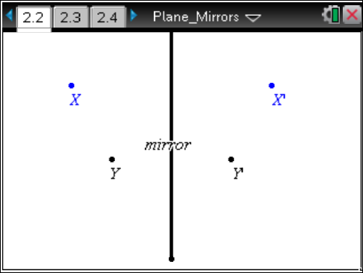
5. Draw a segment from Y to the point where segment XY' intersects the mirror.
Measure the angle of incidence between this segment and the normal.
Move to pages 2.4 and 2.5. Answer the following questions here or in the .tns file.
Q5. What angle does the connecting segment make with the normal to the mirror? Does this angle change when you move the object?

Q6. If X or Y is moved away from the mirror, does it change your answer for the last question?

Move to pages 3.1 and 3.2.  6. Read the description on page 3.1. Then move to page 3.2, which simulates the following scenario. An object is 15 cm in front of a mirror. An observer is standing 40 cm away from the mirror and looking at the image of the object. | 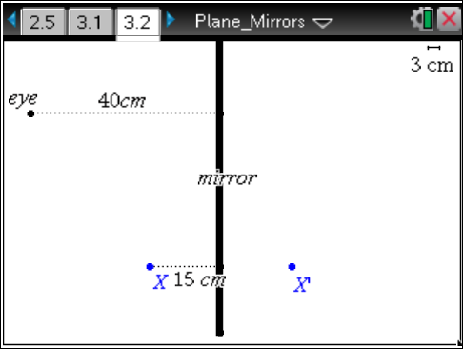
Move to pages 3.3 and 3.4. Answer the following questions here or in the .tns file.
Q7. How far behind the mirror will the image appear to the observer?

Q8. Will this distance change if the observer moves closer to the mirror? Explain your answer.

Move to pages 3.5–3.7. Use the diagram on page 3.5 to answer the following questions here or in the .tns file.  Q9. Will the person be able to see his or her feet by moving farther from the mirror? Make a prediction. |  | 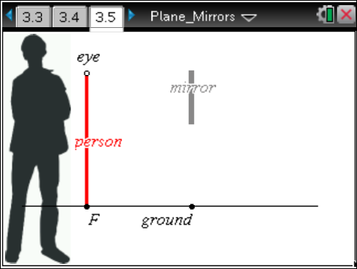

8. Now, use the simulation to test your prediction. Complete any construction needed and then move the dot labeled “eye” toward or away from the mirror. The man will not move.

Q10. Was your prediction correct? If not, explain any errors in your reasoning.

Move to pages 4.1 and 4.2.
9. A photographer at point P is taking a picture of three people (located at points A, B, and C). The photographer may move left or right to get all three members in the picture through the mirror.  Drag P to a point where A, B, and C are all seen by P in the mirror. Some construction may be needed to find the point. | 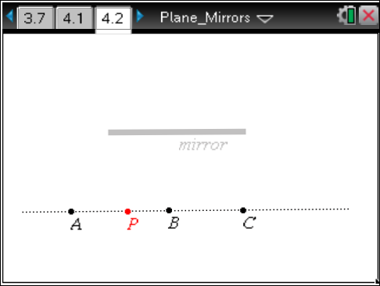
Move to pages 4.3 and 4.4. Answer the following questions here or in the .tns file.
Q11. Is it possible for the photographer to take a photograph of the reflections so that everyone appears in the mirror without anyone (except the photographer) having to move? Explain your answer.

Q12. Where could the photographer stand (along the line) so that he or she does not appear in the photograph? Will all three other people still be visible in the photograph? If not, who will be left out?

