Open the TI-Nspire document Blood_Pressure.tns.  Blood delivers essential nutrients and oxygen to all the cells in your body. This is one reason why the circulatory system is so carefully regulated by the body. Doctors use blood pressure as a quick way to assess a person’s cardiovascular health, which is very important for overall health. But what is meant by “blood pressure”, and how is it measured? | 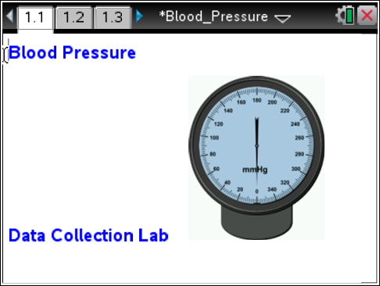
In this lesson, you’ll learn about blood pressure and the factors that can influence it by measuring your own blood pressure and pulse data and comparing blood pressure under different testing conditions. You’ll be using a blood pressure sensor to collect this data.
Move to pages 1.2 – 1.3.
- In this lesson, you will be collecting blood pressure and pulse data. Read the background information on pages 1.2 and 1.3.

Move to pages 1.4 – 1.6.
Answer questions 1-3 on the handheld, the activity sheet, or both.
Q1. Which factors do you think influence blood pressure? (Select all that apply.)
A. diet C. age
B. genetics D. race

Q2. Blood pressure is a vital sign that can tell doctors about _________. (Select all that apply.)
A. hygiene C. heart health
B. respiratory health D. diseases

Q3. Blood pressure changes depending on the activity a person is performing.
Strongly Agree
Agree
Neutral
Disagree
Strongly Disagree
Move to pages 1.7.
2. Read the instructions to take the first blood pressure reading.

Connect the blood pressure sensor to the Data Collection interface, such as EasyLink. Then connect it to the TI-Nspire handheld.

Move to page 1.8.  3. Have your partner strap on the cuff and inflate the cuff to 160mmHg. Click the Start Collection button ().The pressure will slowly reduce while blood pressure data is collected.  The handheld will collect data at 25 samples per second for 99 seconds. Once the data collection stops, the handheld will calculate the systolic and diastolic pressures. | 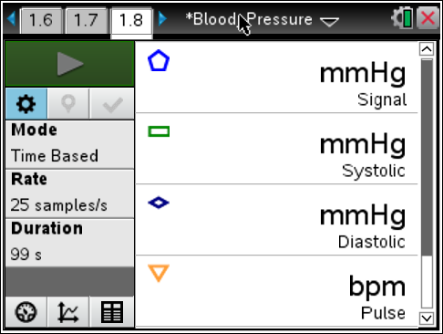
Move to page 1.9.
Answer question 4 on the handheld, the activity sheet, or both.
Q4. What are your systolic and diastolic pressures? What was your pulse rate?

Move to pages 2.1 – 2.3.  4. Read the introduction to the next data collection on page on page 2.3.  Next, lie down for 1 minute while breathing slowly. Have your partner place the cuff on your arm and start the data collection. | 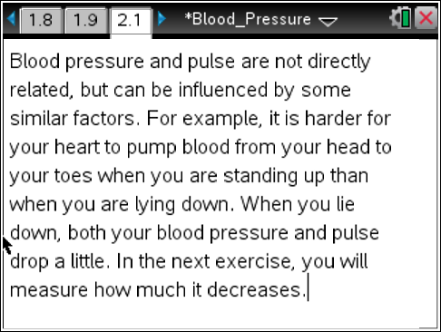
Move to pages 2.4 – 2.6.
Answer questions 5-7 on the handheld, the activity sheet, or both.
Q5. What are your systolic and diastolic pressures? What was your pulse rate?

Q6. Did your pressures and/or pulse rate change from the first reading? If so, by how much did the values change?

Q7. Based on your readings in Question 5, is your blood pressure in the healthy range? Look back at page 1.3 for the ranges.

Move to pages 3.1 – 3.3.  5. Read the instructions for the final data collection in the activity.  6. As directed by your teacher, complete 3 minutes of intense  activity immediately before collecting your blood pressure data.  Have your partner perform the data collection. | 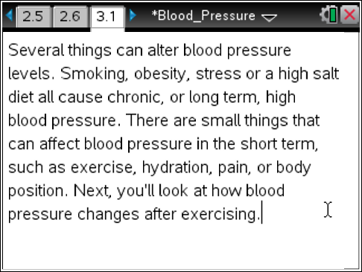
Move to pages 3.4 – 3.6.
Answer questions 8-10 on the handheld, the activity sheet, or both.

Q8. What are your systolic and diastolic pressures? What was your pulse rate?

Q9. Is this blood pressure reading still in the healthy range? Does this mean you are unhealthy? Explain your reasoning.

Q10. Of the three factors you have been recording, pulse, systolic pressure, and diastolic pressure, which factor changes most quickly? Explain.

