Open the TI-Nspire document Impulse_of_a_Force.tns.  How do the mass and speed of a cart affect the impulse of the force acting on the cart when it hits a stationary object? You will measure the force exerted by a stationary object on the cart during the collision and the time of collision. You will add mass and change its speed of motion, and observe the effect of these changes on the magnitude of the impulse. | 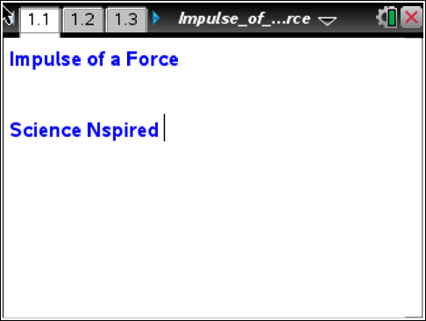

Move to pages 1.2 and 1.3.
In this activity you will explore the impulse of force of a cart when it hits a stationary wall. Then you will observe the changes in impulse of force depending on the mass and speed of the cart. In this experiment, you will observe elastic collisions of a moving cart with a stationary object and will explore the impulse acting on the cart during the collision.
Exploring impulse for carts of different masses
1. You will use a Vernier Dual-Range Force sensor to collect force data. Make sure the switch on the force sensor is in the ±10 N position. Set up the track so that it is inclined at a slight angle, as shown to the right. Mark a starting point on the track, about 30 cm from the end. Mount the force sensor on the end of the track with the hook directed up the track.
Move to page 1.4.  2. When on the DataQuest page, connect the force sensor to the EasyLink interface (if you are using a TI-Nspire handheld to collect data) or to the Go! Link interface (if you are using  TI-Nspire computer software to collect data).  3. Now, connect the EasyLink interface to your handheld (or the  Go! Link interface to your computer). The DataQuest application on page 1.4 should show that you are collecting data for force. | 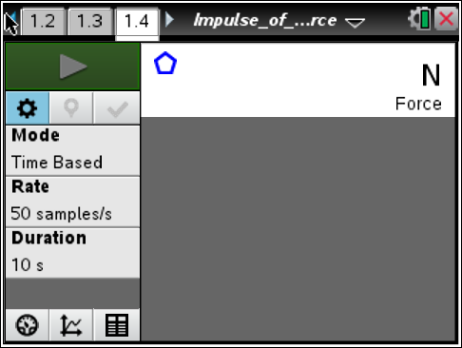
4. Select the graph tab.
5. Wait for the data collection display to stabilize, and then zero the force sensor (Menu > Experiment > Set Up Sensors > Zero).
6. Next, set up the data collection for Time Graph mode (Menu > Experiment > Collection Mode > Time Based). In the configuration window select 0.01 s for the time between the samples and 5 s for the experiment length.
7. Once you are ready to begin data collection, place the cart on the track so that its front wheels are aligned with the starting position.
8. Start the data collection by selecting Start Data Collection in the DataQuest application. Immediately after data collection starts, release the cart so that it slides down the track and bounces off the force sensor. Stop the cart after its first bounce. A graph of force vs. time should be displayed on the screen. Study the graph and then answer Questions 1–5. | 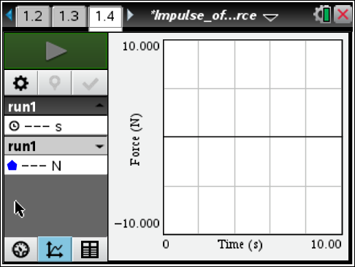
Answer the following questions here.
Q1. Use the graph to determine the time of collision and the magnitude of the force acting on the cart during the collision.

Q2. Calculate the impulse produced during this collision.

Q3. What do you think will happen to the time of collision if you add weight to the cart but keep its speed the same?

Q4. What do you think will happen to the force of impact if you add weight to the cart but keep its speed the same?

Q5. What do you think will happen to the impulse of the collision if you add weight to the cart but keep its speed the same?

9. Test your prediction by adding weight to the cart and repeating your experiment. (Store your original data run so that you can compare the two data sets.) Then, answer Question 6.
Answer the following question here.
Q6. What do you think will happen to the impulse of the collision if you add weight to the cart but keep its speed the same?

Exploring impulse for a cart moving with different speeds
Return to page 1.4.
10. Move to page 1.4 and answer Questions 7 – 9.
Answer the following questions here.
Q7. What do you think will happen to the time of collision if you increase the speed of the cart but keep its weight constant?

Q8. What will happen to the force of impact if you increase the speed of the cart but keep its weight constant?

Q9. What do you think will happen to the impulse of the collision if you increase the speed of the cart but keep its weight constant?

Return to page 1.4.
11. Increase the incline of the track, and then repeat Steps 6 – 9 from Part 1. (Store your previous data run before collecting new data.) Then, answer Questions 10 – 12.

Answer the following questions here.
Q10. Were your predictions about force, time, and impulse correct? If not, describe any errors in your reasoning.

Q11. What factors affect impulse?

Q12. If a scientist wants to minimize the impulse produced during a collision between two objects, what should the scientist do?

