Open the TI-Nspire document Exploring_Power_Functions_1.tns.  This activity investigates patterns and properties for equations of the form y = x^{p} where p is an integer greater than or equal to zero. Pay close attention to end behavior, symmetry, and behavior near the origin. | 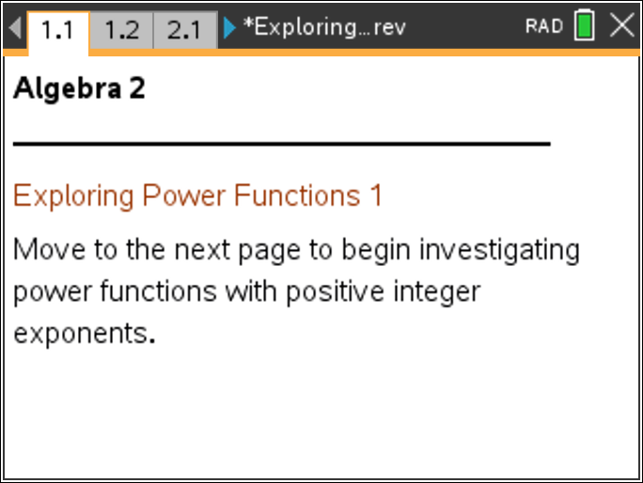

Move to page 1.2. | Press / ¢ and / ¡ to navigate through the lesson.
1. Click the slider along the left side of the screen to change the value of p to odd values from 1 to 15. The graph will change as the value of p changes.
a. Describe the appearance of the graph as p changes. How are the graphs similar? How are they different?

b. Why are the y-values negative for negative x-values?

Move to page 2.1.

2. Click the slider along the left side again. This time a “trail” of graphs remains as p changes to odd values.
a. What points are common to all the graphs on this page?

b. Why are they common to all the graphs?

Move to page 2.2.

3. Clicking the slider along the left side will zoom in or zoom out on the graph of y = x⁵. Recall that the end behavior of a graph is how the y-values of the graph behave for very large or very small values of x. What do you notice about the end behavior of this graph?

Move to page 3.1.

4. Clicking the slider along the left side of the screen will change the value of p. This time even exponents will be used.
a. Describe the appearance of the graphs as p changes. Why do the graphs have this shape?

b. Why are the y-values positive when the x-values are negative?

Move to page 4.1.

5. Click the slider along the left side again. A “trail” of graphs should remain as p changes to even values from 2 to 12.
a. When the graph is of the form y = x^{p} and p is even and greater than or equal to 2, what points do each function have in common?

b. Why are the points different than when p was odd?

Move to page 5.1.

6. Clicking the slider will show the graphs for all values of p from 1 to 15.
a. Describe how the shape and end behavior of the graphs change as p changes.

b. Why do the graphs change as you alternate between even and odd values of p?

Move to page 6.1.

7. Recall that when an object has symmetry, it can be reflected, rotated, or translated and remain unchanged. The point (1, 1) is marked on an even power function graph. This point can be grabbed and moved to show symmetry. Where does the point move to? What kind of symmetry does this curve have? Explain.

Move to page 7.1.

8. The point (1, 1) is marked on an odd power function graph. This point can be grabbed and moved to show symmetry. Where does the point move to? What kind of symmetry does this curve have? Explain.

