Open the TI-Nspire document Waves and Spectrum.tns.  Why is it that neon lights are so attractive? Neon (Ne) is a single type of atom that gives off an orange light to the naked eye. When Neon’s light is passed through a spectrum, though, a number of colors appear. Each element will admit a different set of colors called the emission spectrum. | 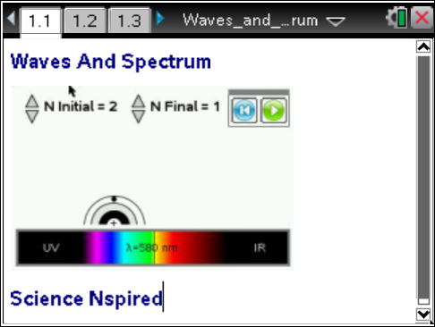

Move to page 1.2.
1. Read the description and instructions on pages 1.2 through 1.4 of the .tns document.

Move to page 1.5.
2. Adjust the slider to change the wavelength of the electromagnetic wave. Observe how this effects the shape and color of the waveform. |  | 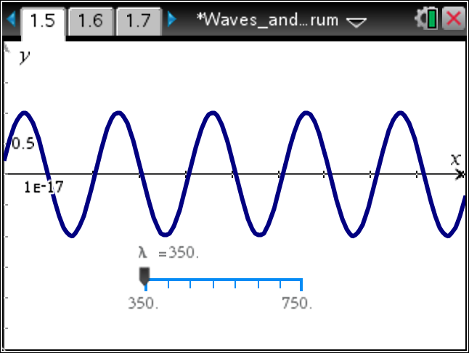
Tech Tip: Grab and drag the slider to adjust the wavelength. The slider may lag behind your finger as you drag it.
Move to pages 1.6 - 1.8. Answer questions 1 - 3 below and/or in your .tns file.
- Which wavelength of light has the highest frequency?
- red
- orange
- yellow
- green
- violet
- Calculate the frequency of light with a wavelength of 400nm.
- 7.49x10⁵ s^{–1}
- 7.49 s^{–1}
- 7.49x10⁻⁴ s^{–1}
- 7.49x10¹⁴ s^{–1}

- Calculate the wavelength of light in nm if the frequency is 1.5x10¹⁸ Hz.
A. 2.0x10^{–10} nm
B. 2.0x10^{–1} nm
C. 2.0 nm
D. 2.0x10¹⁰ nm

Move to pages 1.9 - 1.10. Read the information below and/or in your .tns file.
Light is released in small particles called photons. Photons have wavelengths that help determine their colors. Each color, or wavelength, of light also contains a certain amount of energy. The energy can be determined by calculating the frequency of the photon and multiplying that frequency by Planck's constant (h).

Move to pages 1.11 - 1.14. Answer the questions below and/or in your .tns file.
- Which color of light has the highest energy?
A. red
B. orange
C. yellow
D. green
E. violet

- Calculate the energy for red light with a frequency of 4.15x10¹⁴ Hz.
A. 1.60x10^{–48} J
B. 2.75x10^{–19} J
C. 4.78x10^{–40} J
D. 1.39x10⁶ J

- How much energy is released from a photon with a wavelength of 555 nm?
A. 3.68x10^{–31} J
B. 3.68x10^{–40} J
C. 3.58 x10^{–19} J
D. 3.58x10^{–28} J

- What is the frequency of a photon that releases 4.00 x 10^{–21} J?

Move to page 2.1. Read the information below and/or in your .tns file.
The physicist Niels Bohr predicted that electrons could only exist at certain energy levels. He determined that the energy levels (n) are indicated by whole numbers (1, 2, 3, 4, ...). He also calculated that when electrons move from a higher energy level to a lower energy level, the energy is released in the form of light.

Move to pages 2.2 - 2.4.  3. Read the directions for the simulation on page 2.2. On page 2.3, N Initial is the initial energy level where the electron starts, and N Final is the energy level where the electron lands.  - Change N Initial to 10 and select the Play button to start the animation.  - Select the Reset button and repeat for all value of N Initial from 9 to 2.  - Change N Final to 2, and run the simulation for all values of N Initial.  - Continue to increase the value of N Final and run the simulation to see each of the electron drops. All wavelengths and transitions will appear in the spreadsheet on page 2.4. | 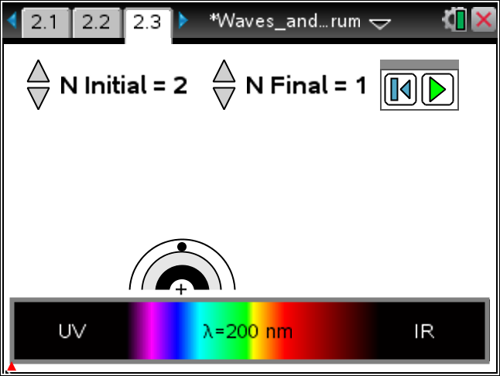  Note: Only wavelengths within the range of 200 nm to 950 nm will appear. Visible light wavelengths range from about 400 nm to 700 nm.
Move to page 2.5. Answer question 8 below and/or in the .tns file.
Q8. What electron movements produce visible light?

Move to page 2.6. Read the information below and/or in the .tns file.
- Lyman series are the wavelengths of light that are produced when electrons drop to the first energy level.
- Balmer series are the wavelengths of light that are produced when electrons drop to the second energy level.
- Paschen series are the wavelengths of light are produced when electrons drop to the third energy level.
Move to pages 2.7 - 2.9. Answer questions 9 and 10 below and/or in the .tns file.
Q9. Calculate the energy for the 4 wavelengths of light generated in the Balmer series.

Q10. Calculate the ∆E for an electron moving from n = 4 to n = 3.
A. 1.06 x 10⁻¹⁹J
B. –1.06 x 10⁻¹⁹J
C. 2.42 x 10⁻¹⁹J
D. 1.36 x 10⁻¹⁹J

