Open the TI-Nspire document Circuit Construction Kit.tns.
In this simulation you will learn about electrical circuits and you will construct simple circuits.
Read the information on page 1.1.  An electric circuit is a continuous loop of wire that carries electric current through it. There is a source of electricity and an electrical device that uses that electricity. In this diagram, a battery is the source of electricity. Wires connected to both ends of the battery allow current to flow through the wires. The electric current is used to power an electrical device, in this case a light bulb. | 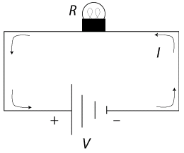
Move to page 1.2. Construct a circuit.
Step 1: Place six wire segments as shown. Select Wire and then move the wire to the desired location. Select the wire again to drop it. | 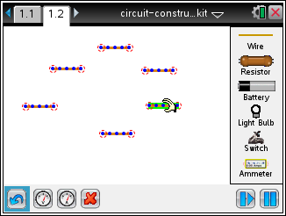
Step 2: Arrange the wires as shown, connecting the four corners. Select the middle of the wire to move the whole piece. Select either end and drag it to make the wire longer. | 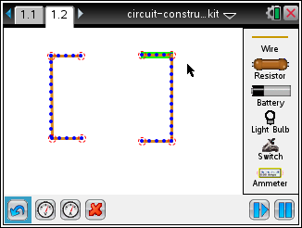
Tech Tip: To place a wire on the screen, select Wire . Then, place your finger on the wire and drag it to the desired location.

Tech Tip: If you accidentally connect two wires, you can undo the connection. Select the red circle connecting the wires and select . To delete a wire segment, select the middle of a segment and the wire is highlighted in green. Then select .
Step 3: Now place a resistor in the top opening and a battery in the bottom opening, as shown. Make sure the resistor and battery snap into wires. |  | 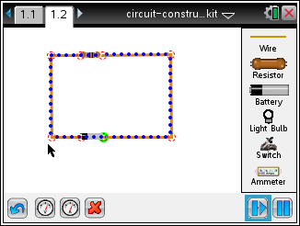
Q1. Describe what happens.

Part 1: Exploring Electric Circuits
This circuit diagram shows three key components of a circuit: (1) a closed loop of wire, where electric current flows, (2) a battery, which is the source of the electric current, and (3) a resistor, which affects the amount of current in the circuit. |  | 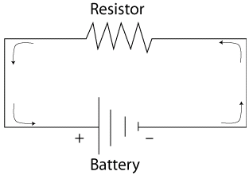
The amount of current flowing through the circuit is denoted by I; the amount of resistance R; and the amount of force pushing current through the circuit is denoted by V, the voltage. |  | 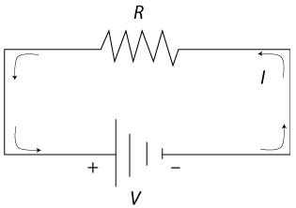
- Measure the current and voltage in this circuit by selecting one of these buttons on the bottom toolbar: . The one on the left is for voltage and the one on the right is for current.  To measure voltage, place the two leads, and , for voltage across the connections to the resistor. To measure current, place the single lead over the circuit. Voltage is measured in volts and current is measured in amperes. |  | 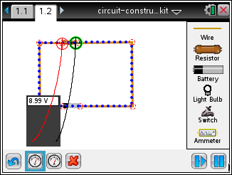
Q2. What are the measurements for voltage and current?

Current will continue flowing through the circuit, unless the connection between any of the wires is interrupted.  In fact, you don’t always want current flowing through a circuit. For that reason, a switch is another important component of a circuit. When the switch is closed, the current flows; when the switch is open, the current stops flowing. |  | 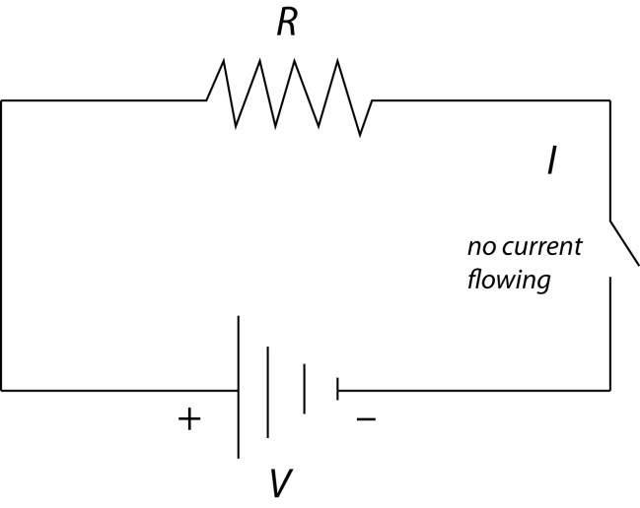
- Add a switch to the circuit. Highlight one of the points connecting two pieces of wire and select Delete . to disconnect the wires. Be careful that only one segment is highlighted, not the whole item. Bring a switch onscreen and connect it to the circuit. By default the switch is open. Select the circle next to “Closed” to close the circuit.  (Open Circuit Icon) (Closed Circuit Icon) |  | 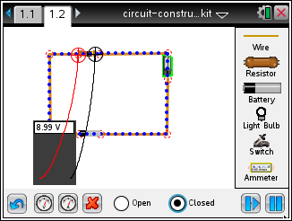
 | Tech Tip: To disconnect two wires, select the red circle connecting the wires and select . After the switch is inserted into the circuit, select the switch to bring up the buttons to open or close it.

Q3. How can you tell that the circuit is open or closed other than the change in the icon?

The units of measurement for R are Ohms, and recall that the units for V are volts and I are amperes.  In fact, the relationship among the three variables is summarized in this formula: |  | 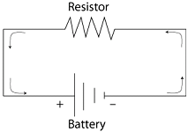
Q4. To calculate the resistance in the circuit, first solve the formula for R.

Q5. What are the values of V and I?

Q6. Substitute the values of V and I into the formula from Question 4. What is the resistance in the circuit?

Part 2: Creating a Circuit with a Light Bulb
One of the most common uses for an electric circuit is to power an electrical device. And one of the most common electrical devices is a light. In this circuit a light is connected. This light has its own resistance (R) and its own voltage (V) and has current (I) flowing through it. |  | 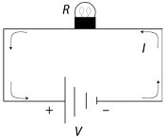
- Replace the resistor with a light bulb. Select the resistor and select . to remove it. Select the light bulb button and place it in the open space. Grab and drag the wires from either side and connect them to each end of the light bulb. You may need to move the leads of the voltmeter in order to attach the wires to the light bulb terminals. Then select the switch. Select the open circle next to “Open” or “Closed” to turn the switch on and off. |  | 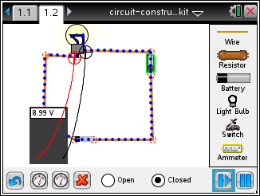
 | Tech Tip: To replace the resistor with the light bulb, select the resistor and select to remove it.
Q7. Describe what happens when you turn the switch on and off.

Q8. How much current, or amps, is flowing through the bulb? What is the voltage?

Q9. What are the values of V and I?

Q10. What is the amount of resistance, or value of R? Substitute the values of V and I into the formula from Question 4 and simplify.

Part 3: Creating a Circuit with Several Light Bulbs
- Now connect a second bulb next to the first one. You’ll need to add another piece of wire. Try to get your screen to look like this. |  | 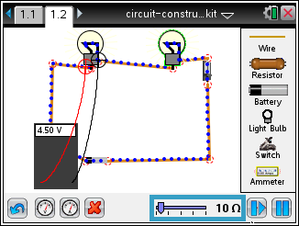
Adding two of the same kind of bulbs doubles the resistance. However, the voltage across the two resistors is the same. This is summarized in this formula. |  | 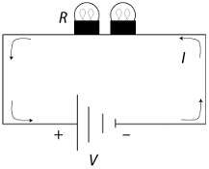
Q11. Calculate the current, I. using the formula in Step 4. Use the previous values for voltage, V, and the calculated value for resistance, R.

Q12. Run the simulation to check the calculated value for the current.

Q13. Suppose the circuit now had 10 bulbs. What would be the current?

Q14. What happens to the current as more electrical devices, such as light bulbs, are added to a circuit?

