Open the TI-Nspire document Whats_Right_About_ Triangles.tns.  In this activity, you will explore the Pythagorean Theorem and explain why the theorem works for right triangles. | 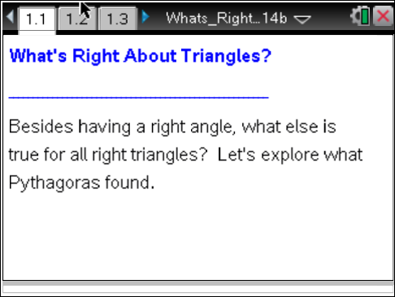

Move to page 1.2.

The Pythagorean Theorem describes a relationship between the areas of squares built off of each of the 3 sides of right triangles (see figure to the right). You will explore what is true about the sums of these areas for different triangles by dragging sides of triangles (with squares built off of these sides) to see what happens and to see if the Pythagorean Theorem holds true for non-right triangles as well (see Page 1.3 to the right). | 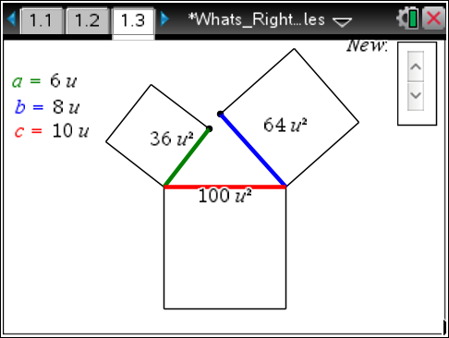
Move to page 1.3.

1. Select the closed circles to see if you can make a triangle with the given side lengths. Record your findings in the table below. If you cannot connect the sides to form a triangle, you should leave the “measure” column blank and write “no” in the “right triangle” column. Complete several examples**.

a² | b² | c² | Measure of new angle formed | Right triangle?  (Yes or No)
36u² | 64u² | 100u²
**Table continued on next page.

a²
b² | c² | Measure of new angle formed | Right triangle?  (Yes or No)

2. a. Based upon your completed table, what is true about the sums of the areas of the squares for right triangles?

b. Does this relationship hold for non-right triangles?

c. So if you know that a² + b² = c², for the sums of squares built off of the 3 sides of a triangle, then what kind of triangle do you have to have?

Move to page 1.4.

Let the base be the bottom side of the parallelogram. The height is the perpendicular distance between the base and its opposite side.
3. Horizontally drag the open circle on the parallelogram. Describe what is happening to the parallelogram’s
a. base:

b. height:

c. non-horizontal side lengths:

4. With the above information, explain why the perimeter of the parallelogram is changing but the area is not.

5. Change the sliding direction of the open circle to vertical (by selecting on v in the upper left corner), and see what happens to the perimeter and area as you drag the open circle on the parallelogram. Describe what you find, and explain why it is happening.

You will use what you have found here with parallelograms to help explain what is happening next with a visual proof of the Pythagorean Theorem.

Move to page 1.5.

6. On this page, you should see squares built off of a right triangle’s sides. Drag the closed circle downward, and describe what happens with the areas of the two squares.

7. Using what you know about the area of a parallelogram where the base and height don’t change, explain how the moving shapes prove the Pythagorean Theorem for right triangles.

