Open the TI-Nspire document Mechanical_Advantage.tns.  In this activity, you will experiment with the incline plane and lever to discover the relationship between resistance and force. Then, you will derive formulas for the mechanical advantage of these simple machines. | 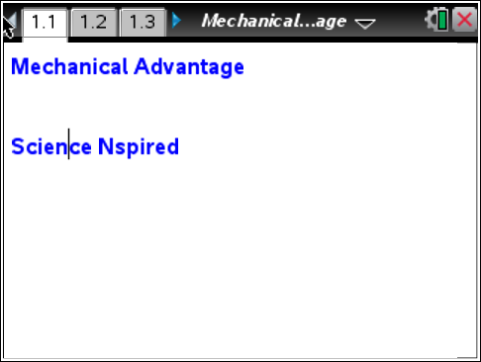

Problem 1: Mechanical advantage of inclined plane and lever

In this activity, you will explore the general concept of mechanical advantage. Next you will to analyze several specific cases of simple machines. Then you will derive formulas for mechanical advantage of an inclined plane and a lever. Finally, you will calculate the mechanical advantages of these simple machines.
Move to pages 1.2 and 1.3.  1. Read the text in pages 1.2 and 1.3.  2. Set up the inclined plane by resting the piece of wood on top of several books. During the experiment, will change the height of the inclined plane by varying the number of books underneath the wood. For best results, use a wide variety of angles, including several that are quite steep and several that are quite shallow. Measure the length of the plane and record this value on paper. Enter the data on page 1.4. | 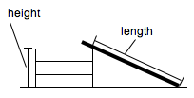
Move to page 1.4.  3. Next, you should gather the data using the blank DataQuest application on page 1.4. Connect the force sensor to the EasyLink or Go!Link interface, and then connect the interface to your TI-NspireTM or computer. | 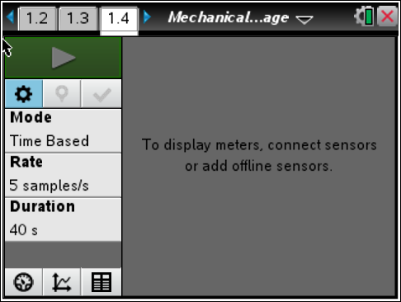
4. Next, zero the force sensor (Menu > Experiment > Set Up Sensors > Zero). Then, use the string to connect the cart to the hook on the bottom of the force sensor. (Make sure the switch on the force sensor is set to the correct range. The range you use will depend on the mass you use.) Let the cart hang from the force sensor without touching anything. Once the weight reading on the force sensor has stabilized, record the weight of the cart on paper.
5. Next, set up the sensor to Events with Entry mode (Menu > Experiment > Collection Mode > Events with Entry) and begin the experiment by selecting Start . (Note: The data shown here are simulated; your data will vary.)
6. Next, place the cart on the inclined plane. Wait for the force reading to stabilize and record a data point. Measure the height of the ramp and enter that value as the "event" value.
Move to page 1.5.  7. Repeat Step 6 at least five times, changing the height of the ramp at each repetition. (Make sure you measure the height of the ramp at each step and use that value for the "event" value.) Once data collection is complete, stop the data collection and disconnect the force sensor. If your data do not automatically appear in the Lists & Spreadsheet application on page 1.5, assign Column A to the height data (stored in the variable run1.event) and Column B to the force data (stored in run1.force). To assign data to a column, select the formula bar (light gray square) of the column and press h. Select the variable you want to assign to the column. | 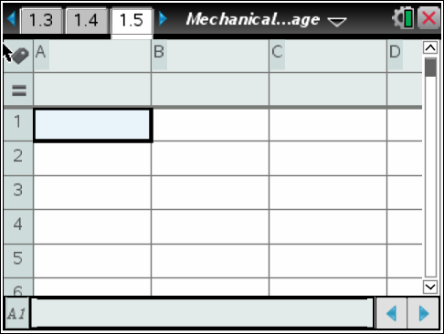
8. Define the variables hratio (Column C) and wratio (Column D). The variable hratio should be the ratio of the height of the inclined plane at each data point to the length of the ramp (which you measured in Step 2). The variable wratio should be the ratio of each measured force value to the weight of the cart. | 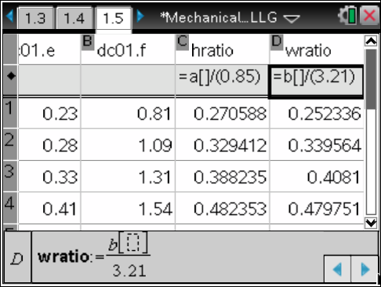
Move to page 1.6.  9. Page 1.6 contains an empty Data & Statistics application. Make a plot of hratio vs. wratio. | 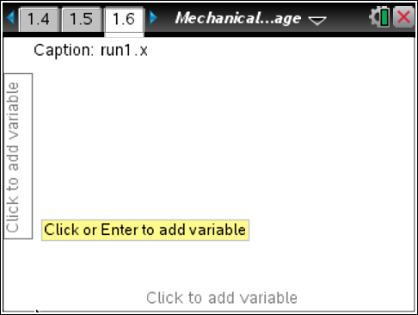
Move to page 1.7. Answer the following question here or in the .tns file.
Q1. What does the shape of the graph of hratio vs. wratio imply about the relationship between the height of an inclined plane and the amount of force required to move an object up the plane?

Move to pages 1.8 and 1.9.  10. Page 1.8 introduces the inclined plane simulation on page 1.9. In the simulation, the weight of the box, B, is 3 N. You can drag point B up the incline, drag point A to change the slope, or drag point C to change the height of the plane. The effort force (W), resistance force (Fi), and mechanical advantage (MA1) are given in the simulation. Vary the height and slope of the inclined plane and observe the effects on the mechanical advantage. | 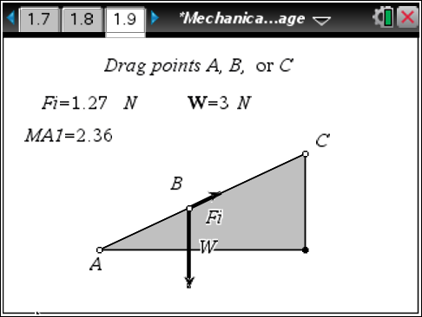
Move to pages 1.10 and 1.11. Answer the following questions here or in the .tns file.
Q2. How can you increase the mechanical advantage of the inclined plane?

Q3. What is the formula for calculating the mechanical advantage of this inclined plane?

Q4. Verify the formula you figured out in Question 3 using the simulation on page 1.8.

Move to pages 1.12 and 1.13.  11. Read the introduction on page 1.12 and move to the simulation on page 1.13. Page 1.13 shows a first-class lever. Change the position of the fulcrum and observe the effect of the fulcrum position on the effort force, Fl. The weight of the box is mg = 3N.  Vary the position of the fulcrum and observe the effects on the mechanical advantage (MA2). | 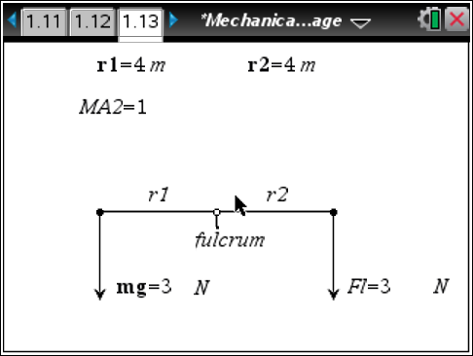
Move to pages 1.14 and 1.15. Answer the following questions here or in the .tns file.
Q5. How can you increase the mechanical advantage of the lever?

Q6. What is the formula for calculating the mechanical advantage of this lever?

Q7. Verify the formula you figured out in Question 6 using the simulation on page 1.13.

Problem 2: Another formula for the mechanical advantage of an inclined plane
Move to pages 2.1 – 2.5.  12. Read the text on page 2.1. Then use the simulation on page 2.4 to answer questions 8 to 10. Write your answers here or in the .tns file. Use the blank calculator on page 2.6 to answer Question 10. | 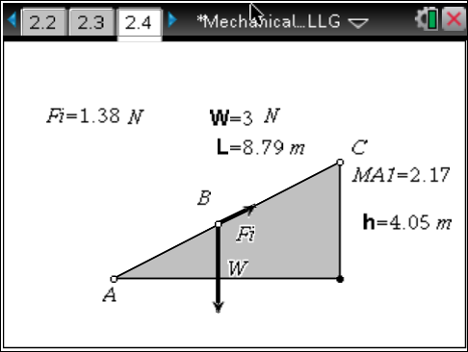
Q8. Derive a formula for the mechanical advantage of an inclined plane that involves only the height (h) of the plane and the length (L) of the plane. (Hint: The amount of work done is the same whether a box is lifted to height h or moved up a plane of length L to height h.)

Q9. Test your derived formula from Question 8 using the simulation on page 2.4.

Q10. A dump truck weighing 15,000 N is at the bottom of a mountain. The height of the mountain is 100 m, and the sloped road the truck is going to drive up is 3,000 m long. What is the mechanical advantage of the road? How much effort force is needed to push the dump truck up the mountain?

Problem 3: Another formula for the mechanical advantage of a first-class lever
Move to pages 3.1 – 3.4. Answer the following questions here or in the .tns file.
13. Use the simulation on page 3.3 to answer questions 11 – 13.  A blank calculator application is provided on page 3.5 to show your work. | 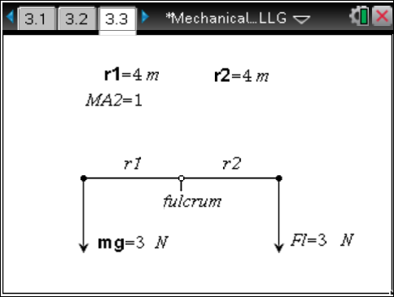
Q11. Derive a formula for the mechanical advantage of a first-class lever in terms of the lengths of the two arms of the lever, r1 and r2. (Hint: The torques created by both forces, effort and resistance, are equal.)

Q12. Test your derived formula from Question 11 using the simulation on page 3.3.

Q13. A student uses a lever to lift a 20 kg box. The distance between the fulcrum and the point at which the student grabs the lever is 0.5 m. If the student applies a force of 50 N to the lever, how far is the box from the fulcrum? What is the mechanical advantage of this lever?

