Open the TI-Nspire document Solving_Systems_by_Graphing.tns.  In this activity, you will explore moving a point to illustrate solving systems of linear equations graphically. | 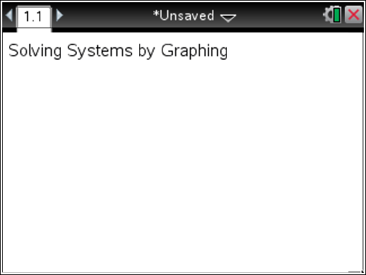

Move to page 1.2.

Questions 1–3 refer to the system of equations graphed in the TI-Nspire document:
f1(x) = x + 1
f2(x) = -x + 3

Move the point that is on the x-axis to the left or right as needed.

- Move the point so that x = -2 in both sets of coordinates. Is either of these ordered pairs a solution to the given system of equations? Justify your answer.

- Move the point so that x = 3 in both sets of coordinates. Is either of these ordered pairs a solution to the given system of equations? Justify your answer.

- What is the solution to the system pictured? Explain how you know.

- Jean told the class that she knew of another system that had the same solution as the system pictured in the graph. Her system is
f1(x) = x + 1
f3(x) = 4x – 2
Bryan argued that he thought that the system with the same solution as the system pictured in the graph was the following:
f2(x) = -x + 3
f4(x) = 2x
Who is right? Explain your reasoning.

- Find the solution to the following system graphically. Show the necessary work to check the solution.
f1(x) = x + 1
f2(x) = -x – 3

- Find the solution to the following system graphically. Show the necessary work to check the solution.
f1(x) = -x + 3
f2(x) = -x – 3

- How does the solution to the system in problem 6 compare to the solution of the system in the previous problems? Justify your answer.

