Open the TI-Nspire document Critical_Points.tns.  A function f has a critical point at c if  - the value c is in the domain of the function f (in other words, f(c) is defined) and  - either f′(c) = 0 or f′(c) is undefined.  A function has a local maximum at c if f(c) ≥ f(x) when x is near c (that is, if f(c) ≥ f(x) for all x in some open interval containing c). Similarly, f has a local minimum at c if f(c) ≤ f(x) when x is near c (if f(c) ≤ f(x) for all x in some open interval containing c).  In this activity, you will see several different examples of critical points and local extrema (maxima or minima). | 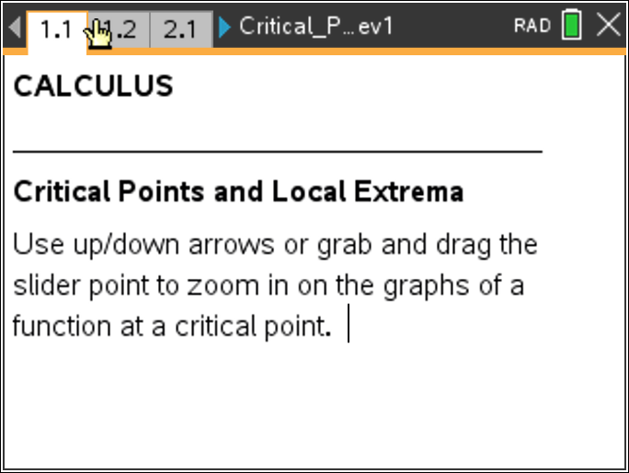

Move to page 1.2.

1. The graph of the differentiable function shown in the left window has a box centered around the point (1, 2). Drag the point on the line segment at the top to see a “zoomed in” view of this boxed area of the graph in the right window.

a. This function has a local minimum at x = 1. Using the graph and the definition of local minimum above, explain why.

b. What appears to happen to the graph as you zoom in on the point (1, 2)?

c. What is f′(1)? Explain your answer. Why is c = 1 a critical point of f?

Move to page 2.1.

2. This is the graph of a function having a local maximum at x = –2.

a. What appears to happen to the graph as you zoom in on the point (–2, 1)?

b. What is the value of f′(–2)? Explain your answer. Why is c = –2 a critical point of f?

c. What value could the derivative of a function have at the location of a local maximum or minimum? Explain your answer.

Move to page 3.1.

3. This is the graph of a function having a local minimum at x = –1.

a. What happens to the graph as you zoom in on the point (–1, –2)?

b. Assuming this behavior persists no matter how far you zoom in, is this function differentiable at
x = –1? Why or why not?

Move to page 4.1.
4. The graph of this increasing function has a horizontal tangent at the point x = 2.

a. Is x = 2 a critical point? Why or why not?

b. Does f have either a local minimum or local maximum at x = 2?

Move to page 5.1.

5. The graph of this increasing function has a vertical tangent at the point x = –2.

a. Is x = –2 a critical point? Why or why not?

b. Does f have either a local minimum or local maximum at x = –2?

c. Does this contradict the statement you made in question 3d? Explain why or why not.

