Open the TI-Nspire™ document Probability_Distributions.tns.  Some people prefer one color jellybean and search for bags with a higher number of jellybeans in that color. In this activity, you will explore the probability of getting a jellybean of a certain color when you randomly draw jellybeans from a bag. | 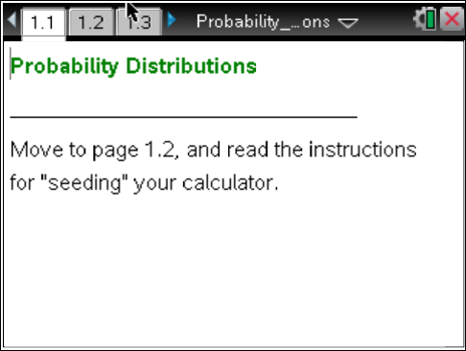

Move to page 1.2.  Read the instructions to seed your calculator prior to beginning the lesson. | Press / ¢ and / ¡ to navigate through the lesson.
Move to page 2.1.

1. Each click of the arrow on page 2.1 will draw a jellybean from a bag of jellybeans and plot the jellybeans by their color.
- Draw until you have ten jellybeans. How many jellybean colors do you think are in the bag? Explain your reasoning.

b. Predict the number of each jellybean color you will have if you draw 10 more jellybeans and add them to the distribution.

c. Draw the next 10 jellybeans. Were you surprised by the resulting distribution? Explain why or why not.

Move to page 3.1.

The arrow will count the jellybeans in sets of five and show a bar graph of the number of jellybean colors as sets of five are added to the total. (Note that moving the cursor over each bar provides information about the number of jellybeans represented by the bar.)

2. Click the arrow until you have generated a distribution that has 50 jellybeans.
a. Make a rough sketch of the distribution you generated, and describe its characteristics.

b. What is the percentage of each jellybean color in your distribution? Which color jellybean seems to be the most likely to draw?

c. Continue clicking the arrows to generate a distribution that has 100 jellybeans. Sketch the distribution, and describe how it changed from your sketch in part a.

Move to page 4.1.

The set of all possible outcomes from a chance experiment is called the sample space for that experiment. Here, the sample space contains the colors blue, green, orange, red, and yellow, but they are not equally likely to occur, as was evident from Questions 2 and 3.

3. The bottom graph represents the distribution of the number of each jellybean color in the bag.
a. If you draw a jellybean from the bag, what is the probability of getting a jellybean of each color?

b. How does the distribution you generated and sketched in Question 3 part c compare to the actual population distribution of colors?

c. Click the arrow to generate a distribution in the upper plot that has 50 sample elements. Describe what is happening to the distribution of the colors as the number of jellybeans increases.

Move to page 5.1.

4. a. Draw 10 jellybeans, and enter the observed relative frequency of getting each jellybean color in the first row of the table. (Note: Each trial should consist of exactly 10 jellybeans.) Use the reset arrow to clear that set of ten jellybeans and draw a new set of ten jellybeans. Record the relative frequency of each color in the table. Repeat this process to fill in all five rows of the table.

Outcome/Run | blue | green | orange | red | yellow
First Trial
Second Trial
Third Trial
Fourth Trial
Fifth Trial

b. Based on your results in the table, do you think this is the same bag of jellybeans used on page 4.1? Why or why not?

Move to page 6.1.

In the previous problems, you dealt with a sample space having five separate possible colors of jellybeans, with probabilities ranging from 0.1 to 0.4. The next questions focus only on one color.
5. Draw four jellybeans.
a. Make a sketch of the plot, describe what occurs, and interpret its meaning.

b. Interpret the results in terms of the probability of obtaining that jellybean color after each sample.

c. Continue to draw more jellybeans. If the jellybeans are drawn from the original bag used in questions 1 to 4, what jellybean color do you think you are counting? Explain how you know.

