Open the TI-Nspire document Graphical_Analysis.tns.  Have you ever wondered why graphs differ from each other? What does it mean if a graph is linear? Why are other graphs curved upward or downward? We’ll explore this through a simulation in this activity. | 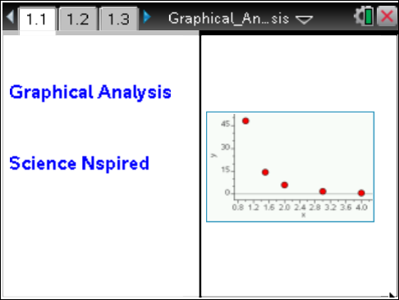

Move to pages 1.2–1.6. |  |  |  | Press / ¢ and / ¡ to navigate through the lesson.
1. Read the introduction on pages 1.2–1.6. In many laboratory investigations, finding a mathematical relationship between two variables can help explain a situation. An example may be the relationship between the volume of a gas and the pressure it exerts, or the volume and the temperature. One method for determining mathematical relationships is to make a graph of the data. A mathematical model (in the form of an equation) is then found to match the graph. A graph and its corresponding equation can also be used to make predictions about data.
In this lesson, you will investigate linear, quadratic, and inverse functions. You will analyze the data to decide whether it is linear or curved. If data is curved, you will linearize it, and the method you use to linearize will help to determine which model best fits.
If the data appear curved, the relationship may be quadratic or inverse. It may also have another non-linear relationship. To determine if it is quadratic, calculate the square of the x value and graph the y value vs. x². (This will linearize the data). If the data points then form a line, the model for the original data is quadratic. This means that the equation for the original x and y would be y = k • x².
If the data is inverse, it will be curved. To determine if the data is an inverse relationship, calculate the reciprocal of x (1/x). Graph the y value vs. the (1/x). If this relationship is linear, the original data is inversely related. This means that the equation for the original x and y would be y = k • x^{–1}.
Move to pages 1.7–1.9. Answer the following questions here or in the .tns file.
Q1. The expression x^{–1} is equal to ______.
A. 1/x  B. –x |  | C. –1x  D. 1/–x
Q2. How do quadratic and linear equations differ? (List all that apply.)
A. They create graphs with different slopes.  B. The exponent value of X is different. |  | C. One curves and the other doesn't.  D. One has a negative exponent, the other doesn't.
Q3. What does it mean to linearize data?

Move to pages 1.10–1.14.
Read the introduction and materials list on pages 1.10–1.12.
Then complete the graphical analysis on pages 1.13 and 1.14.
Example 1
2. In this first example, four ordered pairs of data are given on the List and Spreadsheets table on page 1.13. See the one shown to the right.
3. Your data should look like the Data and Statistics graph shown on page 1.14 and to the right.
Because the data points all lie in a line, the exponent n for
y = k • x^{n} will be 1. The graph is therefore linear.
The slope of the line is 3 and the y-intercept is zero.
Move to pages 2.1–2.3.  Example 2  4. Read the introduction on page 2.1 and move to 2.2. In this second example on page 2.2, four ordered pairs of data are given on the List and Spreadsheets table. |  |  |  | 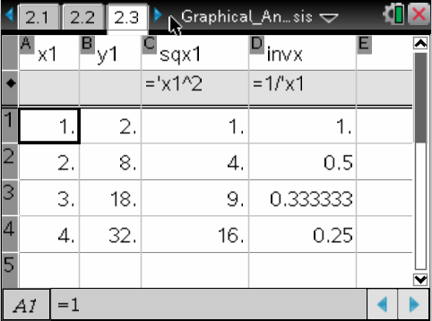
5. The data are graphed on the Data and Statistics graph on page 2.3, like the one shown to the right. The data are not randomly distributed about the line. The graph curves upward, so the relationship is not linear. |  |  |  | 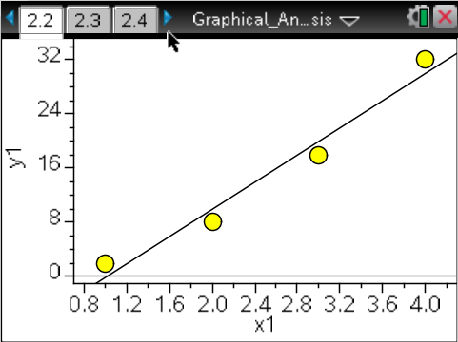
Move to pages 2.4 and 2.5.
6. Read the introduction on page 2.4 and move to page 2.5. On page 2.5, follow directions and move back to the graph on page 2.2 to see if it is quadratic. Graph y vs. the square of x, x². See the Lists and Spreadsheet table on page 2.3
7. To see the graph of y vs. x², move the cursor to the x-axis label on the Data and Statistics graph on page 2.3 and choose sqx. The graph is now linear, indicating that the relationship is linear for y vs. x².
Move to pages 3.1–3.4.  Example 3  8. Read the information on pages 3.1–3.4. There are five ordered pairs of data on the List and Spreadsheets table on page 3.4 The data is graphed on the Data and Statistics graph on page 3.2. The graph curves downward. The decrease is rapid at first, then begins to level off. |  |  |  | 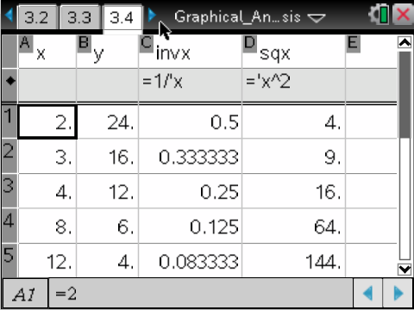
9. The relationship may be an inverse proportion. To check whether it is, click on the x-axis label on the Data and Statistics graph, and choose invx.  The graph should now appear linear, indicating that y vs. 1/x is linear. Therefore, the exponent n of x is –1. |  |  |  | 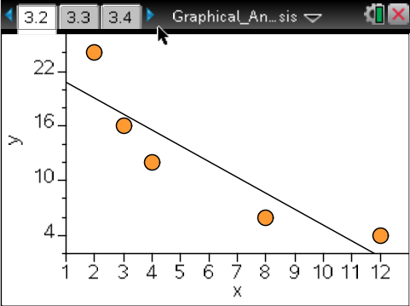
Move to pages 4.1–4.7.  Example 4  10. Read the information and follow the directions on these pages. In this example, there are five ordered pairs of data on the List and Spreadsheets table on page 4.3. The data is graphed on the Data and Statistics graph on page 4.7. The graph curves downward. The relationship is not linear. It may be inverse, quadratic or a combination. |  |  |  | 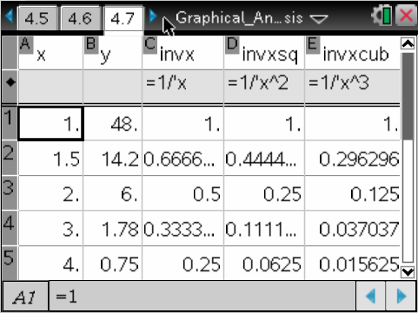
11. It appears to be an inverse proportion. To confirm this, click on the x-axis label on the Data and Statistics graph and choose invx. The graph is still curved. Therefore, the exponent n of x  is not –1.  12. Click on the x-axis label of the Data and Statistics graph and choose invxsq. The graph is still not linear since the regression line does not pass through each of the points. Therefore, the exponent n of x is not –2. |  |  |  | 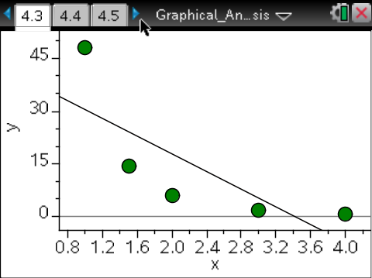
13. Next, click on the x-axis label of the Data and Statistics graph and choose invxcub. The graph is now linear. Therefore, the exponent n of x is –3.
Move to page 4.8. Answer the following question here or in the .tns file.
Q4. As the graph was changed from x to the inverse of x to the inverse of x², and finally to the inverse of x³, how did the alignment of the data points change in relation to the regression line?

Move to pages 5.1–5.3.  14. Your instructor will assign you three problem sets. Enter the problem sets into the x and y columns of the Lists and Spreadsheet table on page 5.2 for Questions 5, 6, and 7.  15. Graph your data on the Data and Statistics graph on page 5.3. Determine the value of the exponent n for each data set. |  |  |  | 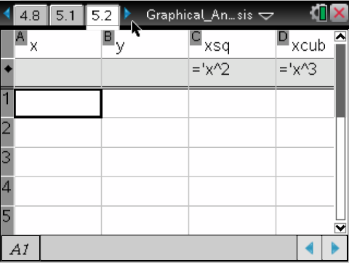
Move to page 5.4. Answer the following question here or in the .tns file.
Q5. The value of the exponent (n) for the first data set is ______.

Move to pages 5.5 and 5.6.  16. Read the information on page 5.5. The equations from this exercise fit the equation y = k • x^{n}. Write your equation for Question 6 in this form substituting in the value of n that you determined for the data set.  17. Isolate k from this equation. Page 5.6 is a calculator page. Choose an ordered pair (x, y) and solve for k. Repeat for a second ordered pair. The two values of k MUST be equal  (or very close). |  |  |  | 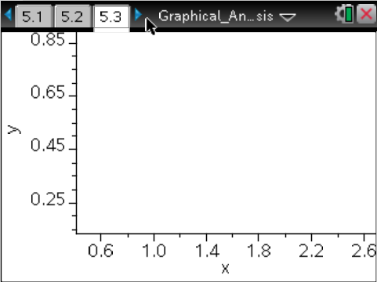
Move to page 5.7. Answer the following question here or in the .tns file.
Q6. What is true of the value of k that was calculated for the two ordered pairs?

Move to pages 6.1 and 6.2.  18. In the space below:  a. show the equation solved for k  k = ______________  b. give the two values of k that you solved  k = ______ & ______  c. write the original equation with the value of k substituted  into the equation  y = ______________  19. Repeat the steps from Question 6 for your second data set. |  |  |  | 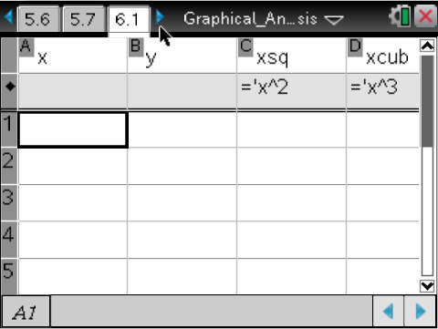
Move to page 6.3. Answer the following question here or in the .tns file.
Q7. The value of the exponent (n) for the second data set is ______.

Move to page 6. 4 and 6.5. Answer the following question here or in the .tns file.
Q8. What is true of the value of k that was calculated for the two ordered pairs?

a. show the equation solved for k
k = ______________
b. give the two values of k that you solved
k = ______ & ______
c. write the original equation with the value of k substituted
into the equation
y = ______________
20. Repeat the steps from Question 5 for your third data set.
Move to page 6.6. Answer the following question here or in the .tns file.
Q9. What is true of the value of k that was calculated for the two ordered pairs?

Move to pages 7.1 and 7.2.  21. In the space below:  a. show the equation solved for k  k = ______________  b. give the two values of k that you solved  k = ______ & ______  c. write the original equation with the value of k substituted  into the equation  y = ______________  22. Repeat the steps from Question 5 for your third data set. |  |  |  | 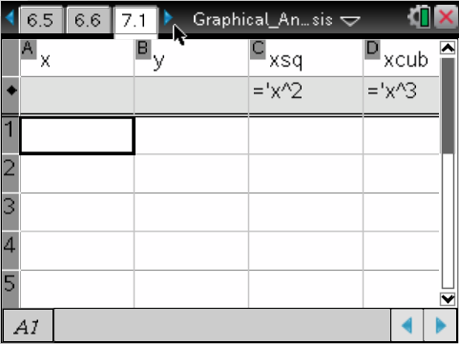
Move to page 7.3. Answer the following question here or in the .tns file.
Q10. The value of the exponent (n) for the third data set is ______.

Move to pages 7.4 and 7.5.
23. Write your equation for Question 5 in this form substituting in the value of n that you determined for the data set. Isolate k from this equation. Use page 7.5 as a calculator page. Choose an ordered pair and solve for k. Repeat for a second ordered pair.
Move to page 7.6. Answer the following question here or in the .tns file.
Q11. What is true of the value of k that was calculated for the two ordered pairs?

Move to pages 8.1–8.10. Answer the following questions here or in the .tns file.
Q12. When a graph of y vs. x is linear, the value of the exponent (n) is ______.
A. 1  B. 2 | C. 3  D. –1 |  | E. –2
Q13. When the graph of y vs. x curves upward, the value of n must be ______.
A. = 1  B. < 1 |  | C. > 1  D. = 0
Q14. When the graph of y vs. x decreases rapidly and then levels off, the value of n must be ______.
A. = 1  B. < 0 |  | C. > 0  D. = 0
Q15. When the value of n = 2, the equation for the relationship is ______.
A. y = 1/x²  B. y = 2x |  | C. y = ½ x  D. y = x²
Q16. When the value of n = –1, the graph is said to be ________.
A. linear  B. inverse |  | C. exponential  D. logarithmic
Q17. When the value of n is 1, the graph is ________.
A. linear  B. inverse |  | C. exponential  D. logarithmic
Q18. When the value of x is 2 and y is 8, the equation would be y = ______.
A. x  B. x^{–2} | C. x²  D. x³ |  | E. x^{–3}
Q19. When the value of x is greater than 1, the graph is said to be ________.
A. linear  B. inverse |  | C. exponential  D. logarithmic
Q20. If the equation for a relationship between x and y were y = x⁰, the graph would be ________.
A. curved upward  B. curved downward |  | C. vertical line  D. horizontal line
Q21. If a graph curves downward, first try ________ the value of x and regraphing the data to make the graph linear.
A. squaring  B. cubing |  | C. the inverse of  D. the logarithm of

