Open the TI-Nspire document Sum_of_Exterior_Angles_of_Polygons.tns.  An exterior angle of a polygon is an angle formed by any side of a polygon and the extension of either of its adjacent sides. In this activity you will be exploring the sum of the measures of the exterior angles of polygons. | 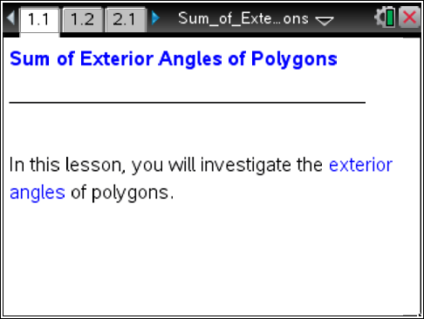

Move to page 1.2.

1. The figure on page 1.2 is a regular pentagon.

a. Move the arrow by dragging point T along the side of the pentagon. What appears when the arrow reaches the vertex?

b. Make a conjecture about the number of degrees needed to rotate the arrow for it to line up with the next side of the pentagon. What mathematical relationship between the exterior and interior angles could help you determine the number of degrees to rotate the arrow?

c. Press d. Test your conjecture by grabbing point T and rotating the arrow so that it "snaps" to the next side. What do you notice about the sum of the exterior angle and the adjacent interior angle?

Tech Tip: To release point T, tap the white space outside of the polygon.
Notice the words “Exterior Angle Sum” and the arrow below them. Before you rotated the arrow, the sum was 0 and the arrow was pointing horizontally to the right.
d. Press d. Move point T to the next vertex and complete the needed rotation for the arrow to line up with the next side of the polygon. Explain the new exterior angle sum.

e. Repeat steps a–d to continue moving and rotating the arrow until the message “You’re done!” appears on the screen. How does the Exterior Angle Sum relate to the arrow’s movement around the pentagon?

Move to page 2.1

2. The figure on page 2.1 is an irregular hexagon.
a. Find the final exterior angle sum for the irregular hexagon. Before you begin, do you think the final exterior angle sum for the irregular hexagon will be the same as it was for the regular pentagon? Why or why not?

b. At each vertex, explain how you can determine the number of degrees needed to rotate the arrow for it to line up with the next side.

c. Continue moving the arrow until the message “You’re done!” appears on the screen. Observe the final exterior angle sum. How do the results compare to your expectations in part 2a?

d. Based on your findings, what do you think is true for the exterior angle sum of any regular or irregular polygon?

Move to page 3.1.

3. On page 3.1, there is a polygon with an exterior angle at each vertex.
a. Drag point P. What do you observe about the exterior angles as the polygon changes size?

- Drag point P so that the polygon shrinks to a point. What do you observe about the exterior angles?

c. Do some more experiments by moving point P. Click the up and down arrows at the top of the screen to change the number of sides of the polygon. Drag the open circle at the bottom of the screen to change the polygon from regular to irregular. What do you observe about the exterior angles?

d. Based on your findings, what is the sum of the measures of the exterior angles of any polygon?

e. What is the sum of the exterior angles of a dodecagon (12-sided polygon)?

4. a. If you know the sum of the exterior angles of any regular n-gon, what formula could you use to determine the measure of one of its exterior angles?

b. If you know the measure of an exterior angle of a regular n-gon, what formula could you use to determine the measure of one of its interior angles?

c. How does the formula in part 4b relate to a common formula that is given for the measure of the interior angle of a regular n-gon?

