Open the TI-Nspire document DC_Motors.tns.  In this investigation you will explore a DC motor in a TI-Nspire simulation. Initially, you will explore the parts of the motor. Then you will adjust the power supply of the motor to cause the rotor to spin in different directions and at different speeds. In the second simulation, you will change the strength of an electromagnet to increase or decrease the speed of the rotor. |  |  |  |  |  | 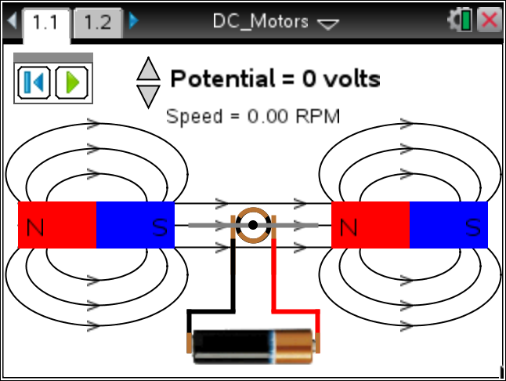
As you explore the motor you will examine the relationship between the voltage of the power supply and the speed of the rotor. A DC motor is a collection of parts connected in such a way as to have a spinning rotor that will then be used to do work.
Part 1: Exploring the DC Motor
1. Read the directions explaining how to use the simulation. Close the pop-up box when you are finished. Press b if you need to view the directions again.  2. Explore the hot spots, or different parts, of the motor shown in the simulation. Move the cursor over the page and click when you see the magnifying glass icon . |  |  |  |  |  | 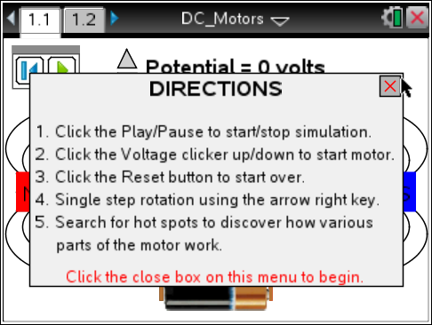
Q1. In the simulation, there are three motor parts indicated by hot spots. On each set of lines below, do the following:  - On the top line, write a part of a motor that you observed in the simulation.  - Then, write a description of the motor part in your own words.  - Draw an arrow from each motor part you listed to its location on the screenshot. |  |  |  |  |  | 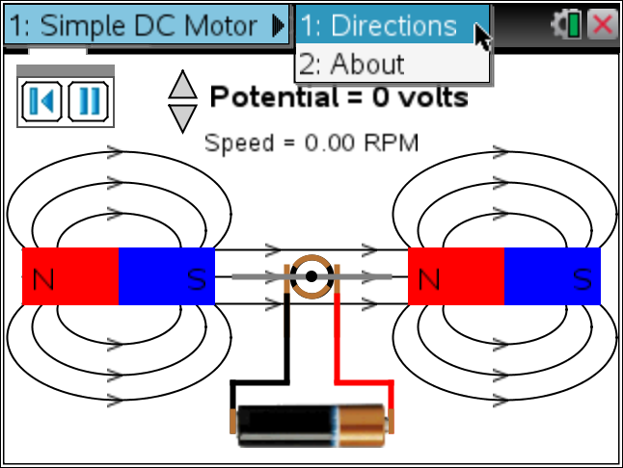
__________________________  __________________________  __________________________  ____________________________________________________  __________________________  __________________________  ____________________________________________________  __________________________ |  | 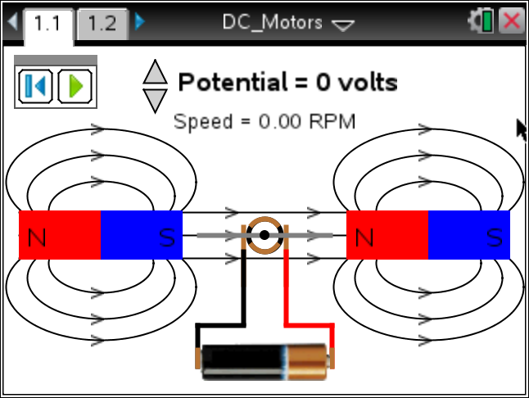 |  | __________________________  __________________________  __________________________  ____________________________________________________
3. Press the play button and use the up and down arrows £¤ to change the potential, or number of volts of the battery. Observe the simulation.  To pause the simulation, press . To reset, press . |  |  |  |  |  | 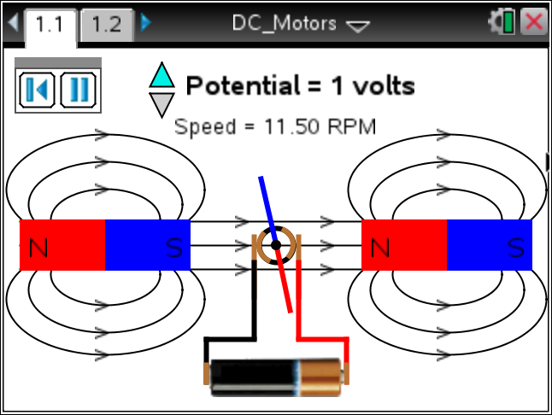
Q2. What do you observe in this simulation? Write your answer and share this with a neighboring student and the class as requested.

4. This motor is using a power supply to start a rotor rotating and then using the moving rotor in a magnetic field to do work. Answer questions 3–5 based on your observations. Adjust the motor simulation as needed to answer the questions.

Q3. What is RPM and what makes the value increase?

Q4. How can you change the direction of the spin of the rotor?

Q5. As you play the simulation, watch the colors on the rotor. What happens when blue meets blue? What happens when blue meets red? Why is this interaction important in a motor?
5. Now let’s explore the quantifiable relationship between the voltage of the potential and the speed of the rotor.

Q6. Use the simulation to fill in the missing values in the table below:
 | Potential |  | Speed
 | –8 volts
 |  |  | –80.50 RPM
 | –3 volts
 |  |  | 23.00 RPM
 | 5 volts
 |  |  | 126.50 RPM
Q7. How would you describe the relationship between the potential provided to a motor and the speed at which it runs?

Part 2: Windings and the Motor
Move to page 1.2.
This simulation contains a different set up for the motor. In this case, there are wires wrapped around a piece of metal to create an electromagnet. A spinning magnet produces an electric current and a flow of electricity produces a magnetic field. This is called electromagnetic induction and is an important concept that is used in many different parts of our lives.

6. Read the directions box and then close the pop-up menu when you are finished by clicking in the upper right corner.  7. This simulation has one hot spot. Move the cursor over the page and click when you see the magnifying glass icon . |  |  |  |  | 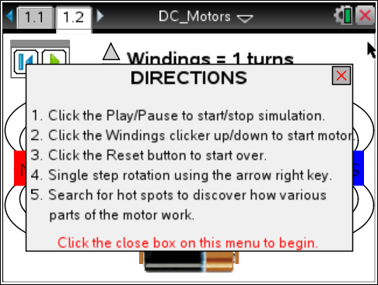
Q8. a. What is the name of the motor part?  b. Write a description of the motor part in your own words.  c. Draw an arrow to the motor part’s location on the screenshot. |  |  |  |  | 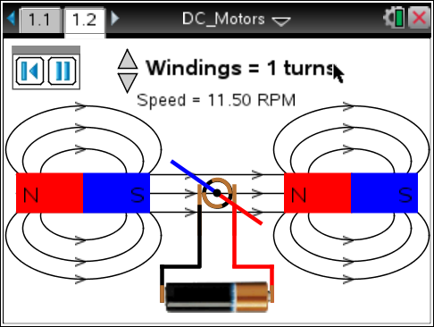
8. Press the play button , use the up and down arrows £¤ to adjust the Windings, or number of turns, and observe the simulation. To pause the simulation press . To reset, press .

Q9. Describe what you observe as you experiment with the motor on this page. Write your answer and share this with a neighboring student and the class as requested.

Q10. Explore the simulation by increasing the windings. Note what happens to the speed each time you increase the number of turns. Use what you’ve learned from the simulation to calculate how many turns would be required to get a speed of 632.50 RPM.

