Open or create the TI-Nspire document Tessellations_with_Regular_Polygons.tns.  In this activity, you will explore some regular polygons to see which of these will tessellate in the plane. You will use your observations to answer the question, “Which regular polygons will tessellate in the plane and why?” | 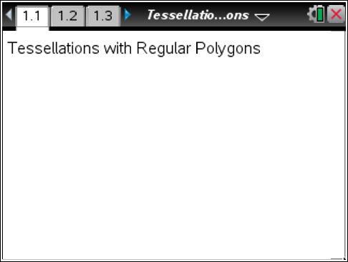

Move to page 1.2. | Press / ¢ and / ¡ to navigate through the lesson.
Part 1 – Tessellating a regular polygon  Definitions: A tessellation is a covering, or tiling, of a plane with a pattern of figures so there are no overlaps or gaps. A monohedral tessellation is a tessellation made up of congruent copies of one figure.  A regular polygon is a polygon with equal sides and equal interior angles. An equilateral triangle and a square are both examples of regular polygons. | 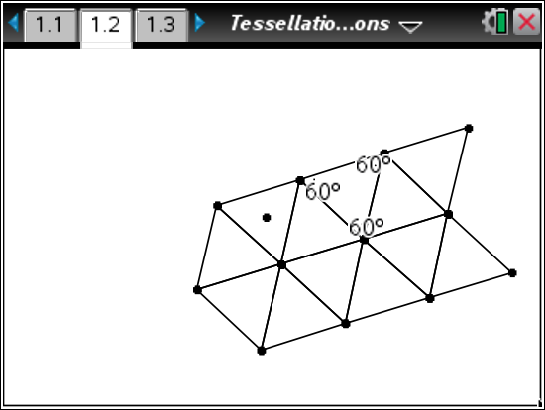
The equilateral triangle in the center has been tessellated in the plane.
1. What is the measure of each interior angle of the triangle?

2. How many angles come together at one vertex of the tessellation?

3. What is the sum of the measures of the angles at one vertex of tessellation?

Move to page 1.3.

4. What type of regular polygon is shown?

5. What is the measure of each interior angle of the polygon?
Step 1: Press Menu > Transformation > Reflection to select the Reflection tool from the Transformation menu.
Step 2: Move the pointer to a side (not a vertex) of the square, and press x twice. (The first click selects the entire regular polygon as the pre-image for the reflection. The second click selects the side of the polygon as the line of reflection.)
Step 3: The Reflection tool is still active. Continue clicking twice on any side of the original square or on any side of a reflected image.
Step 4: Press d to exit the Reflection tool.
6. Does the square tessellate?

7. How many angles come together at one vertex of the tessellation?

8. What is the sum of the measures of the angles at one vertex of tessellation?

Move to page 1.4.

9. What type of regular polygon is shown?

10. What is the measure of each interior angle of the polygon?

11. Repeat Steps 1–4 above to help you answer the question, “Does the polygon tessellate?”

12. How many angles come together at one vertex?

13. What is the sum of the measures of the angles at one vertex?

Move to page 1.5.

14. What type of regular polygon is shown?

15. What is the measure of each interior angle of the polygon?

16. Do you think that the polygon will tessellate? Why or why not?

17. Repeat Steps 1–4 to test your conjecture in question 16.

Move to page 1.6.

18. What type of regular polygon is shown?

19. Do you think that the polygon will tessellate? Why or why not?

20. Repeat Steps 1–4 to test your conjecture in question 19.

Move to page 1.7.

21. What type of regular polygon is shown?

22. Do you think that the polygon will tessellate? Why or why not?

23. Repeat Steps 1–4 to test your conjecture in question 22.

24. Use the table to organize the information that you have observed. The table can be used to help you generalize and make a conjecture about monohedral tessellations of regular polygons.

Regular Polygon | Measure  of Interior Angle | Does the polygon tessellate? | If the polygon tessellates, what is the sum of the measures at a tessellation vertex?
Triangle
Square
Pentagon
Hexagon
Heptagon
Octagon

25. For the polygons that tessellate, what do you observe about the sum of the measures of the angles at a tessellation vertex? State this observation as a conjecture.

Part 2 – Dihedral tessellations  26. The figure at the right shows a dihedral tessellation—a tessellation using congruent copies of two different shapes.  a. What two shapes are used for the tessellation shown? | 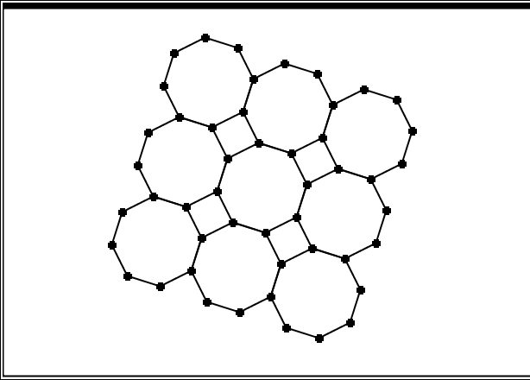
b. Does this new tessellation follow the same rules you discovered in the first part of the activity for monohedral tessellations? In what way?

