Open the TI-Nspire document Completing_the_Square.tns.  This activity lets you build perfect square quadratics with lead coefficient 1 using algebra tiles. This geometric model will be used to verify the algebraic expression. | 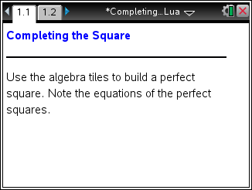
Move to page 1.2. | Press / ¢ and / ¡ to navigate through the lesson.
1. Build perfect square quadratics with lead coefficient 1 by dragging the algebra tiles to the middle window. Record the perfect squares found. Click (R)eset to start over to find a new perfect square.
Side of Square | Perfect Square Quadratic | Coefficient of x-term | Constant Term

2. What patterns do you notice for all perfect squares?

a. What relationship exists between the side of the square and the coefficient of the x-term?

b. What relationship exists between the side of the square and the constant term?

c. What relationship exists between the coefficient of the x-term and the constant term?

d. Why is this called “completing the square”?

3. Expand the following:
a. (x)(x)

b. (x + 1)(x + 1)

c. (x + 2)(x + 2)

d. (x + 3)(x + 3)

e. (x + n)(x + n)

4. Use either method to find (x + 5)².

5. State whether the following are perfect square quadratics. Explain why or why not.
a. x² + 3x + 9

b. x² + 14x + 49

c. x² + 24x + 144

d. x² + 6x + 36

6. Fill in the missing terms to make the following perfect square quadratics.
a. x² + 16x + _____

b. x² + _____ + 81

c. x² + 22x + _____

d. x² + _____ + 100

e. x² + 3x + _____

7. In your own words, explain how to “complete the square” algebraically.

8. Expand the following:
a. (x)(x)

b. (x – 1)(x – 1)

c. (x – 2)(x – 2)

d. (x – 3)(x – 3)

e. (x – n)(x – n)

9. Do the negative values in question 8 change the pattern of perfect square quadratics? Explain.

10. Fill in the missing terms to make the following perfect square quadratics.
a. x² – _____ + 289

b. x² – 26x + _____

c. x² – 36x + _____

d. x² – _____ + 225

e. x² – 5x + _____

