Open the TI-Nspire document What_Makes_a_Planet.tns  How much do you know about objects in the solar system? Do you know the difference between an asteroid, moon, and planet? In this simulation, you will analyze the characteristics of various objects in the solar system and discover relationships between them.. |  | 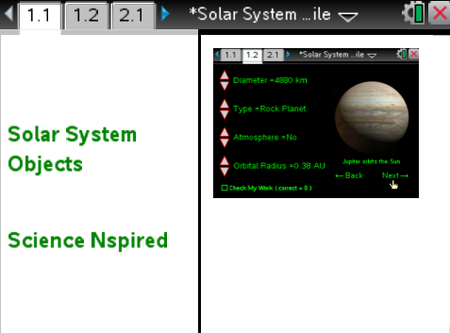
Move to pages 1.2 - 1.3 and read the background information for this activity.
Objects in space are known as celestial bodies. These include objects such as planets, moons, and asteroids. Scientists use a variety of characteristics to analyze and classify a celestial body. One characteristic of a celestial body is its orbital radius. This is the distance an object is from its orbiting body. Planets in our solar system orbit around the Sun, so the orbital radius for each planet is its distance from the Sun. Orbital radius can be measured in units of kilometers or AU (Astronomical Units). Earth has an orbital radius of 1 AU. This means that Earth, is approximately 1 AU, or 150 million kilometers, away from the Sun on average. Other characteristics of celestial bodies include the diameter of the body, the shape of the body, and whether or not the body has an atmosphere around it.

The IAU (International Astronomical Union) has developed rules that determine whether or not a body can be classified as a planet. According to the IAU, a planet must orbit a star. Also, a planet must have so much mass that it takes the shape of a sphere. To explain this, recall that gravity is a force that is related to the mass of an object. When a celestial body has a large amount of mass, the force of gravity associated with that mass pulls the body into a spherical shape. Finally, a planet must have a clear orbital zone. This means that there are no other objects of a similar size in the orbitting path of the planet that might alter the orbit of the planet.

Move to pages 1.4 – 1.5. Answer questions 1 - 2 below and/or on your device.
Q1. The "orbital radius" of an object represents what?

A. the average distance from any two points of an objects orbit
B. the distance between a planet and its closest moon
C. the revolution period of any celestial body
D. the distance between an object and its orbiting body

Q2. The IAU (International Astronomical Union) has developed rules in order for a celestial body to gain planetary status. Which of the following are these rules? (Select all that apply)

A. orbits a star
B. has sufficient mass to assume a round shape under its own gravity
C. has an atmosphere
D. has at least one moon
E. has a cleared orbital zone

Move to page 1.6.
Read the directions for the simulation.
1. You will see an image of a celestial body as well as text stating the object around which the body orbits. Select the up and down arrows (¤ and £) on the left of the screen to change the values for diameter, object type, atmosphere, and orbital radius.  2. Once you think you have selected the correct values for the celestial body, select the Check My Work box on the lower left hand corner of the screen. If all of the values are correct, a happy alien face will appear.  3. If some of the values are incorrect, deselect the Check My Work box and modify the remaining incorrect values. When you believe you have found the correct values, select Check My Work again. Repeat this process until you see the happy alien face appear.  4. Once you obtain the correct values for a body, record the values in the table shown. Then, select Next in the lower right corner of the screen to advance to the next celestial body. | 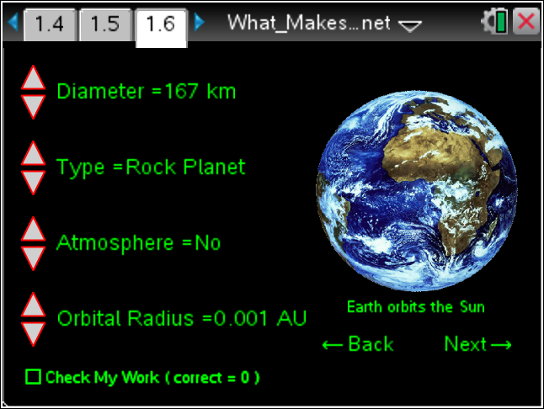
Tech Tip: To access the Directions again, select > What Makes a Planet > Directions.
Tech Tip: To access the Directions again, select b or Document Tools () > What Makes a Planet > Directions.
Celestial Body | Diameter of Object (km) | Orbital Radius (AU) | Type of Object | Atmosphere?

Move to pages 2.1 – 2.9.

After examining the data in the simulation and your data table above, answer questions 3 – 11 below and/or in your .tns file.

Q3. Which of the following is an accurate statement when you compare the gas planets to the rock planets?

A. Gas planets have a larger diameter and a smaller orbital radius.
B. Gas planets have a larger diameter and a larger orbital radius.
C. Rock planets have a larger diameter and a larger orbital radius.
D. Rock planets have a larger diameter and a smaller orbital radius.

Q4. Around which object does a moon orbit? Around which object does a planet orbit? How does the magnitude of a moon’s orbital radius compare to a planet’s orbital radius?

Q5. Which of the following reasons is the best explanation for why an asteroid is not classified as a moon?

A. An asteroid does not orbit a planet.
B. An asteroid is not spherical in shape.
C. An asteroid is not large enough in diameter to be considered a moon.
D. An asteroid does not have an atmosphere.
E. All of the above are correct reasons.

Q6. Which of the following planets do not have an atmosphere? (Select all that apply)

A. Mercury
B. Mars
C. Jupiter
D. Saturn
E. Uranus
F. All of the above planets have an atmosphere.

Q7. Is it possible for a moon to have an atmosphere?

Yes
No

Q8. Pallas has an orbital radius of 2.77 AU. Knowing this, what two planets does it orbit in-between? (___ and ___)

Q9. At one time, Pallas was a candidate for being classified as a planet. Which of the following reasons prevents Pallas from being classified as a planet?

A. Pallas does not orbit a star.
B. Pallas does not have an atmosphere.
C. Pallas does not have a moon.
D. Pallas does not have a cleared orbital zone.

Q10. Titan is spherical and larger than the planet Mercury. It also has an atmosphere. Why is Titan not considered a planet?

Q11. Using the information you gathered throughout the simulation, place the planets in order of increasing distance from the sun.

