Blood is a body part that often gets overlooked because it is made, in large part, of liquid. This liquid portion of the blood is called the plasma, while the “solid” portion is made up of the blood cells. Later, you will have an opportunity to research what the different components of the blood do for you. For now, however, you will examine the relationship between the body weight and blood volume of a human. Look at the data table below and discuss with a partner what you observe about the relationship between body weight and blood volume. | 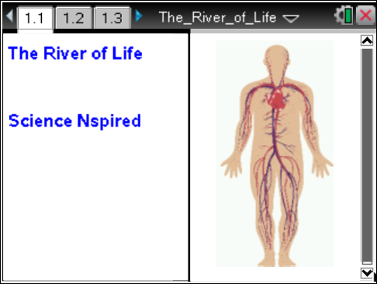

Create a new TI-Nspire™ document. | Press / ¢ and / ¡ to navigate through the lesson.
1. Add a Lists & Spreadsheets page.  2. Name Column A weight, and Column B pints.  3. In cell A1, enter the number 60, then continue to enter values in this column—adding 24 to the previous number—until you reach 300.  4. In cell B1, enter the number 5, and increase it by 2 in each succeeding cell until you have reached 25.  - The weights are in pounds, and the pints are the number of pints of blood in the human body.  - Double-check to make sure you have the same number of items in each column.
  Weight | Pints
  60 | 5
  84 | 7
  108 | 9
  132 | 11
  156 | 13
  180 | 15
  204 | 17
  228 | 19
  252 | 21
  276 | 23
  300 | 25
5. According to the data table, what is the relationship between body weight and blood volume?

- a. What is the change in weight from data point to data point?

b. Is the ΔX the same between each two consecutive x-values?

7. a. What is the change in blood volume from data point to data point?

b. Is the ΔY the same between each two consecutive y-values?

8. Now, graph the data by inserting a Data & Statistics page.
9. Select weight as the x-value and pint as the y-value.
10. Use this graph to figure out approximately how much blood YOU have in your body.
- There is more than one way to do this, so play around until you find a method that works for you.
- Hint: It might be a good idea to have a "best-fit" line on your graph.
11. Next, insert a Graphs page, graph your data again, and figure out a way to determine your blood volume using this page.
- After you have finished experimenting with weight and blood volume, move on to the questions that accompany this activity.
12. What is the significance of your answers to #10 and #11?

13. What is the formula for determining the volume of blood if you know your weight?

14. a. Using the regression model (best-fit line) you produced, estimate the volume of blood you have in your body.

b. How did you make your estimation?

15. How much blood would there be in a person who had a mass of 75 kg? Hint: there are about 2.2 pounds in one kilogram.

16. Estimate the weight in pounds of a person who has 11.5 pints of blood in his body.

17. How much blood would a 7-pound newborn baby have?

18. If this weight/blood volume relationship were true for other animals, too, how many gallons of blood would there be in a horse that had a mass of 500 kg?

19. Estimate the weight of a person who has two gallons of blood in his body.

20. If you decided to donate blood at the blood bank, you would donate one pint. Using your own weight, calculate the percentage of your blood you would be donating.

21 a. If 52% of your blood is water, what is the volume of water circulating in your blood vessels right now?

b. Which of the two main blood components contains the water?

22. Sodium is an abundant ion in the bloodstream. Normally, there are about 2400 milligrams of sodium in one liter of blood. If one liter of blood is about the same volume as two pints of blood, approximately how much sodium do you have flowing through your blood vessels right now? Express your answer in both milligrams and grams.

23. One of the most important functions of the blood is to transport oxygen to all of your cells, and the cells that take care of this for you are called erythrocytes, or red blood cells. Red blood cells are by far the most numerous cells in the blood, averaging about 4.5 x 10⁶ cells per microliter (1000 microliter = 1ml; 1000ml = 1L). How many microliters are there in one liter? Using this information, calculate the approximate number of red blood cells you have in your body right now.

24. Leukocytes, or white blood cells, are another type of blood cell in your body. Human blood contains about 7.0 x 10³ WBC's per microliter. Calculate the approximate number of leukocytes you have in your body right now.

25. White blood cells function mainly in defending you against infections. Explain why the number of white blood cells in a person’s body may tend to fluctuate a lot more than the number of red blood cells does.

