Open the TI-Nspire™ document Exploring_Depths.tns.

Sonja Sonar is an ROV (Remote Operation Vehicle) mechanical engineer and has designed an ROV that can go deep into the ocean, in search of the elusive Giant Squid thought to live deep in the Marianas trench. When she loses track of the ROV, she suspects it has become stuck under a shelf in the canyon. Sonja needs your help to free her ROV.
Move to pages 1.2 and 1.3 in TI-Nspire Document.
- Read the background information on pages 1.2 and 1.3, summarized here:
You are tasked with designing and building a hoist to raise and lower a model of a rescue ROV to free the original ROV. You will conduct a simple experiment, using the scientific method, to understand how vertical motion can be represented by a graph or by a written description. You will build a physical system (a hoist) that will be used to explore position-time graphs while practicing your writing and mathematical skills to describe the rescue ROV’s motion to another person.
Move to pages 1.4 in TI-Nspire Document.
- Analyze the Graph on Page 1.4
- What does the magnitude (size) of slope describe about the ROV’s motion?

- What does the sign (+/-) of the slope represent about the ROV’s motion?

Q1. Where is the rescue ROV at 40 minutes?
- On the surface of the ocean.
- At the meeting point of the stranded ROV.
- First encounter with giant squid.
- The deepest point where the rescue ROV discovers the stranded ROV.
- Identify: You have an engineering goal and a science research question. The engineering goal is to design and build a hoist to lower or raise a rescue ROV. You will be selecting from several objects with different radii to build your hoist. Your science research question is to understand how the vertical motion of your ROV impacts the slope and y-intercept of the position vs. time graph.
- Predict the relationship between radius of the hoist and speed at which the rescue ROV can be raised/lowered.

B) What is the impact of the motor direction on the motion of the rescue ROV?

Move to pages 2.1 - 3.4 in TI-Nspire Document.
- Research: Use the Math Review and Practice in Problems 2 & 3 to learn about position, change in position, and velocity in preparation to solving your engineering problem.
Answer the questions below:
One page 3.2, click to add the variables on the x (time) and y (position) axis.

Analyze the data in the graph with a moveable line (Menu > Analyze > Add Moveable Line).
Practice: Match the moveable line with data and record the slope and y-intercept.

Record the slope and y-intercept: _________________________________
Q2. Calculate the change in position between time 2 and 4 seconds, and record it here.
Q3. Calculate the velocity between time 2 and 4 seconds, and record it here.

Move to pages 4.1 - 4.4 in TI-Nspire Document.
- Task 1: Read the task and research on Pages 4.1 and 4.2. On Page 4.3, try changing the length of the radius, and observe the impact. How does the length of the unwound string change with different sized hoist winders?
Q4. The greater the radius of the winder…  - the faster the motor spins.  - the less string wound up per revolution.  - the more string wound up per revolution.  - the slower the motor spins. |  |  |  | 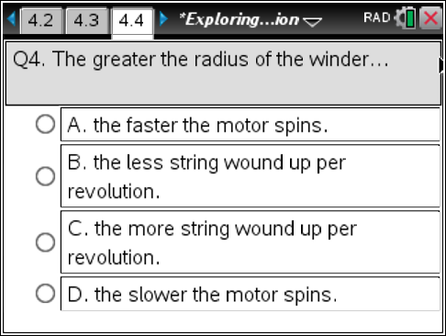
- Design/Prototype: Design a hoist to rescue the stranded ROV in the deep trench. Create a plan for the building of your hoist. Label your sketch with the materials you will be using.
Move to pages 4.5 - 4.6 in TI-Nspire Document.
- Task 2: Build your hoist: Use your design sketch and the materials and tools provided to build your hoist and model of the rescue ROV. Reference the image on Page 4.6 (also below).
Tips:
- The servo motor should be taped to the side of your table.
- Use the meter stick next to the hoist to measure the rescue ROV’s position. The meter stick should be placed with the 0 centimeters measurement on the floor.
- Attach a washer, magnet, or paperclip to the string to represent the rescue ROV.
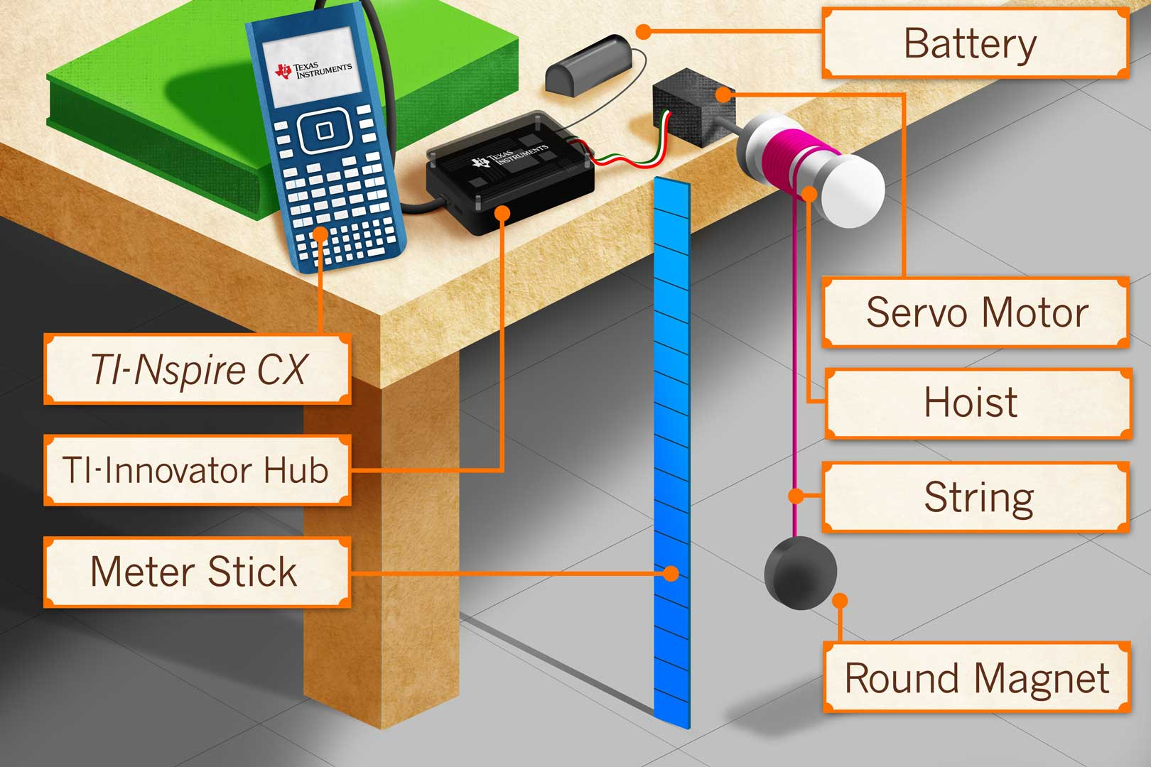
Move to pages 5.1 - 5.2 in TI-Nspire Document.
- Task 3: Read the information on Page 5.1.  On Page 5.2, connect the servo motor to the TI-Innovator™ Hub.  - Connect the servo motor to OUT3 on the  TI-Innovator Hub.  - Connect the power supply to the TI-Innovator Hub where it says PWR.  - Connect your TI-Innovator Hub to the TI-Nspire CX. Insert the “B” connector on the unit-to-unit cable into the DATA port at the bottom of the TI-Innovator™ Hub.  Note: You should note a green line appears at the top of  TI-Nspire CX screen to show you are connected. |  |  | 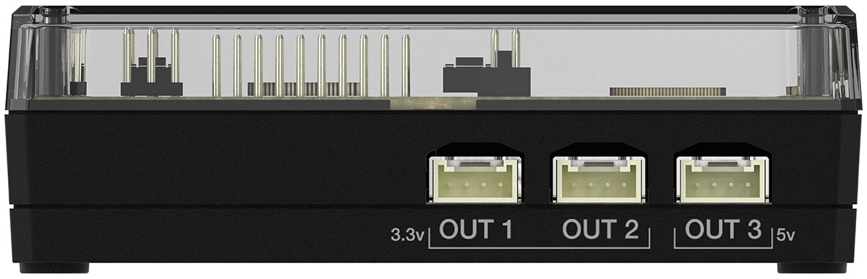  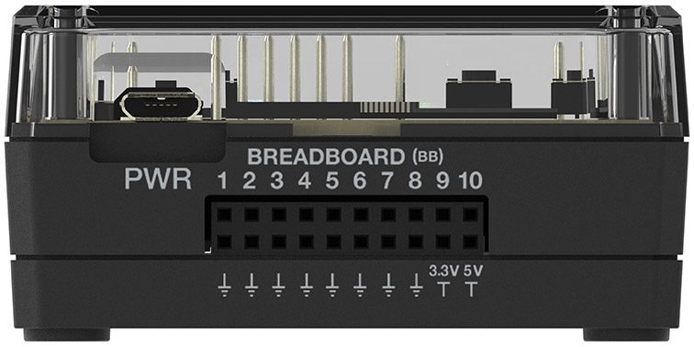  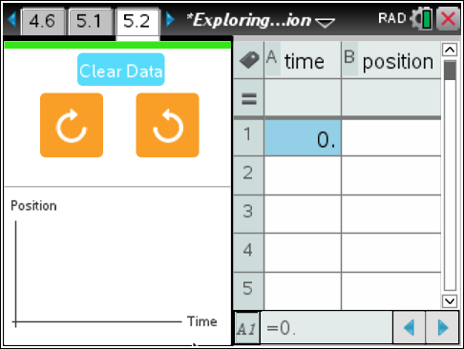
Each time you select the right or left button, the servo motor will run for exactly one second in that direction.
- When you are ready to start your trial, use a meter stick to measure the initial vertical position of your model ROV, and type the position in the table. Note: The floor is position zero.
- Select a direction, and record the next time and position. Note: The time column is cumulative, and the values must be entered in sequential order, as shown in the screenshot.
- Continue in the same direction for that trial.
Read pages 5.3 - 5.4 in TI-Nspire Document.
- Analyze: Read the information on Page 5.3. Using the hoist and model rescue ROV that you’ve built and the control panel on the handheld, investigate the relationships between speed, direction, vertical position, and time.
Analyze the data in the graph on Page 5.4 with a moveable line (Menu > Analyze > Add Moveable Line).

Now select the opposite direction, and record the times and positions in the table as you did for Trial 1. You will analyze the second trial on Page 5.4.
For each of the two different trials, draw the graph below (moveable line matched with data), and record the slope and y-intercept (next page).
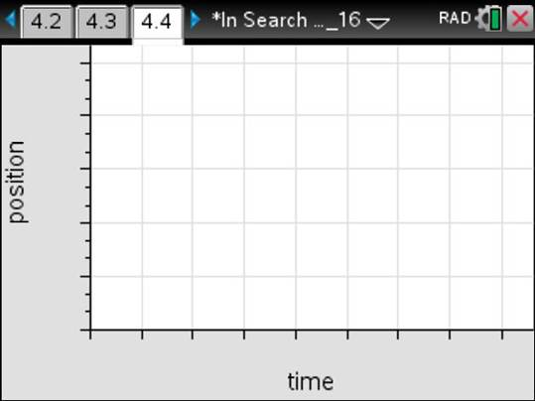
Trial 1 Direction: ___________________  Record the slope and y-intercept:  _________________________________ |  | Trial 2 Direction: ___________________  Record the slope and y-intercept:  _________________________________
Move to pages 5.7 - 5.9 in TI-Nspire Document.
Q5. What effect does changing the rotation direction have on the slope of the line?

Q6. The slope of a position vs. time graph represents the…
- initial position of the model ROV.
- the speed of the hoist.
- the direction the hoist rotates.
- none of the above.
Q7. The y-intercept of a position vs. time graph represents the...
- initial position of the model ROV.
- the speed of the hoist.
- the direction the hoist rotates.
- none of the above.
Q8. What does the sign of the slope on a position vs time graph represent?
- initial position of the model ROV.
- the direction the ROV is moving.
- the speed the ROV is moving.
- none of the above.
Move to pages 6.1 - 6.6 in TI-Nspire Document.
- Application 1: Read the information on Pages 5.1 – 5.2, summarized here:
Sönja Sonar needs your help again. She has found some old position-time graphs and needs your help to understand their meaning. On the next few pages, you will find two graphs to interpret for her. Use the graph trace tool on each to find the position and time of the ROV along the graph. Then, write a description of the ROV’s motion in the space provided.
Q9. Analyze the graph, and write a description. |  |  |  |  | 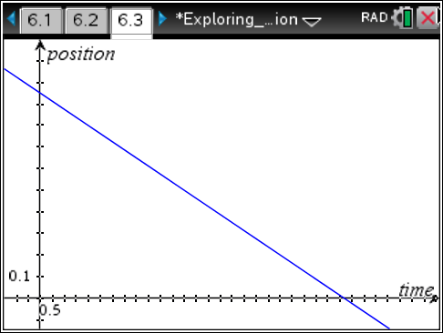
Q10. Analyze the graph, and write a description. |  |  |  |  | 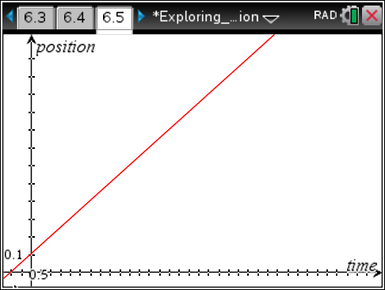
Move to pages 7.1 – 7.4 in TI-Nspire Document.
- Application 2. Read the information on pages 6.1 – 6.2, summarized here:
Sönja Sonar needs your help... again. She now needs your math powers to predict a graph of the rescue ROV's motion in the ocean. Please read her two descriptions, and make a sketch of the graphs (below).
- Graph 1: The rescue ROV starts at .20 meters above the floor and rises to 1.8 meters in 24.5 seconds.  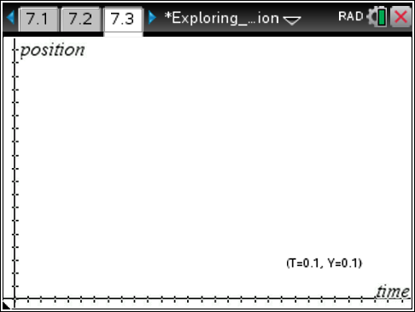 | - The rescue ROV starts 1.5 meters above the floor and lowers to the floor in 14.0 seconds.
- Conclusion: Write a conclusion stating the impact that hoist speed, direction, and initial position have on the appearance of a position vs. time graph.

What additional modifications might need to be made if you were designing a real hoist?

