Open the TI-Nspire document Too_Hot_Too_Cold_Just_Right.tns.  Have you ever been in a REALLY cold environment? The coldest temperature ever recorded on Earth was –129ºF in Antarctica! How about REALLY hot places? The hottest recorded temperature on Earth was 136ºF in Libya, Africa! Both of these extremes are pretty hard to imagine, and both would be virtually impossible to live in. Thankfully, temperatures in most places are much more reasonable than that. However, people and other animals manage to live in places that we consider really cold and really hot. How do they do it? Can ALL animals live anywhere they want? Or do some have an easier time handling extreme temperatures? In this activity, you will observe the metabolic rates of two different animals in various environmental temperatures. One of these animals is an endotherm (“warm-blooded”) and the other is an ectotherm (“cold-blooded”). | 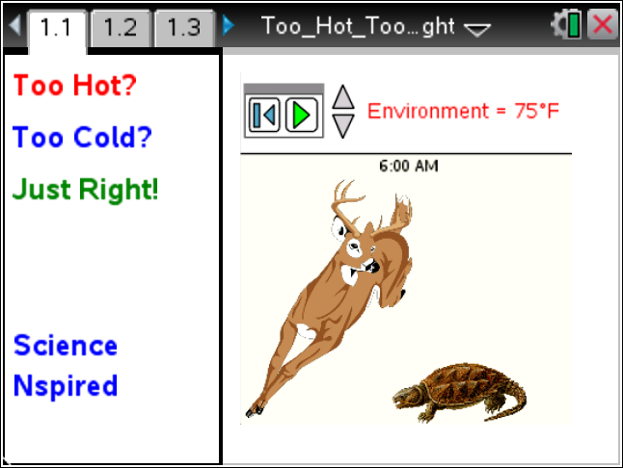

Move to pages 1.2 and 1.3. Answer the following questions here.
On page 1.2, there are some general instructions on how to run the simulation with the deer and the turtle.  Each plot shows the environmental temperature along with the body temperatures of the animal.  1. First, run the simulation at 75ºF by selecting the Play button . The entire simulation runs for about a minute and models temperatures for two days. When the simulation is complete sketch the graphs as instructed below. |  |  |  |  | 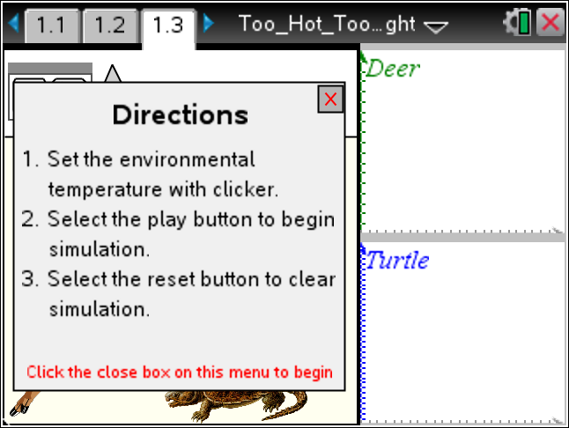
Q1. To the right, draw a sketch of the graphs that were produced when the environmental temperature was 75ºF. |  | Plots at 75ºF
2. Now reset the simulation by selecting . Use the down arrow to lower the environmental temperature and run the simulation again. Then raise the environmental temperature above 75°F and run the simulation again.
Q2. Draw a sketch of the graphs that were produced when the environmental temperature was lower than 75ºF. |  |  | Plots at _____ºF
Q3. Draw a sketch of the graphs that were produced when the environmental temperature was higher than 75ºF. |  |  | Plots at _____ºF
Move to pages 2.1 – 2.3. Answer questions 4 – 6 here or in the .tns file.
Answer questions 7 – 14 here.
Q4. Which animal's temperature fluctuated with the environmental temperature?
A. turtle  B. deer |  |  |  | C. both  D. neither
Q5. Which animal's temperature remained pretty constant, even when the environmental temperature changed?
A. turtle  B. deer |  |  |  | C. both  D. neither
Q6. Which variable were you able to manipulate in the simulation?
A. time  B. temperature |  |  |  | C. animal size  D. animal metabolism
Q7. As the sun rose and the temperature got warmer, what happened to the metabolism of the turtle? Why?

Q8. As the sun rose and the temperature got warmer, what happened to the metabolism of the deer? Why?

Q9. As the sun set and the temperature got cooler, what happened to the metabolism of the turtle? Why?

Q10. As the sun set and the temperature got cooler, what happened to the metabolism of the deer? Why?

Q11. What do you predict would be the normal body temperature of the deer?
A. It depends largely on the environmental temperature. | B. About 72°F |  |  |  |  | C. About 100°F
Q12. What do you predict would be the body temperature of the turtle?
A. It depends largely on the environmental temperature. | B. About 50°F |  |  |  |  | C. About 110°F
Q13. During cold winter months, it's common to see deer, but not common to see turtles. Why not? What happens to the turtles?

Q14. What strategies to you think deer use in the cold winter months to retain their body heat?

