Open the TI-Nspire document Mass_on_a_Spring.tns.  When an object is moved from a position of stable equilibrium, it experiences a restorative force. A restorative force tends to make it return to equilibrium. In some instances the size of this restorative force is directly proportional to the object’s displacement from equilibrium. The resulting motion is called Simple Harmonic Motion (SHM).  Hooke’s Law (F_{spring} = -kx),states that the restoration force is generally proportional to the amount of displacement from equilibrium. Therefore, the oscillation of a mass attached to a spring is the defining example of Hooke’s Law and applies to SHM.  These science concepts also provide the basis for explaining how mechanical waves pass through a medium. In this simulation you will explore the motion of a mass on a spring as it oscillates around its equilibrium position. | 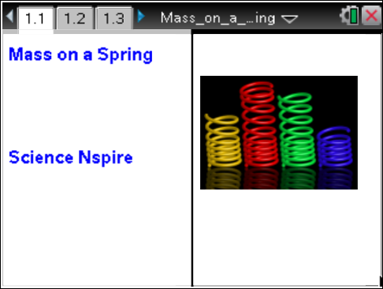

Move to pages 1.2 – 1.6.
1. Read the instructions for the simulation page on pages 1.2 and 1.3. This simulation on page 1.4 models the motion of an anvil attached to a spring as it oscillates across a frictionless, horizontal surface. When the anvil is at a position of x = 0, the spring is neither stretched nor compressed; at this position the spring applies no force to the anvil. When the anvil is moved from this position, the spring applies a force to the anvil back toward x = 0. The magnitude of this force is equal to the spring constant of the spring, k, multiplied by the displacement of the anvil from x = 0.  In this simulation, you can set the anvil’s mass (2 kg ≤ m ≤ 10 kg), the spring constant of the spring (40 N/m ≤ k ≤ 300 N/m), and the initial position of the anvil (-1 m ≤ x_{i} ≤ 1 m).  When you select the Play button , the anvil will oscillate around x = 0. You may pause the motion by selecting the Pause button. A position vs. time graph of the anvil’s motion is plotted on page 1.5 following the simulation. The Reset button allows you to clear the graph and reset the simulation. Following the position vs. time graph page are velocity vs. time and acceleration vs. time graphs of the anvil’s motion on page 1.6. |  |  | 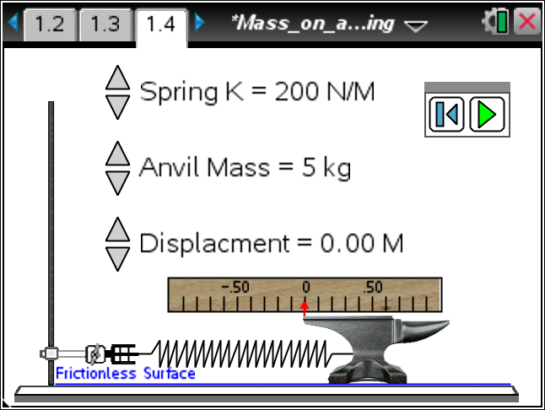  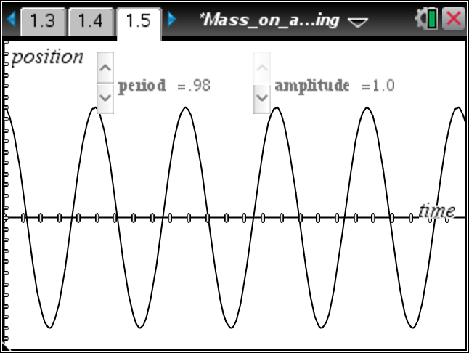
Tech Tip: To access the Directions again, select b or Document Tools () > Mass on a Spring > Directions.
Tech Tip: To access the Directions again, select > Directions.
Refer back to the simulation on pages 1.4 and 1.5. Answer the following questions here.
Q1. Choose mid-range values for the mass of the anvil, the spring constant, and the initial position of the anvil. Record your values below. Select the Play button and observe the motion of the anvil as it moves through several cycles of its motion.
m = ______ kg | k = ______ N/m |  | x_{i} = ______ m
Q2. View the position vs. time graph of the anvil’s motion. Describe the motion of the anvil based on the data points you see (the open circles).

Q3. Simple Harmonic Motion is characterized by period and amplitude. The period of the motion, T, is the time to complete one full cycle. The amplitude of the motion, A, is the maximum displacement from equilibrium (x = 0). Use the controls at the top of page 1.5 to adjust the period and amplitude of the plotted function (the solid curve) so that it fits the data points. Record the values below.
T = ______ s |  | A = ______ m
Q4. Reset the simulation on page 1.4. Increase the mass of the anvil, but keep the spring constant and initial position set to the values you recorded in question 1 above. Describe how this changes the motion. Record the mass, period, and amplitude below.

m = ______ kg | T = ______s |  | A = ______ m
Q5. Reset the simulation. Increase the spring constant, but keep the mass and initial position set to the values you recorded in question 1 above. Describe how this changes the motion. Record the spring constant, period, and amplitude below.

k = ______ N/m | T = ______ s |  | A = ______ m
Q6. Reset the simulation. Increase the initial position, but keep the mass and spring constant set to the values you recorded in question 1 above. Describe how this changes the motion. Record the initial position, period, and amplitude below.

x_{i} = ______ m | T = ______ s |  | A = ______m

Q7. Reset the simulation, and set the mass, the spring constant, and the initial position to the values you used in question 1. Run the simulation once again. Consider the position vs. time graph on page 1.5. Use the Graph Trace tool (Menu > Trace > Graph Trace) to determine two times near the beginning of the motion when the anvil passes through x = 0 and two times when the anvil is at maximum displacement. Record these four measurements below. What function would produce this graph?

Tech Tip: To use the Graph Trace tool, select > Trace > Graph Trace. Then, drag your finger along the graph to move the cursor.
x = 0  t = _____ s t = _____ s |  | Maximum Displacement  t = _____ s t = _____ s
Q8. According to one of the equations of SHM, the period of the motion is calculated by the equation . Substitute your values for m and k into this equation, and calculate the period of the anvil’s motion. Show your work below and compare this to the period you recorded in question 3.

Refer back to the simulation on page 1.6. Answer the following questions here.  2. This page displays the velocity vs. time graph of the anvil’s motion on top and the acceleration vs. time graph on bottom. You may need to adjust the scales on the y-axes to see the graphs well (Menu or > Window / Zoom > Window Settings). Adjust the YMin and YMax values to make the graphs fit the windows. You will need to do this for each window separately. |  |  |  | 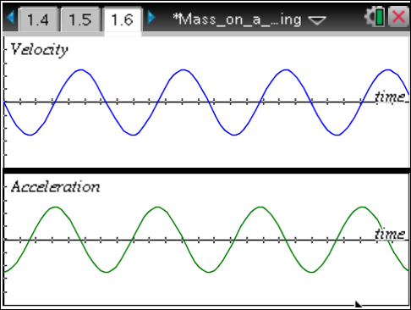
Q9. How are these two graphs similar to the position vs. time graph on page 1.5?

Q10. How is the shape of the velocity vs. time graph different from the position vs. time graph? What function could produce this graph?

Q11. Use the Graph Trace tool to determine two times near the beginning of the motion when the velocity of the anvil is zero and two times when the magnitude of the velocity is at its maximum. Record these measurements below. Compare these times to the times you recorded in question 7 above. What can you infer about the relationship between the velocity of the anvil and its position?

v = 0  t = _____ s t = _____ s |  |  | Maximum Velocity  t = _____ s t = _____ s
Q12. Use your values of m, k, and A to calculate the expression . Show your work below. Use the Graph Trace tool to determine the maximum speed of the anvil. How do these two values compare?

Q13. How is the shape of the acceleration vs. time graph different from the position vs. time graph? What function could produce this graph?

Q14. Use the Graph Trace tool to determine two times near the beginning when the acceleration of the anvil is zero and two times when the acceleration is at its maximum value. Record these measurements below. Compare these times to the ones you recorded in question 7 above. What can you infer about the relationship between the acceleration of the anvil and its position?

a = 0  t = _____ s t = _____ s |  |  | Maximum Acceleration  t = _____ s t = _____ s
Q15. Use your values of m, k, and A to calculate . Show your work below. Use the Graph Trace tool to determine the anvil’s maximum acceleration. How do these two values compare?

Q16. Use the equations given in questions 8, 12, and 15 to calculate the period, maximum speed, and maximum acceleration of the anvil when m = 8.0 kg, k = 220 N/m, and A = 0.60 m. Show your work below. Use the simulation to verify your results.

T = _____ s | v_{max} = _____ m/s |  |  | a_{max} = _____ m/s²
Move to pages 1.7–1.13. Answer the following questions here or in the .tns file.
Q17. The period of motion of an object on a spring is determined by _______________.
(More than one response may be correct.)
A. the mass of the object | B. the amplitude of the motion |  |  |  | C. the spring constant of the spring
Q18. Increasing the mass will increase the period of the motion.
A. True |  |  | B. False
Q19. Increasing the spring constant will increase the period of the motion.
A. True |  |  | B. False
Q20. The velocity of the object _______________.
A. is constant throughout the motion  B. is maximum when displacement is maximum |  |  | C. is zero when the displacement is zero  D. is maximum when displacement is zero
Q21. Select all of the factors below which will increase the maximum velocity of the object.
(More than one response may be correct.)
A. decrease the amplitude of the motion  B. increase the amplitude of the motion  C. increase the spring constant |  |  | D. decrease the spring constant  E. increase the mass  F. decrease the mass
Q22. The magnitude of the acceleration _______________.
A. is constant throughout the motion  B. is maximum when the displacement is maximum |  |  | C. is maximum when displacement is zero  D. is maximum when velocity is maximum
Q23. The direction of the acceleration is _______________.
A. opposite to the direction of displacement | B. the same as the direction of displacement |  |  |  | C. always the same as the velocity

