Open the TI-Nspire document Polar_Coordinates.tns.  In this activity, you will be introduced to the polar coordinate system. You will plot points given in polar form, convert polar coordinates to the rectangular coordinate system, and sketch the graphs of polar equations. | 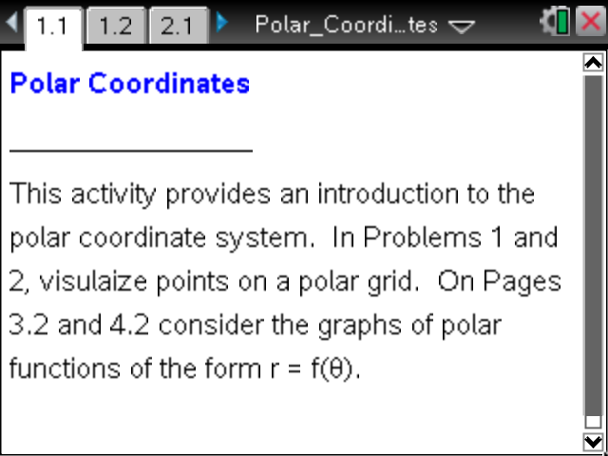

The polar coordinate system is a two-dimensional coordinate system defined by a point, called the pole, and a ray from the pole, called the polar axis. In a rectangular coordinate system, the pole is usually placed at the origin, and the polar axis is represented by the positive x-axis. A point in the polar coordinate system is represented by the ordered pair where is the distance from the pole and is the angle (in radians) measured counterclockwise from the polar axis.

Move to page 1.2.

1. On this page, the left work area contains a slider for and a clicker for The point is plotted in the right panel along with a position vector. Change the values of and as needed to answer the following questions.
a. Complete the following tables by finding the quadrant in which the point lies.

Quadrant

Quadrant

Quadrant

b. Describe the location of the point with the following polar coordinates:
- and

- and

- and

- and

Move to page 2.1.

If a point has polar coordinates , then the rectangular coordinates are given by and Similarly, if a point has rectangular coordinates , then the polar coordinates are such that and
2. Complete each of the following tables. Use Page 2.1 to enter polar coordinates and/or rectangular coordinates, to plot the points, and to check your answers. Enter coordinates in the left work area in the appropriate Math Box. The polar coordinates are represented by the point and the rectangular coordinates are represented by the point
a. For each given rectangular point in polar coordinates, find two different polar coordinates that represent the given point.

b. For each point given in polar coordinates below, determine the rectangular coordinates.

c. For each point given in rectangular coordinates below, determine two representations in polar coordinates.

Move to page 3.2.

3. Over the next two worksheet pages, carefully sketch a complete graph of each given polar equation. Create a table of values, search for patterns, and sketch the graph on the axes provided. Check you results on the handheld, and sketch the graph in the right work area of Page 3.2.
Note: Make sure the Graph Type is set to Polar. Use the clicker in the left panel to step through specific points on the curve in polar and rectangular form.

a. .
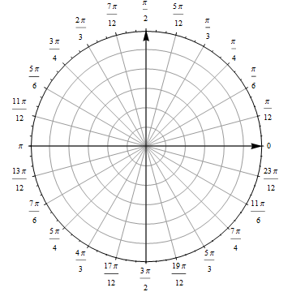

b. .
c. .
d. .

