Activity Overview  In this activity, students visually model the sequence 2^{n} for n = 1…8 by drawing line segments that represent a tree that doubles its height every year. They then extend the sequence “backward though time” over negative values for n.  Topic: Polynomials  - Simulating exponential growth  - Generating and graphing sequences  - Calculating negative and positive exponents  Teacher Preparation and Notes  - Students should already be familiar with sequences of positive exponents.  - This activity is intended to be teacher-led with students in small groups. You should seat your students in pairs so they can work cooperatively on their graphing calculators. You may use the following pages to present the material to the class and encourage discussion. Students will follow along using their graphing calculators.  - To set up the activity, have students turn off all functions and stat plots. Then change the graph axes to ZStandard.  - At the beginning of this activity, make sure that students understand how to use the Line, Seq, StorePic, and RecallPic commands. These are explained in details on the following pages. Students should also know how to enter a formula in the List Editor and set up a Stat Plot.  - To download the student worksheet, go to education.ti.com/exchange and enter “9771” in the keyword search box.  Suggested Related Activities  To download any activity listed, go to education.ti.com/exchange and enter the number in the keyword search box.  - Arithmetic Sequences & Series (TI-84 Plus family) — 8642  - Geometric Sequences & Series (TI-84 Plus family) — 8682  - What’s The Equation? Various Functions (TI-Nspire technology) — 9841 | 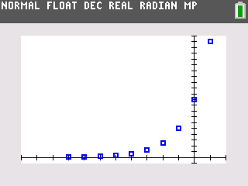  This activity utilizes MathPrintTM functionality and includes screen captures taken from the TI-84 Plus C Silver Edition. It is also appropriate for use with the TI-83 Plus, TI-84 Plus, and TI-84 Plus Silver Edition but slight variances may be found within the directions.  Compatible Devices:  - TI-84 Plus Family  - TI-84 Plus C Silver Edition  Associated Materials:  - DoubleTree_Student.pdf  - DoubleTree_Student.doc  Click HERE for Graphing Calculator Tutorials.

Problem 1 – Modeling Tree Growth After 2000
Students are introduced to a problem where the height of a tree doubles its height every year.  To draw line segments representing the height of the tree each year after 2000, students will use the Line command on the Home screen.  Press   to access the line command in the DRAW menu. |  | 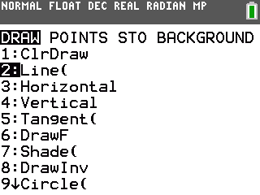
The first two commands are shown at the right. This draws a line from (1, 0) to (1, 2) and a line from (2, 0) to (2, 4).  The window settings will need to be adjusted to the following, to view the tallest of the segments:  Xmin = –.5 Xmax = 11 Xscl = 1  Ymin = 0 Ymax = 260 Yscl = 20  Students should notice the lines for years 2001 and 2002 disappear. |  | 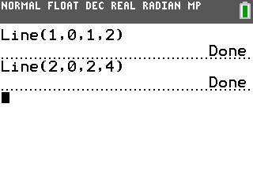
When students have drawn all the segments for 2001 through 2008, they need to store the picture as Pic1 for later use.  Press   arrow to the STO menu to access the StorePic command.  Press  and select Picture to access the variable Pic1. |  | 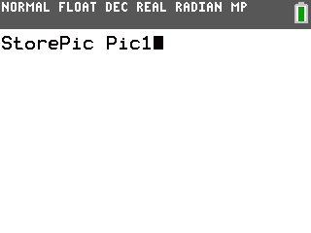
Students will notice that all of the lengths are powers of two and complete the table shown at the right.  The heights form a sequence: 2¹, 2², 2³…. Explain how to write this sequence in shorthand using the variable n.  for n= 1, 2 ...8.  Students are to use the List feature to graph this sequence. Instructions for this are given below.
  Year | x = | Height (feet) | Power of Two
  2001 | 1 | 2 | 2¹
  2002 | 2 | 4 | 2²
  2003 | 3 | 8 | 2³
  2004 | 4 | 16 | 2⁴
  2005 | 5 | 32 | 2⁵
  2006 | 6 | 64 | 2⁶
  2007 | 7 | 128 | 2⁷
  2008 | 8 | 256 | 2⁸

Method 1: Enter the sequence in the List Editor.  - Press   to open the List Editor.  - Enter the values of n in L1.  - Arrow up to the top of L2 and enter the formula for the sequence, but replace n with L1. | 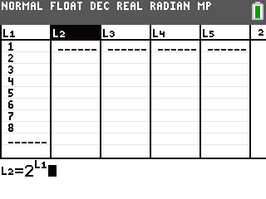
Method 2: Using the seq( command.  - From the Home screen, students enter first command shown at the right to store the integers  1, 2, 3 ...8 in L1.  - Press  , arrow to the OPS menu to access the seq( command.  - Press  to enter the arrow. Press   to enter list L1 and   to enter list L2. | 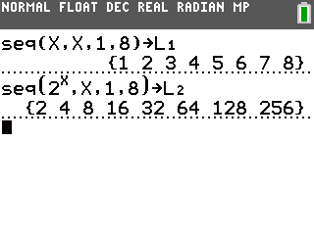
- Then enter the second command shown at the right to store
for the values of 1, 2, 3...8 for n in L2.
After students have created the sequences using one of these methods, they can graph the result as a scatter plot. Students need to adjust the settings for Plot1 as shown.  Press . Students should notice that graphing the scatter plot cleared the lines you drew from the graph screen.  To view the lines and the scatter plot together, students need to recall the picture on the Home screen.  Press   and arrow to the STO menu to access the RecallPic command.  Caution: Students must have the same window settings on the graph when they recall the picture as they did when they saved it for this to work! | 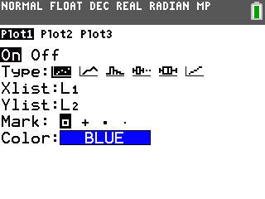  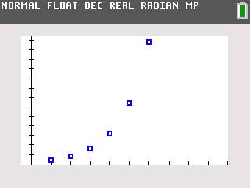

Problem 2 – Modeling Tree Growth Before 2000
Take some time to discuss the mapping between years and x-values. Ask, What formula can I use to find the x-value from the year? This will help students understand why the years prior to 2000 are represented by negative values.
The window settings shown at the right will allow students to view the segments of the years that came before 2000. |  | 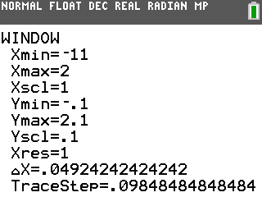
Press  to view the graph. One dot from the scatter plot shows the height of the tree in 2001. Draw a line segment that is half this height at x = 0.  Students should realize that this segment is not visible because it lies on the y-axis. |  | 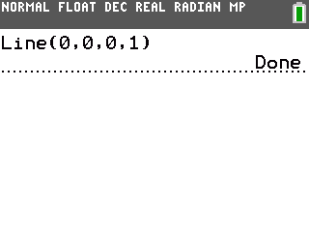
Students should continue drawing line segments to represent the height of the tree in 1999, 1998, 1997, 1996, and 1995, cutting the height of the tree in half each time stepping back a year. |  | 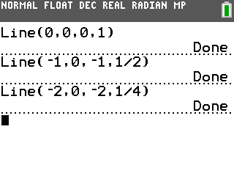
When students have drawn all of the segments for 2000 back through 1995, they need to store the picture as Pic2 in the same manner as they saved Pic1. |  | 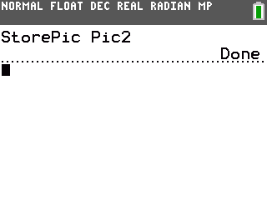
Students should see that the lengths of these segments are also powers of two! Using patterns, they need to complete the table.  They should see that the denominators have the same pattern as the heights of years after 2000.  Looking at the table, students will see that these heights also form a sequence:  2^{–1}, 2^{–2}, 2^{–3} ….
  Year | x = | Height (feet)  Decimal form | Height (feet)  Fraction form | Power of Two
  2000 | 0 | 1 | 1 | 2⁰
  1999 | –1 | 0.5 |  | 2^{–1}
  1998 | –2 | 0.25 |  | 2^{–2}
  1997 | –3 | 0.125 |  | 2^{–3}
  1996 | –4 | 0.0625 |  | 2^{–4}
  1995 | –5 | 0.03125 |  | 2^{–5}
  1994 | –6 | 0.015625 |  | 2^{–6}
  1993 | –7 | 0.0078125 |  | 2^{–7}
  1992 | –8 | 0.00390625 |  | 2^{–8}
The sequence graphed earlier can be extended to more values of n = –8...8  Now students are to use one of the methods described earlier to extend the sequences in L1 and L2. List L1 should list the values of n, and L2 should list the values of . |  | 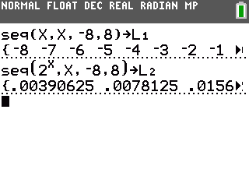
Press . The scatter plot will update automatically to show the extended sequences, as well as clear the lines students drew from the graph screen.
To view the lines and the scatter plot together, go to the Home screen and recall the picture, Pic2, which was saved earlier.  This helps students see that the negative and positive powers of 2 are parts of the same sequence. |  | 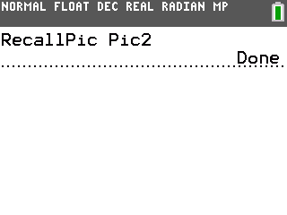
Students are instructed on the worksheet to write a rule for evaluating negative powers of 2. Test it by evaluating 2^{–12} and 3^{–5} two different ways. |  | 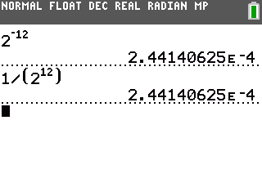
If there is time, discuss how the tree's rate of growth. Originally it seemed like a tree that doubled its height every year must grow very fast. But from 1997 to 1998, it grew only 0.25 foot, or 4 inches.

