Open the TI-Nspire document Polynomial_Roller_Coaster.tns.  In this activity, we will examine data from roller coasters and find polynomial functions to model the track. | 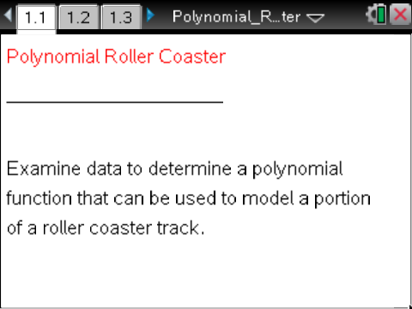

Move to page 1.4. | Press / ¢ and / ¡ to navigate through the lesson.
The Ride of Steel roller coaster in Darien Lake, New York, reaches a maximum height of about 208 feet. Page 1.3 contains a spreadsheet of data of horizontal and vertical distances, in feet, of a section of roller coaster track.
1. What is the lowest degree polynomial function that could model the points in the scatter plot on Page 1.4? Explain your answer.

Move to page 1.5.

2. Use this Calculator page to find a cubic regression equation. Select MENU > Statistics > Stat Calculations > Cubic Regression. Select horizontal for the X List, vertical for the Y List, and save it to f1. Press OK or ·.

Move back to page 1.4.

3. To activate, or graph, the regression equation just found, select MENU > Graph Entry/Edit > Function. Move to f1(x), press ·, and the equation will be activated, or graphed. Write the regression equation below.

4. According to the regression equation, what is the maximum height you could expect to reach on this portion of the roller coaster track? According to the data, what is the maximum height you could expect to reach on this portion of the roller coaster track? Explain why the two values are different.

5. Based on the regression equation, when you’ve traveled 500 feet horizontally, what height could you expect to reach? Does this value make sense? Explain.

6. What does your answer to question #5 tell you about the equation that you obtained?

7. A cubic function can have three zeroes. Would you expect a function that fits this data to have three zeroes? Explain.

Move to page 2.1.

The Kingda Ka Flags Great Adventure in Jackson, New Jersey, with a drop of 418 feet, is reported to be the world's tallest roller coaster. Page 2.1 contains the graph of a section of a polynomial roller coaster function with equation
8. What is the maximum height that the roller coaster reaches in this section? What is the minimum height?

9. Is the roller coaster boarded at ground level? If not, from what height is it boarded? Is this height reasonable?

10. Assume that there was a smaller section of the roller coaster that preceded the section shown in this graph. To add the section of roller coaster from Page 2.1 to the plans for the complete roller coaster, we will have to shift this section 100 feet to the right. Write an equation to do so, and enter your answer into f2(x) to check your work.

11. The builder of the roller coaster decided that a minimum height of approximately 4.41 feet was too close to the ground and now wants to raise this section of the roller coaster so it is at least 15 feet above the ground. Write an equation that would make this change, and enter your answer into f3(x) to check your work.

Move to page 3.1.

It is not difficult to create a polynomial roller coaster as we have done. Create a simple cubic polynomial equation, and then adjust it to model a roller coaster.

12. Write an equation, in factored form, for a cubic polynomial function to model a section of roller coaster with the following conditions:
- the roller coaster is boarded at ground level,
- reaches a maximum height,
- returns to ground level after traveling horizontally for a total of 180 feet,
- reaches a minimum height,
- returns to ground level after traveling horizontally for a total of 250 feet,
- and continues to travel.
- The coaster reaches a height of 200 feet after traveling 100 feet horizontally.

Enter your equation into f1(x), and copy it below.

13. Based on your equation, at what height do the passengers board? What is the maximum height reached by the roller coaster? What is the minimum height?

14. Do you think it would be possible to build a roller coaster to fit your model? Why or why not?

15. Adjust your equation so the minimum height of the roller coaster is approximately 10 feet. Enter your equation into f2(x), and copy it below.

16. If the equation were adjusted as suggested in question #15, what changes have to be made in the location of the boarding platform?

17. How could you create a section of roller coaster with more peaks and dips?

18. How would you determine the lowest degree polynomial function to use for a roller coaster with n peaks and dips?

http://godarienlake.com/rides/thrill-rides/
http://www.sixflags.com/greatadventure/rides/kingdaka.aspx

