Open the TI-Nspire document Classification_Challenge.tns.

Move to pages 1.2 – 1.3.
1. Read through pages 1.2 and 1.3 in the .tns file as well as the background information stated below.

Ever wonder how organisms are classified? Whenever a new species is discovered, it must be placed into orderly groups based on similar characteristics. This process is known as taxonomy, which is the science of describing, naming and classifying organisms. Classification of organisms has been going on for a long time (since 350BC!). Aristotle began classifying organisms into groups based on many simple characteristics such as if they laid eggs or not. In this activity, it's your job to be the taxonomist!
Activity 1: Key Vocabulary
Move to page 1.4.
2. You will see a list of vocabulary words on the right hand side of the page. Each one of the words represents one of the eight major taxonomy "ranks." Your job will be to drag and drop the words onto the left side of the page in order from largest group of organisms to smallest group of organisms.

Once the task is completed, you will then be given either a smiley face or a “no” face depending on whether your answers are correct or not. You can select the Reset button on the screen to try again.
Tech Tip: The text will drag to the right of your finger as you slide it across the screen. Be sure to drag the text all the way to the correct position so that you do not drop it in the incorrect position by accident.
Move to pages 1.5 and 1.6. Answer questions 1 and 2 below and/or in the .tns file.

Q1. Which taxonomic rank has the largest amount of organisms placed in it?

A. Phylum
B. Species
C. Class
D. Kingdom
E. Genus
Q2. Which taxonomic rank has the smallest amount of organisms placed in it?

A. Kingdom
B. Species
C. Family
D. Genus
E. Class

Q3. Fill in the table with all of the seven major taxonomy classifications ranked in order from Largest to Smallest.
  Levels of Classification
Activity 2: If It Doesn’t Fit…
Move to page 2.1.
3. Read the descriptions and instructions on page 2.1 for the simulation on page 2.2.
Move to page 2.2.
4. In this activity you will select which organism fits LEAST with the others in the list. There are many possibilities, so be prepared to defend your answer in class. Once you make your selection, then select 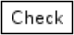. If you select the correct choice a smiley face will be displayed. If not, you will see a "no" face. |  | 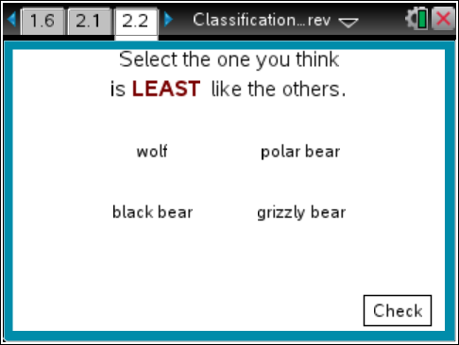
Continue through this simulation by selecting the Next button.

Make sure you answer all 12 of the scenarios before you move onto page 3.1. You will know you have answered all 12 of them when your score pops up on the screen.

You may go back to view your choices, but once you select the Check button you will not be allowed to change your answers.

Q4. Circle your selection for each scenario and then record your justification for your selection.

1. | grizzly bear |  |  | polar bear |  |  | wolf |  | black bear
Answer Justification:

2. | oak tree |  | maple tree |  |  | pine tree |  |  | birch tree
Answer Justification:

3. |  | black lab | Felis catus |  |  | beagle |  |  | Australian shepherd
Answer Justification:

4. |  | mushroom | mold |  |  | yeast |  |  | moss
Answer Justification:

5. |  | segmented worms | roundworms |  |  | insects |  |  | flatworms
Answer Justification:

6. |  | sea turtle | green tree frog |  |  | American toad |  |  | tiger salamander
Answer Justification:

7. |  | lizard |  |  | alligator |  |  | frog
Answer Justification:

8. |  | box turtle |  |  | frog |  |  | snake
Answer Justification:

9. |  | yeast | worms |  |  | sponges |  |  | insects
Answer Justification:

10. |  | kangaroo | panda |  |  | brown bear |  |  | black bear
Answer Justification:

11. |  | shark | trout |  |  | penguin |  |  | minnows
Answer Justification:

12. | whale | human | dolphin | trout
Answer Justification:

Activity 3: Sorting Challenge
Move to page 3.1.
5. Read the descriptions and instructions on page 3.1 for the simulations on page 3.2 and 4.1.

Move to pages 3.2 and 4.1.
6. On the top of page 3.2, you will see a specific organism that you will have to drag and drop into one of the correct categories below. Once you drag and drop the first one into a category, another one will appear.

If you make a mistake, you can select the reset button on the top right corner of your screen. A smiley face or a “no” face will appear depending on whether or not you responded correctly. Page 3.2 and page 4.1 each have a sorting challenge. Good Luck!
Q5. As you go through the simulation, circle the organisms that have chlorophyll in the table below.

Page 3.2 | algae | ferns | flowering plants | fungi | moss
Justification:

Q6. As you go through the simulation, circle the organisms that reproduce by seeds in the table below.

Page 4.1 | algae | ferns | flowering plants | moss | fungi
Justification:

Move to pages 5.1 and 5.2. Answer questions 7 and 8 below and/or in the .tns file.
Q7. Which organism (of the ones listed on pages 3.2 and 4.1) has chlorophyll AND reproduces by seeds?
A. moss
B. algae
C. ferns
D. flowering plants
E. fungi

Q8. In this activity, you used characteristics like chlorophyll and seeds to classify plants. What characteristics do you think scientists use to classify animals?

