Open the TI-Nspire document Symmetric_Secant.tns.  The Symmetric Difference Quotient given by: is often used to approximate the derivative of a function at a point. In this activity, you will explore the symmetric difference quotient both graphically and numerically to consider its benefits and limitations. | 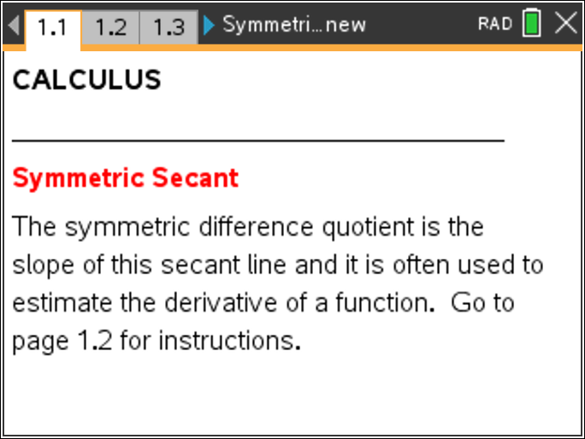
Move to page 1.2 for instructions and then to page 1.3.

- Page 1.3 shows the graph of y = f1(x) and the tangent line through the point (x, f1(x)). The slope of the secant line through the points (x – h, f1(x – h)), and (x + h, f1(x + h)) is also given.
  - Explain why the slope of the secant line is represented by the Symmetric Difference Quotient given above.

  - Drag the point on the x-axis to change the x-value. Describe the changes in the secant and tangent lines as you move along the graph of y = f1(x).

  - Does the slope of the secant line provide an estimate for the derivative of this function? Explain.

- Use the arrows in the upper left corner to change the value of h.
  - Describe changes you note to the secant line as you decrease the value of h.

  - Explain why decreasing the value of h improves the estimates for the derivative.

Move to page 2.2.

- The definition of a derivative f'(x) is often given as .
  - Explain how this difference quotient can also be interpreted as the slope of a secant line. What are the coordinates of the two points used to calculate the slope of this secant line?

  - The two dotted lines indicate these new secant lines for positive and negative values of h. Drag the point on the x-axis to change the x-value. Compare all three secant lines with the tangent line for h = 1. Which seems to provide a better estimate for the derivative of the function at (x, f(x))? Explain.

  - Use the arrows to change the value of h. How do the secant line approximations change as you decrease the value of h?

- Use the graph to explain why the symmetric difference quotient given by is often a better estimate of the derivative of a function.

Move to page 2.4.
On this page you see numeric values displayed for the symmetric difference quotient, sdq, as well as the difference quotients for the traditional secant line from (x, f1(x)) to
(x + h, f1( x+ h)). Here rdq refers to this quotient when h is positive, that is, when the secant line is through a point to the right of (x, f1(x)), whereas ldq is this quotient for negative values of h, when the secant line is through a point to the left of (x, f1(x)).

- Use the slider on this page to decrease the value of h. What do you notice about these difference quotients as you decrease the value of h toward 0?

- Use the graph on page 2.2 to change the x-value. What is always true about the relationship between these three difference quotients?

- How could you use these numeric results to support the claim that the symmetric difference quotient provides a better estimate of the derivative of a function?

Move to page 3.2.
- Drag the point along the x-axis and compare the slope of the tangent line and the slope of the secant line for this new function f1(x).
- For what values of x does the slope of the symmetric secant seem to provide a good approximation for the slope of the tangent line?

- Use the symmetric secant to estimate the derivative of the function at:
x = 3

x = 0

x = 1

- What happens to the tangent line when x = 1? What does that tell you about the derivative of the function at x = 1?

- Explain how the symmetric difference quotient might lead to a misrepresentation of the derivative of a function.

Move to page 4.2.
- Drag the point along the x-axis and compare the slope of the tangent line and the slope of the secant line for this new function f1(x).

- For what values of x does the slope of the symmetric secant seem to provide a good approximation for the slope of the tangent line?

- Use the symmetric secant with h = 0.05 to approximate the derivative of this function at:
x = –2

x = 1

x = 0

- What problems do you note in the above estimates?

- What do the previous two examples caution about when using the symmetric difference quotient to estimate a derivative?

