Overview

A slider is a useful calculator tool in action/consequence documents. Sliders can be used to control various parameters, for example, in equations, or values in a table. This calculator feature may be used to illustrate transformations and translations of graphs, specific values of a function, and limits. This document provides detailed steps showing how to construct a tns file with one minimized slider that cycles through a specific list of values together with two traditional sliders.

Materials

• TI-Nspire™ handheld or Teacher Software

Step 1—Preparing the document  1. Open a new document on the handheld by pressing c > New Document. Open a new document in the Teacher Software by clicking File > New.  2. Select Add Graphs. | 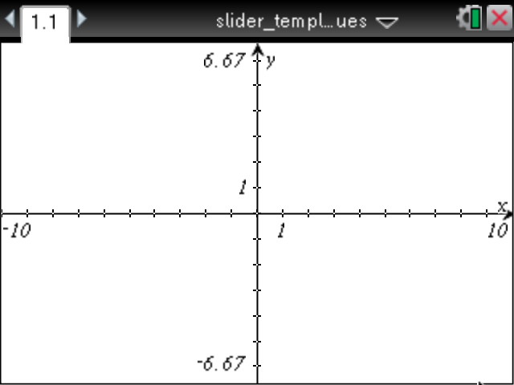
3. Press ~ > Page Layout, and under the Page Layout Menu, select layout to split the page in half vertically.  4. Add a Graphs page to the right-hand work area as well. | 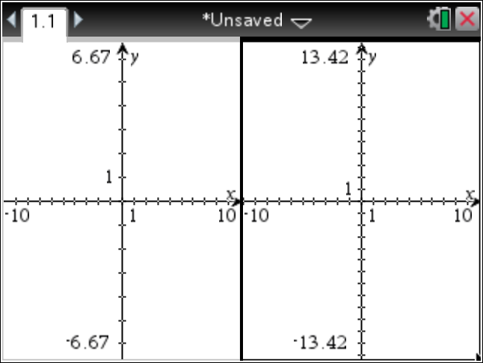
5. In the left work area, select MENU > View > Hide Axis.  6. Using the computer software, position the cursor along the boundary of the two screens. Left-click and hold the button down to move the boundary to the left, leaving room for a slider. On the handheld, select ~ > Page Layout > Custom Split, and use the arrow keys to move the boundary to the left. | 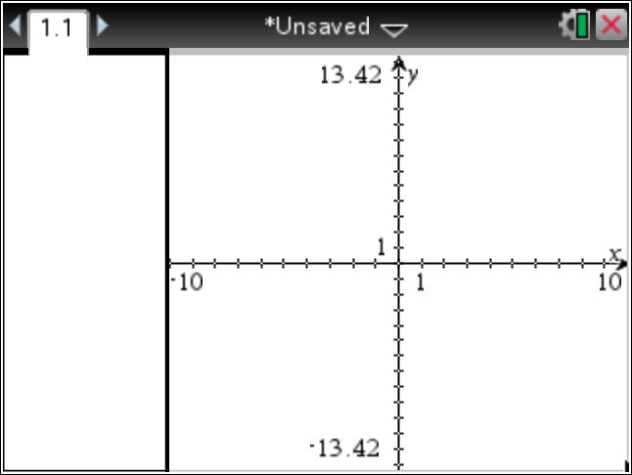
Step 2—Adding a Slider  7. In the left work area, select MENU > Actions > Insert Slider, and position the slider near the top left portion of the screen.  8. Press enter to drop the slider, and rename the slider variable | 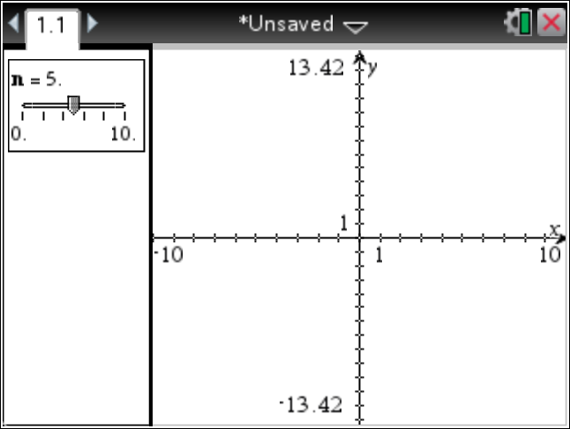
9. Right-click (on the handheld, press / b) in the slider box, and select Settings.  10. Change the slider settings as indicated in the screens to the right, and click OK. | 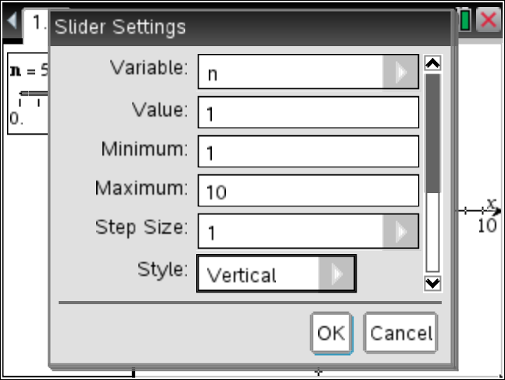  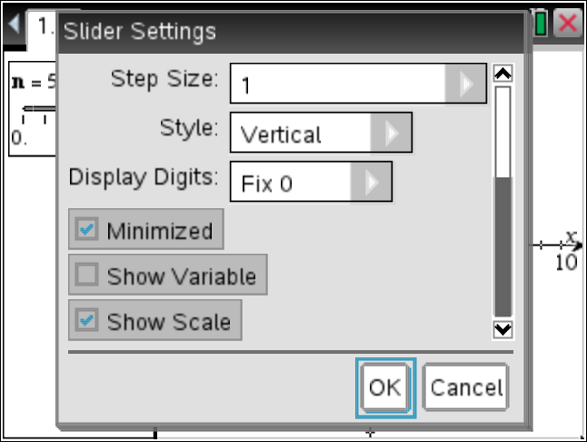
- In the figure to the right, the slider is minimized, and the variable is not shown. | 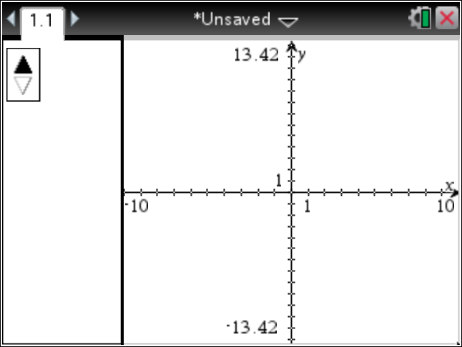

Step 3—Creating a Spreadsheet  11. Select ~ > Insert > Lists & Spreadsheet to insert a Lists and Spreadsheets page.  12. In Column A, enter the numbers you would like the slider to cycle through.  13. Click in the top row, and name the column alist. | 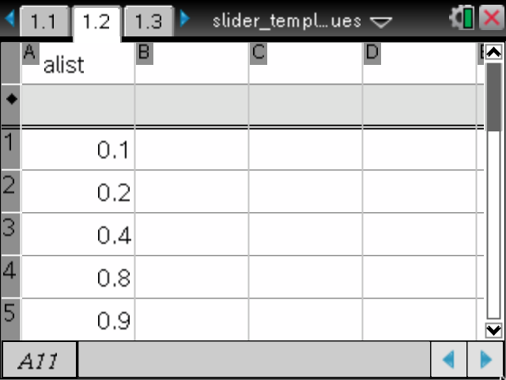
Step 4—Creating a Math Box  14. Select ~ > Insert > Notes to insert a Notes page.  15. Select MENU > Insert > Math Box, and define the variable a to be a := alist[n].  Note: alist and n should be available under h. | 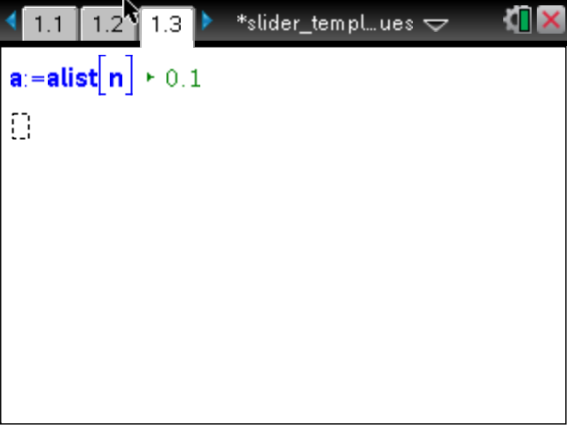
Step 5—Activating the Slider  16. Click Page 1.1, and select MENU > Actions > Text.  17. Click below the slider, and add the text a =.  18. Click on another location below the slider, and add another text box with just the letter a. | 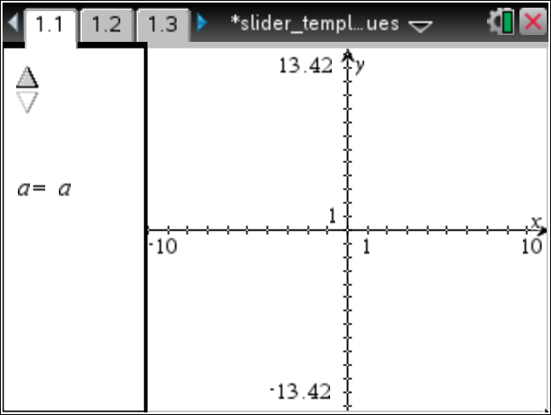
19. Select MENU > Actions > Calculate and click on the text box with only the letter a.  20. In the pop-up pane, tap L for the variable a, and position the value of a in the left panel next to the top slider (see figure).  21. Press d to deactivate Actions > Text.  22. Select MENU > Actions > Hide/Show, and click on the text box with only the letter a.  23. Tap d to deactivate Actions > Hide/Show.  24. Grab and move the remaining text box and the value of a as desired.  By following these steps, you have labeled the values of the slider. | 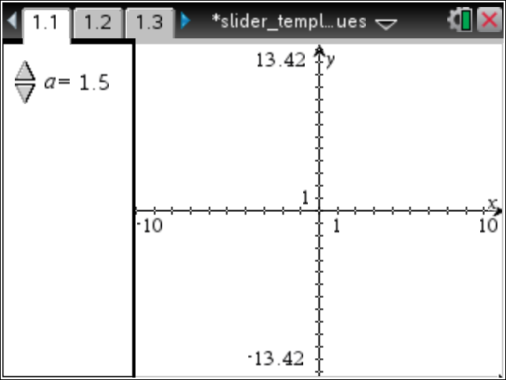
The slider will now cycle through the values in the column labeled alist on the Lists & Spreadsheet page. For example, in the right panel, define the logarithmic function  25. Use the slider to change the value of and view the various graphs.  Note: The function can be accessed through / Ö or by typing log(x,a). | 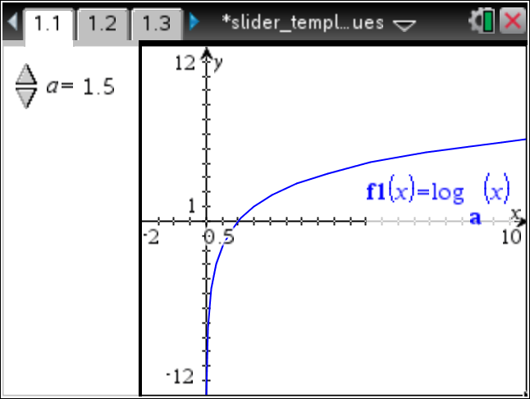  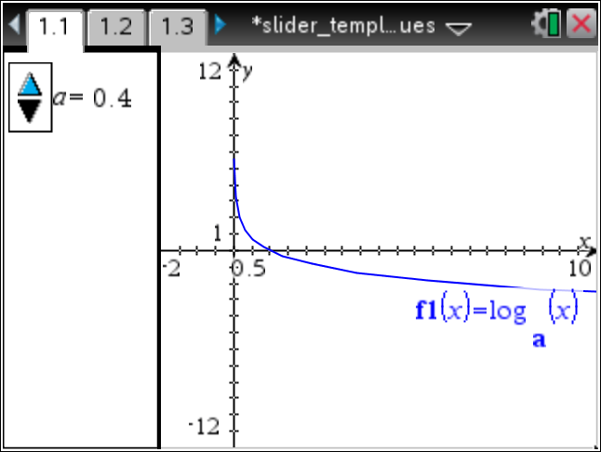
26. Using the handheld, select ~ > Insert > Problem. Using the computer software, select Insert > Problem.
27. Insert a new Calculator page at the beginning of the Problem. After copying the pages below, you can delete this blank Calculator page.
28. On the handheld, press / © to view the document pages. Select the page to be copied (1.1). Press / b > Copy, select the position for the new (copied) page, and press / b > Paste.
- Using the Computer Software, select Toolbox > Page Sorter. Right-click (control-click on the Mac) on the appropriate page, and select Copy (or use ctrl+C). Select the position for the new (copied) page, right-click, and select Paste (or use ctrl+V).
29. Copy Page 1.1, and paste into the new problem as Page 2.1.
- Copy Page 1.2, and paste into the new problem as Page 2.2.
- Copy Page 1.3, and paste into the new problem as Page 2.3.
30. Move to Page 2.3, click in the Math Box, and tap · to evaluate the expression.
A document / problem can contain both value sliders and traditional sliders.  31. Add a traditional slider to this problem. In the left work area of Page 2.1, select MENU > Actions > Insert Slider. Position this second slider below the first, and name the slider variable | 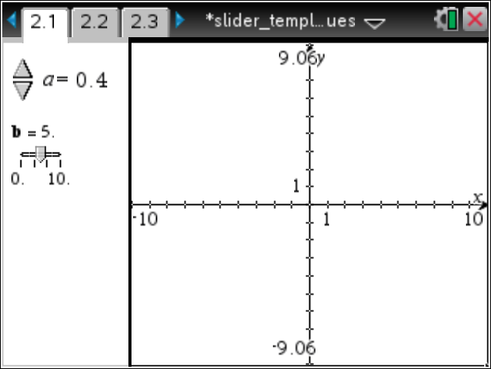
32. To change the slider settings associated with right-click in the slider box, and select Settings.  33. Change the slider settings as desired. For example, consider the settings in the figures to the right. | 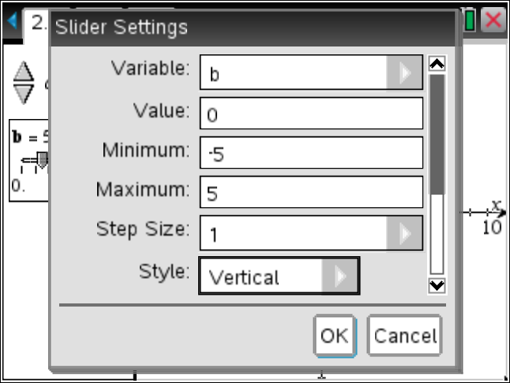  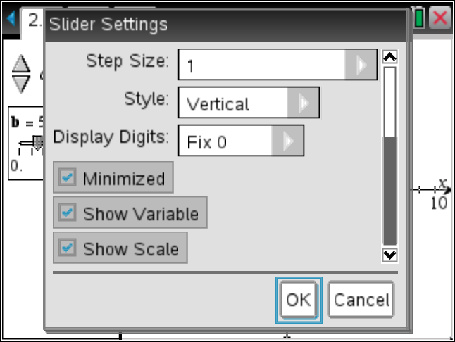
34. Clear any function that was used in Problem 1.
35. You can now add a function characterized by the parameters and on the entry line of the right screen. For example, type Then click the slider arrows on the left screen, and watch the graph of the function change dynamically with the value of the slider.
36. Insert another new problem (3.1).  37. Copy Pages 2.1, 2.2, and 2.3, and paste them into the new problem as Pages 3.1, 3.2, and 3.3, respectively.  38. On Page 3.3, click in the Math Box, and tap enter to evaluate the expression.  39. In the left work area of Page 3.1, select MENU > Actions > Insert Slider to add another traditional slider to this problem.  40. Position this third slider below the first and second, name the slider variable c, and use slider settings as desired. | 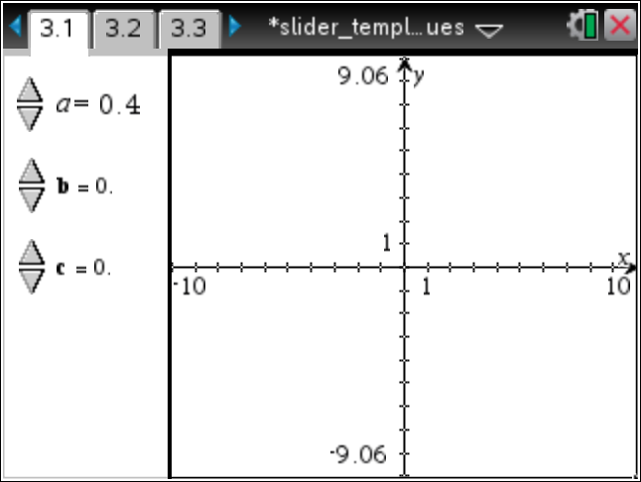
41. Clear any functions that were used in Problem 2.
42. You can now add a function characterized by the parameters and on the entry line of the right screen. For example, type Then click the slider arrows on the left screen, and watch the graph of the function changes dynamically with the value of the slider.
Note: Additional sliders that cycle through specific values and/or traditional sliders can be added. Create another list of numbers and a list name (for example, blist, clist, etc.) for each additional slider that cycles through specific values.

